About the Show

*If I Could I Would* is a fast-paced piece of physical theatre featuring virtuoso acrobatics, imagination and humour to recognise it sometimes takes a superhuman effort to rise above the relentless demands of everyday urban life. From every woman to superwoman, *If I Could I Would* delivers a heart-warming message for everyone about resilience in the face of the everyday grind. If you could, what would you change?

****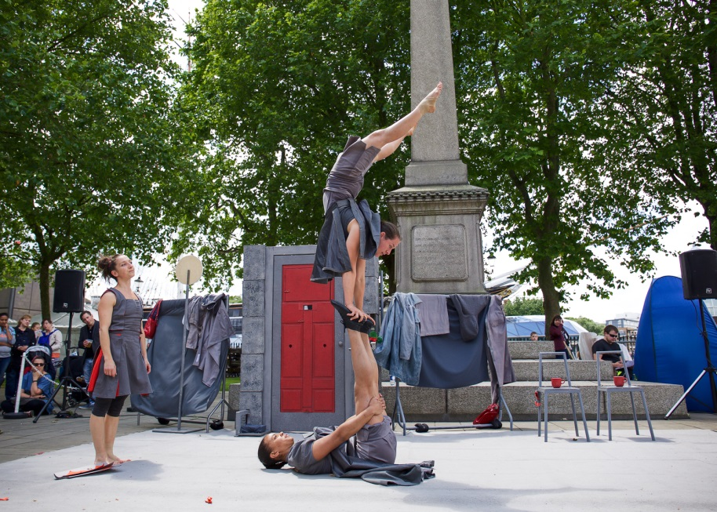

**Workshop Options**

Mimbre can deliver a series of workshops connected with the performance, where participants get to work physically and creatively around the themes of the show. This could either be delivered as relaxed, fun taster workshop or as an in depth physical exploration; where participants get to create characters and small choreographies connected with existing scenes in the show and performed as part of the professional performance. The workshops are always adapted according to the abilities and ages of participants and they connect with Mimbre's philosophy of making arts and physicality accessible and empowering for everyone.

Watch our video filmed with our local youth programme. In the video we mainly talk about our work with young people, but it remains a great of our inclusive approach to teaching and illustrates how it can translate to working with a variety of participants. <https://vimeo.com/162605855>

**Formats and price lists**

Please consult the adjacent table for a detailed look at how we can deliver our workshops alongside our show. Workshops can accommodate up to 32 participants, however if you are interested in different formats or deliveries please let us know. We are happy to tailor our offer to suit your needs and budget.

|  |
| --- |
| **1 Day – 1 Taster workshop and 1 performance**  2 hour taster workshop with acrobatics, acrobalance/human pyramids and performance exercises with a make your own superhero costume option for young children.  Performance of *If I Could I Would*, with an optional superhero flashmob at the end of the show.  Indicative price: £2,400 |
| **3 days – Mini residency mix of performances and workshops**  Day 1. A series of workshops connected to the themes of the show. These could include a mix of acrobatics, performance and discussion based workshops around empowerment.  Day 2. Two Performances of *If I Could I Would*.  Day 3. A performance workshop where participants create characters and small choreographies connected with existing scenes in the show and culminates with a performance of *If I Could I Would* with the participant's scenes incorporated.  Indicative price: £3,900 |
| **1-week residency with in-depth workshops and performances**  A 5 days programme of physical and performance workshops with a set group of participants to create original material around the themes of super-powers and empowerment. This option also culminates in a public performance with the participant's scene incorporated alongside the show. Depending on structure we can perform up to 4 shows in this option.  Indicative price: £4,400 |

