**Hull City of Culture: 'Stunning' light show to end year**

* 14 November 2017

* From the section [Humberside](http://www.bbc.co.uk/news/england/humberside)
* [Share this with Facebook](http://www.bbc.co.uk/news/uk-england-humber-41983409)

* [Share this with Twitter](http://www.bbc.co.uk/news/uk-england-humber-41983409)

* [Share this with Messenger](http://www.bbc.co.uk/news/uk-england-humber-41983409)

* [Share this with Email](mailto:?subject=Shared%20from%20BBC%20News&body=http%3A%2F%2Fwww.bbc.co.uk%2Fnews%2Fuk-england-humber-41983409)

* [Share](http://www.bbc.co.uk/news/uk-england-humber-41983409#share-tools)

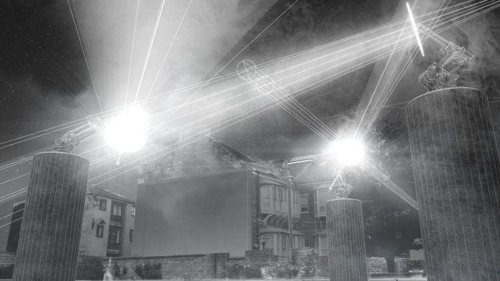Image copyrightJASON BRUGES STUDIOImage captionAn artist impression of the Where Do We Go From Here? art installation, which features more than 20 robotic arms

**A major artwork involving interactive robots is to end the year-long City of Culture celebrations in Hull.**

Robotic arms with lights, mirrors, prisms and speakers are being installed at Beverley Gate, Trinity Square and the Old town area.

It is the last in a series of big temporary commissions marking Hull's year as UK City of Culture.

Titled Where Do We Go From Here?, the large metal structures are due to go on display on 1 December.

[**More on this and other stories across East Yorkshire and northern Lincolnshire**](http://www.bbc.co.uk/news/live/uk-england-humber-41929197)

They are being fitted on 3m tall plinths and have been created by Jason Bruges Studio, which was behind [**the Aeolian tower show in London**](http://news.bbc.co.uk/1/hi/technology/7730330.stm) and the [**Sunderland station light art project**](http://news.bbc.co.uk/1/hi/england/wear/8674290.stm).

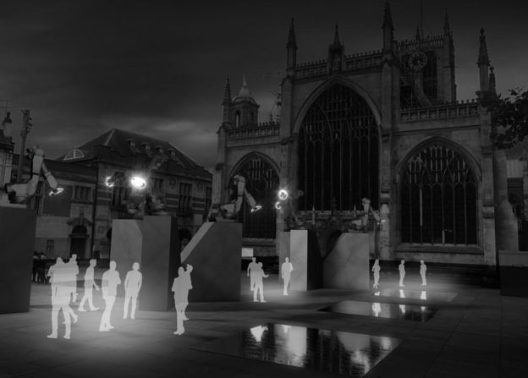Image copyrightJASON BRUGES STUDIOImage captionThe robotic arms will be mounted on 3m high plinths around the city centre, including the front of Hull Minster

The robotic arms move and interact with each other, as well as people passing by.

Niccy Hallifax, executive producer of Hull 2017, said: "This is an artwork about light and movement, reflecting how Hull continues to move forward, into 2018 and beyond.

"Jason Bruges is known around the world for his mastery of light and Where Do We Go from Here? will be a visually stunning piece of art unlike anything ever seen in a public space."

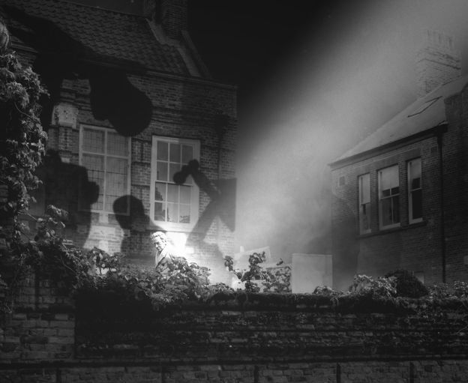Image copyrightJASON BRUGES STUDIOImage captionEach robotic arm is fitted with lights, mirrors, prisms and speakers, all casting light and shadows on buildings and landmarks in the city

It coincides with another installation, which uses virtual reality technology showing a huge wave being created after a real ball is thrown from a great height.

A Colossal Wave! has been designed by London-based group Marshmallow Laser Feast and runs until 10 December.

At the same time there is a 10-day music, art and performance festival called Substance, which examines the north of England's cultural future.

Hull actor Reece Shearsmith, co-creator of the BBC comedy series The League of Gentlemen, and The KLF's Bill Drummond are among the high-profile names appearing at the event.

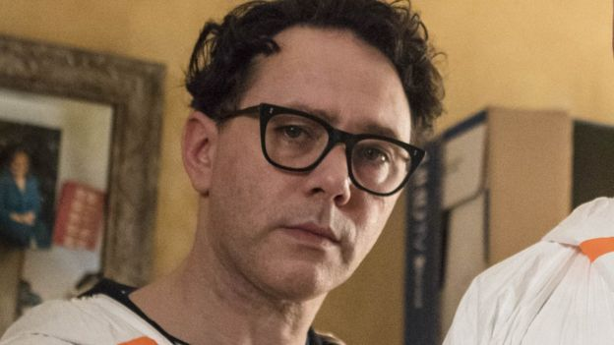Image captionHull-born Reece Shearsmith is among the high-profile guests appearing in the final season of City of Culture events

*Where Do We Go from Here? runs until 7 January*