**Total number of ‘Programming Poker’ games played** 66

**Total number of people spoken to / consulted with** 122

**Have you seen anything like this before?**

Yes – 74% 48  
No – 26% 17

**Why did you go see it?**

Regular – 60% 30  
Special occasion / present – 40% 20

**Would you go see these things in the city centre at a venue like City Hall?**

Yes – 68% 41  
No – 32% 19

**Would you be more likely to see these shows if they took place in a community venue or a space like this one (if consultation taking place in potential venue)?**

Yes – 83% 49  
No – 17% 9

**Would you travel to a different city to see a show like this?**

Yes – 62% 36  
No – 38% 22

**Most picked cards**

**GAME 1**

Pop (M6) 39   
Rock and Indie (M1) 35   
Jimmy Carr (Co1) 33  
Lucy Beaumont (Co6) 33   
Made in Hull (Fi1) 26  
Playing the Joker (T2) 24  
Family Film Club (Fi2) 23  
One Incredible Night of Cabaret (Ca4) 22

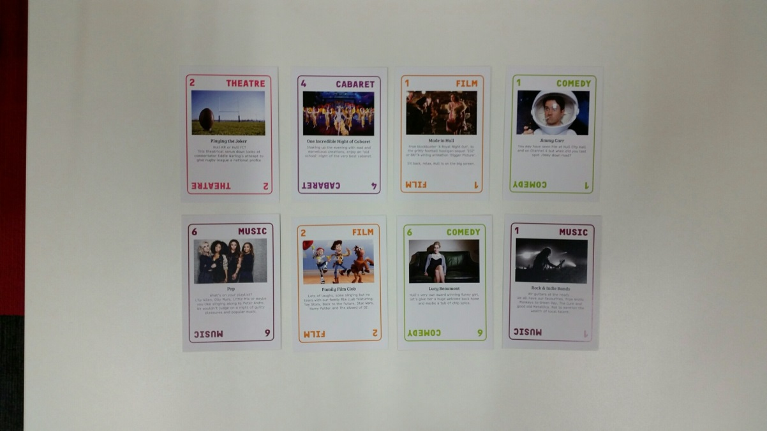

**GAME 2**

Potted Potter (Fa6) 30  
Pop (M6) 25  
Bar Story (D1) 24  
One Incredible Night of Cabaret (Ca4) 23  
Jimmy Carr (Co1) 22  
Family Film Club (Fi2) 19  
Made in Hull (Fi1) 18  
Indie and Rock (M1) 18

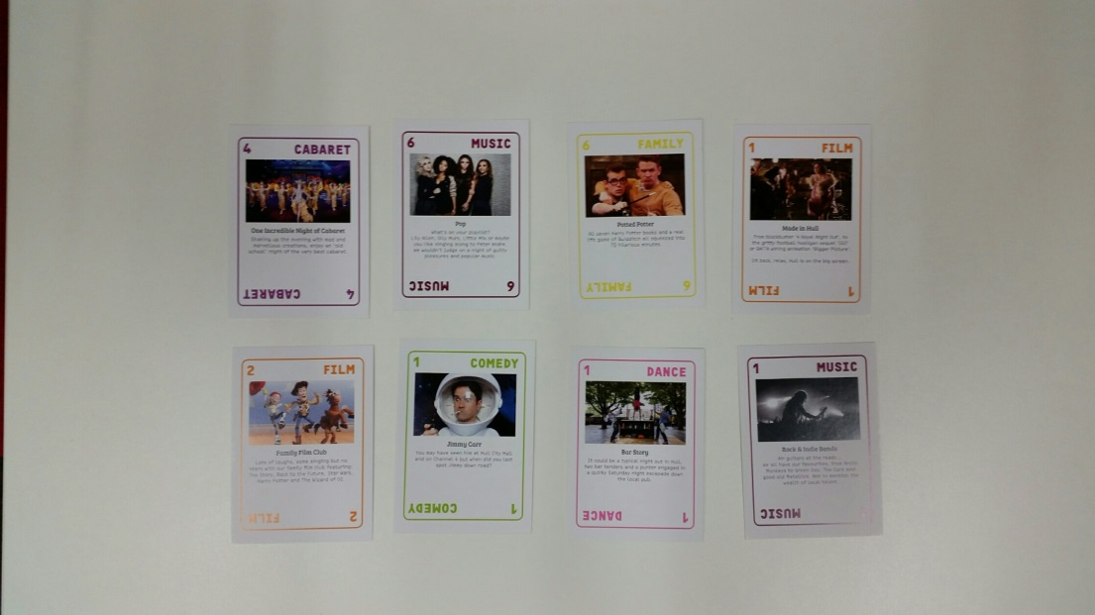

**GAME 2 (top choice per category)**

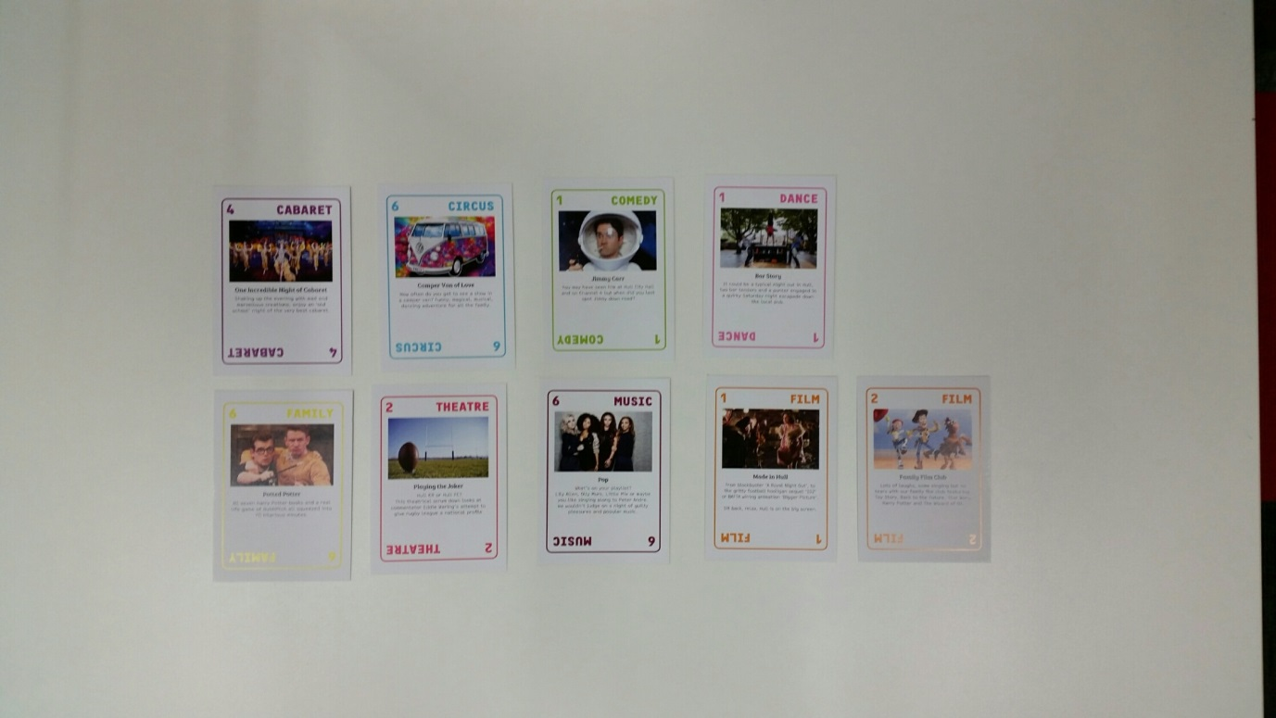One Incredible Night of Cabaret (Ca4) 23  
Camper Van of Love (Ci6) 18  
Jimmy Carr (Co1) 22  
Bar Story (D1) 24   
Potted Potter (Fa6) 30  
Family Film Club (Fi2) 18  
Pop (M6) 25  
Playing the Joker (T2) 16

**Ticket prices** – looking at about 114 ticket prices suggested for various categories

Cabaret up to £10

Circus up to £7

Comedy £12.50 (either £10 / £15 average depending on how big a name)

Dance £5

Family £5

Film £5

Music £12.50 (either £10 / £15 average depending on how big a name)

Theatre £10

**Comments / quotes**

**Liz – West**Could have picked all of circus.  
Wary about comedy – wouldn’t pay to go and see Jimmy Carr.  
Don’t make me ever go to anything jazz.

**Glynis – East**Too much choice.  
Everything is worth a fiver.  
More choice over short period of time, same amount of money to spend – cheaper tickets.

**Jonathan – East**We’ve always got sport, 2017 is about new experiences.  
If it’s near where people live, it gets a real buzz going – ‘have you got your tickets?’

**Cheryl – West**Would never go and see dance.  
Theatre – not a fan but would see an interesting story.

**Laura – West**Thinking about who I would go and see things with.  
Happy to pay for a bigger production.

**Bob – West**We have singers on but that’s about it, would be nice to mix it up in 2017.  
Lovely to see a mix of entertainment, something for young and old.  
Keep it cheap and same price for all types of shows.

**Fred – West**Most of the choices were crap.

**Phil – West**Would not see dance or cabaret.

**Craig – East**Something that I couldn’t typically see in the city.

**Julie – East**I tend not to appreciate dance but the shows you’ve suggested sound interesting so I’d give it a try.

**Sheila – West**I picked thinking about my grandchildren and what I could take them to see.

**Tim – North**I don’t get cabaret or dance.

**Paul – East**Cabaret and dance wouldn’t be top of my list.

**Vicky – East**I only really go out and see things like this for a special occasion.  
Thinking about things that families in the area would be interested in.

**Mark – West**I don’t want a watered down version of a musical, I want the real thing.

**Karen – North**Something like circus would be really good round here, I think families would be interested.  
There isn’t a lot going on, you know, on our doorsteps round here.  
Have a 4 year old so really interested in interactive performances and the experience.

**David – West**Really into brass music since I saw Brassed Off.

**Jodie / Stacey / Mel**As well as things we’d do together as families, I think cabaret would be a great night out for the parents! The sort of thing we could go and see together as a big group.  
Venue would need to have a license.  
Family ticket should not be restricted to family of 2+2.

**Libor / Magda – East**I want to see a B-movie film club.  
Non-mainstream quartet.  
Not looking at mainstream comedy either, Lucy Beaumont would be good but other than that, a few comedians doing smaller sets.  
I picked cabaret because I saw a programme on TV about men in clubs in London (drag queens?).  
I’m used to free and regular outdoor cinema screenings in Poland, I think Hull should have more!

**Val – North**I’d want more things to do as a family, rather than as a couple – things to do in a bigger group.

**Steve – North**I never see anything, it’s too expensive and I don’t know where to look, there’s no one guide is there. Not sure there is stuff for more in Hull any more.  
I thought who would I go with.  
Circus looks impressive.  
I would need to get the bus there and back.  
I’m really into Pink Floyd so wouldn’t see any other band. Would go to most circus events, love Freedom – it’s free! Have to leave early to get home so things like this in my area would be exciting.

**Sarah – North**One off chance to see what you want in 2017 so I’ve selected a mix for me, my partner and my kids.  
Would like pop-up physical theatre just at shops or garage / bus stop – a nice surprise. Films are already on at cinema but drive-in would be nice.

**Andrea – West**We prefer to go to pub / club rather than theatre or City Hall.  
Want things for me and the grandkids.  
Loved opera in the park when I went to Italy on holiday – even my husband enjoyed it!  
I don’t like going into town, that’s for young people not families. We have lots of pubs why not liven them up for 2017. No bus from my door to town. Town is rough – show people real Hull.

**Albert – West**I’m too old for town, I don’t like it at night.  
I’d go to London if I was with the family for the weekend.

**Karen – East**No comedians that are sexist please.  
Use nice places in east so they can be used in future and it becomes like west/Avenues and town.  
I hate theatre.  
Why shouldn’t we have great things, east never gets anything.

**Gary – East**Don’t get chance to see stuff it’s usually too expensive and in town or marina, I want it to be local – East Park would be great for me and my family.  
My choices are based on my family, I love cabaret and circus, it’s entertaining and accessible to lots of people.  
If you’re going to do music, make it good well known bands not rubbish that nobody has heard of.

**Jane – East**Comedy would need to be looked at, John Bishop or similar content for school location.  
Families struggle to pay for arts activities and don’t feel it’s for them, it’s not accessible.  
I’ve tried to pick things that I think families would be interested in.  
Comedy would be the way to engage people in Hull.  
It has to be accessible. People don’t feel comfortable with new art forms or high art. Maybe eventually but at first it needs to be something people either know or content is known – rugby / music.

**Katie – East**people are not multi-cultural in this area so not had the chance to see this type of thing. Arts are too expensive. People don’t travel into town.  
Consider a payment scheme for tickets, under 5s free.  
Films would be good outside and staggered throughout the day – kids, teens and adult up to midnight – horror.

**Liam – East**People attending school and in this area haven’t seen very much, if anything. Just school productions.  
First choice was what families in Preston Road would like. Mainly a popular choice or at least things they might recognise.  
A lot of families in east never go into town. Young people say they don’t know how to get into town.

**Kevin – North**I don’t really get chance to go into Hull to see bands or theatre. I never have spare money.  
People like world music – they just don’t know they d – mix things up.

**Lucy – North**Not something we think of would be good for 2017. We only see what’s on at school or club – my kids, not me, I see nothing.  
I want a mix but no idea what else to choose. I would have to see clips.  
Families would go if they can afford it.  
Would love to see a big show, just don’t make it too expensive or people won’t go.

**Gary – West**Don’t need a joker, don’t need big named acts, just good stuff going on.

**Janet – North**Want to see more music but where and how much is a big thing for me. I feel silly asking.  
I wouldn’t go into town by myself.

**Cara – West**It’s a special year for kids in the city, I would love my kids to see new things.  
It’s about kids, I would enjoy watching them enjoying a show. In our area we never see things like shows and I don’t take the kids in town it’s too busy and expensive. My mum takes them to panto in town, is it any good?

**Mac – East**I enjoyed trying new things at Edinburgh Fringe the other year so more open to trying new things, even if I don’t like them! Especially when tickets are quite cheap / less than you’d pay for the theatre.

**Sue – West**I’m not sure about some of them, I don’t know what to expect with some of them.

**Paula – West**I go to other cities to see big shows but wish Hull could attract them sometimes – why don’t shows keep coming down the M62!

**Adele – East**Think music would bring people together.  
Needs to be things my family and friends would like to go and see.

**Danielle – East**Think people in the area would enjoy coming to venue like Freedom Centre to see things like this.

**Tony – East**I’m not a big fan of circus.  
Everyone should see classical music at some point in their life.  
Opportunities people wouldn’t normally get.

**Michelle – North**Current circumstances have stopped me getting ticket for Rod Stewart, I would have normally been the first to get it – ticket prices can’t stop people from going.

**Kirstine – West**I like to go to things with a big group of mates.  
Not seen circus like this or cabaret, seems like a Southern/London thing.  
I didn’t pick any film or family. I really wouldn’t go to these unless they were on my doorstep and cheap or free.  
I made my choices based on things I want to see with mates or family.

**Adam – East**There should be pop for young people.  
I hate Jimmy Carr, he’s sexist.  
Under 4s should be free.  
Different price range for different kids.  
Don’t charge too much, young / unemployed people won’t be able to go.

**Nicola – West**I’ve picked things I want my kids (aged 4-7) to see, not really interested for myself.  
I can’t get childcare so would have only picked kid stuff but if it was in a local pub, I would go if I could.  
I’d want a mix for my kids but would only go if cheap or was something known either subject person (popular / famous).  
I think 2017 is more for kids than adults.  
Not thought about circus or cabaret being about culture before.

**Kev – West**I went to see a play at Hull Truck a few years ago, my friend got a free ticket.  
I never have much spare money so don’t think about arts but would go if near me.  
I want there to be pop music for people in Hull. It’s what people want but never get chance to see it.  
You can see film any time, 2017 is supposed to be more special. Don’t we want people in Hull to feel proud.

**Chris / Sue – East**I would rather stay at home to watch a film than pay to go out and see them.  
I want things that I can go and see with my family, that’s what 2017 is about.

**Ann – East Riding**Even though I live in the East Riding, I don’t use venues in the city centre. I prefer to go to venues like Freedom Centre because they’re easier to access and don’t have hassle of getting into and out of city centre – parking!  
I’m quite happy to give anything a go – especially if I’ve heard of it through word of mouth.

**Lucy / Sarah – North**When we’re not working, we want to do things with our families but happy to use venue sin city centre or community venues, depends what’s on, not where it’s on.

**Caitlyn / Emma / Charlie / Lucy – West**We don’t want classical music or clowns, would like to learn circus though.  
We want to see things that look interesting and different.  
If the tickets were cheaper it means we could go and see more rather than having to just pick one or two things.

**Hymers teachers - West (for pupils / their parents / residents in area)**Film would have to be an event, not just a screening.  
There would need to be family tickets, not just individually priced tickets.  
We’d want pupils to be able to participate in events.

**Adam / Jonathan / Angel / Danny / Josh / Vicky / Damian – North / West / East**(PADD disability group for young people)  
It’s about the variety of stuff – the first thing that comes to mind when you say art / culture is paintings, the boring stuff.  
Don’t really go and see cabaret / dance.  
Don’t like theatre, I have a short attention span so couldn’t sit through more than a 30 minute performance.  
Won’t / don’t go to Hull New Theatre, tickets are too expensive.  
If it’s not something I know, I don’t want to pay more than £1 / £5 for a ticket in case I don’t like it and if it’s more, I just wouldn’t go.  
Family tickets need to be cheaper.

**Sam / Anita / Jane / Ria / Julie / Kerrie / Kay / Helen – East** (strong young person focus from this group)  
Need something big to attract people.  
If it’s for children it needs to be PM not AM.  
Comedy – should give you belly laughs, a bit risqué, not Chubby Brown, too much swearing, take teenagers and your mam.  
Cinema, needs to have a twist, drive-in, sleepover etc  
Keen on shadow performance.

**Ticketing**Family tickets would be popular  
Youtubers – ticket should be £5  
3 things for kids would pay £7-£10 – expensive though if you have 3 or more children. Could age banding work?  
Feeling some stuff should be free but appreciate trying to build ticketing culture  
Maybe charge children and adult goes free.  
Film events should be £1.  
Headlines eg Diversity, Lenny Henry max £10.  
Good idea to hold events in neighbourhoods but needs to be advertised properly with plenty of notice and places other than online to purchase tickets.

**Dan / Christine / Martin / Bex – Kingswood Academy (North)**What would be special about film.  
Got to have things for adults.  
It doesn’t just have to be for families.  
This venue is on the doorstep for families around here. We always wanted the school to be used in this way but not had the time / resources.  
Roy Chubby Brown is more adult based – who are we thinking of for the project.  
Not thinking Jimmy Carr.  
Think students would look up to Lucy Beaumont.  
Students would not get Romeo & Juliet – not sure about adults around here.  
What about the older people that live round here.  
Would pick cabaret over dance.  
Sometimes you think it’s nice to bring thigs they haven’t seen before to introduce them to new things.  
To attract an audience, it would need to be a big name (music).  
Needs a bit hype. Start with a good named band.  
Classic rock, been big.  
Could create a crèche for childcare.  
Concessions for older people / benefits.  
I think it’s a nice mix. I think it’s a broad range for people round here.  
Needs to be participatory opportunity.  
People want to see things that are a bit different.  
Do we dare go over £8 a ticket?

**Karen – East**Found it hard to pick 8.  
Not picked family – kids have grown up.  
Don’t like circus in any form.  
Would like to see ballet – a good one.  
Could or would big ballet came to community though?  
Think it would be more sustainable if middle age are targeted – they have spare money.  
Needs to be after things going on around the event i.e. somewhere to go for a drink or food.  
Nowhere to get decent food at tea time in Hull City Centre.

**Ian / Lisa - West**Like to take kids to classical to try if was free.  
Dance – kids more interested in music so need to incorporate somewhere.  
Cost is big factor.  
Need commercial stuff too.

**Alex – East**Local singer at Kardomah was great – intimate venue.  
Edgy circus appeals to me – though provoking.  
Have to think about cost if more than one.  
Think about household income – the impact.  
Would like to see Shakespeare in a community venure e.g. school. But good quality!!

**Sue – West**Would like to see comedy acts but likely to be booked so need to get booked early..  
Would not go to dance, unless part of Freedom Festival – would go to ballet if quality and price was right. Find a lot of events are expensive, especially if more than 1.  
Community venue doesn’t seem like a night out. (JM - but could be!?

**Paul – North**Music needs a big selection – would appreciate some top bands in Hull.  
Needs to be attractive to Hull – not ‘arty, farty c***  
Family choices don’t appeal as children older.  
Circus would really need to be sold to me.  
Dance – daughter danced, put me off for life!

**Des – West**Would go to theatre on own, not with family.  
Interactive for kids, digital arts.

**Annice – East**Wants comedy in her life!  
Circus would be good for all the family.  
As a family cost increases so unable to go outside of the city so community venues would be inclusive.

**Rebecca – North**Everyone now has a limited budget.

**Isaac – East**Wouldn’t go to theatre but the sport one looks ok.

**Dawn – West**Cabaret and circus does not interest me, certainly not paying for it.  
Substantial number of alcohol free events.

**Janette – West**Don’t really go and see things at theatre but would like to.  
need confidence or a friened who would so with me.  
Wouldn’t go to family or friends things now, kids have grown up.  
Would like to see a proper ballet.

**Ann – East**Needs to be really well advertised if things are going on in the community.

**Phil / Sue / Amy / Callum / Stacey / Anita / Saj – North**Romeo and Juliet would be great in our open air theatre, linking to when we teach it.  
Kids and parents would relate to Lucy Beaumont.  
Most people would have already downloaded the films and watched them rather than paying.  
There isn’t much out there for under 5s.  
People round here don’t go to theatre, they don’t go to Hull Truck.  
If tickets go above £10, it will exclude people.  
We have none of this, with us being City of Culture we need to pull our socks up.  
Having different locations in the city makes events more accessible to people who may not live as local or have own transport.

**Jokers** – based on what they would like to see in a community based venue

|  |  |  |
| --- | --- | --- |
| Poppy exhibition | Ennio Marchetto | Phantom of the Opera |
| Adele | Marvell / Pixar film premiere | Austen – modern version |
| The Lion King – West End | The Lion King – West End | Taylor Swift |
| Ed Sheeran | Wicked | Funny Girl |
| Modern Orchestra – with Adele like twist | Northern Ballet e.g. 1884 | The Lion King – West End |
| Stevie Wonder | Adele | Little Mix |
| Dance music | Red Hot Chilli Peppers | Bouncers (or other Godber play) |
| DJ | TV Sketch Show (theatre) | Cirque de Solei |
| Florence and The Machine | Dance music / DJ | VW Camper Van show |
| The Stone Roses | Aerosmith | Green Day |
| Punk / Ska | Bon Jovi | New Orleans Brass Band |
| Large scooter rally | Iron Maiden | Kids West End show / characters / disco |
| Improve Murder Mystery | Transformers – lifesize | Jazz to dance to |
| Dynamo | Hairspray | Paloma Faith |
| AC/DC tribute | Billy Elliott | Sarah Pascoe |
| John Richardson | Opera in park | Les Miserable |
| Noel Gallagher | Paloma Faith | The Stone Roses |
| Pink Floyd | Elbow | Tony Law |
| Beautiful South vs Philharmonic Orchestra | Sigur Ros | Fleetwood Mac |
| Foo Fighters | Chvrches | U2 |
| Olly Murs | Sleaford Mods | Chitty Chitty Bang Bang – musical |
| Grease | The Lion King | Mary Poppins – West End |
| Adele | John Bishop / Peter Kay / Lee Evans | Rod Stewart / ELO |
| Jersey Boys / The Lion King / Wicked | Jersey Boys | Westlife |
| Eminem | Peter Andre | Robbie Williams (with Orchestra) |
| Philharmonic Opera – outdoor event | Peter Kay | Chicago |
| Radiohead / The Smiths / Morrissey | Pink Floyd | Sean Lock |
| Rachmaninov / Schostakovich | Depeche Mode | West End show in park |
| Die Antwoord | The Lion King | Blood Brothers |
| Small Faces / Beatles / Who | The original Top Gear team | Steve Coogan |
| Rob Bryden | David Gray | Robbie Williams |
| Cirque de Solei | Rod Stewart | Soul music |
| UB40 | Classical violinist – Joshua Bell | Happy Mondays |
| Chitty Chitty Bang Bang | We Will Rock You | Zach Brown |
| Olly Murs | Little Mix | Sketch Show – Keith Lemon / Mighty Boosh |
| Rocky Horror | Miranda Hart | Music Festival (Leeds / Reading) |
| Justin Bieber | Mega Jam | Last Night at the Proms |
| Murder Mystery | Outdoor pantomime | Taylor Swift |
| A street festival | Adele | Rocky Horror |
| Reece Shearsmith | Rhod Gilbert | John Bishop |
| Diversity | Oasis / Florence and The Machine / Lucy Spraggan | Gaming vloggers |
| Nicki Minaj | Champions League Final | Total Wipeout |
| Dolly Parton | Video tournament | YouTube convention |
| Wrestling convention | Lazer quest competition |  |
| 1D / Justin Bieber / Little Mix / Cheryl Cole / Ed Sheeran | Cirque de Solei | Wicked / broadway musicals |