**PRSF NEW MUSIC BIENNIAL**

**HULL**

**29th JUNE to 2nd JULY 2017**

**ARTIST PACK**

**ARTIST**: Laurence Crane

**ARTIST CONTACT (Mobile number):** TBC – PROMOTER TO CONFIRM

**VENUE**: Albermarle Music Centre

[Address](https://www.google.com/search?biw=2400&bih=1217&q=www+fruitspace+co+uk+address&stick=H4sIAAAAAAAAAOPgE-LWT9c3LDOyTMpKK9GSzU620s_JT04syczPgzOsElNSilKLiwFSWNTXLgAAAA&sa=X&ved=0ahUKEwiT5cTKt7jUAhUlKMAKHZ4BA-AQ6BMIowEwEA): Albermarle Music Centre, 60 Ferensway, Hull HU2 8LN

[Phone](https://www.google.com/search?biw=2400&bih=1217&q=www+fruitspace+co+uk+phone&sa=X&ved=0ahUKEwiT5cTKt7jUAhUlKMAKHZ4BA-AQ6BMIpgEwEQ): 01482 318800

**LOADING IN FROM:**

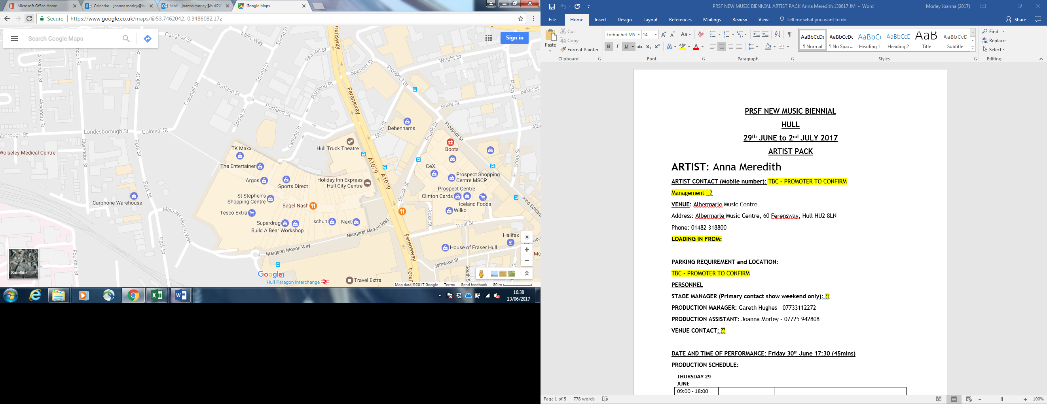

**PARKING REQUIREMENT and LOCATION:**

TBC – PROMOTER TO CONFIRM

**PERSONNEL**

**STAGE MANAGER (Primary contact show weekend only):** ??

**PRODUCTION MANAGER:** Gareth Hughes – 07733112272

**PRODUCTION ASSISTANT**: Joanna Morley – 07725 942808

**VENUE CONTACT**: ??

**DATE AND TIME OF PERFORMANCE: Sunday 2nd July 15:00 (45mins)**

**PRODUCTION SCHEDULE:**

|  |  |  |  |  |  |  |  |  |  |  |  |  |  |  |  |  |  |  |  |  |  |  |  |  |  |  |  |  |  |  |  |  |  |  |  |  |  |  |  |  |  |  |  |  |  |  |  |  |  |  |  |  |  |  |  |  |  |  |  |  |  |  |  |  |  |  |  |  |  |  |  |  |  |  |  |  |  |  |  |  |  |  |  |  |  |  |  |  |  |  |  |  |  |  |  |  |  |  |  |  |  |  |  |  |  |  |  |  |  |  |  |  |  |  |  |  |  |  |  |  |  |  |  |  |  |  |  |  |  |  |  |  |  |  |  |  |  |  |  |  |  |  |  |  |  |  |  |  |  |  |  |  |  |  |  |  |  |  |  |  |  |  |  |  |  |
| --- | --- | --- | --- | --- | --- | --- | --- | --- | --- | --- | --- | --- | --- | --- | --- | --- | --- | --- | --- | --- | --- | --- | --- | --- | --- | --- | --- | --- | --- | --- | --- | --- | --- | --- | --- | --- | --- | --- | --- | --- | --- | --- | --- | --- | --- | --- | --- | --- | --- | --- | --- | --- | --- | --- | --- | --- | --- | --- | --- | --- | --- | --- | --- | --- | --- | --- | --- | --- | --- | --- | --- | --- | --- | --- | --- | --- | --- | --- | --- | --- | --- | --- | --- | --- | --- | --- | --- | --- | --- | --- | --- | --- | --- | --- | --- | --- | --- | --- | --- | --- | --- | --- | --- | --- | --- | --- | --- | --- | --- | --- | --- | --- | --- | --- | --- | --- | --- | --- | --- | --- | --- | --- | --- | --- | --- | --- | --- | --- | --- | --- | --- | --- | --- | --- | --- | --- | --- | --- | --- | --- | --- | --- | --- | --- | --- | --- | --- | --- | --- | --- | --- | --- | --- | --- | --- | --- | --- | --- | --- | --- | --- | --- | --- | --- | --- |
| |  |  |  | | --- | --- | --- | | **THURSDAY 29 JUNE** |  |  | | 09:00 - 18:00 (ACCESS) | 09:00 | Stage manager on site | |  | DAY | Delivery of Harmonium (Gavin Bryars) | |  | DAY | Set up dressing rooms | |  | DAY | Dressing and branding | |  | DAY | BBC to park up to the corner / rear | |  | 12noon | Tech set up | |  | 12noon | Set up Anna Meredith - percussion set up (see also Hannah Peel plot) | |  |  |  | | **FRIDAY 30 JUNE** |  |  | | 09:00 - 23:00 (ACCESS) | 09:00 | Stage manager on site - set for Anna Meredith | |  | 09:00 | BBC OB in | |  | 10:00 | Anna Meredith - Artists arrive | |  | 11:00 - 12:00 | Anna Meredith - Set up | |  | 13:00 - 16:00 | Anna Meredith - rehearsal | |  | 16:30 | Box office on site | |  |  |  | |  | 17:00 | Doors | |  |  |  | |  | 17:30 | Anna Meredith PERFORMANCE | |  | 18:15 | FINISH | |  | 18:30 - 18:45 | Reset for Gavin Bryars | |  | 18:45 | Rehearsal Gavin Bryars | |  | 19:00 - 21:00 | Moulettes rehearsal - rehearsal - Rivers and Railways | |  | 19:45 | Doors | |  | 20:00 | Gavin Bryars - PERFORMANCE | |  | 20:45 | FINISH | |  | 21:00 - 23:00 | Reset for Hannah Peel and Laurence Crane | |  | 21:00 - 23:00 | Reset Dressing rooms | |  |  |  | | **SATURDAY 1 JULY** |  |  | | 09:00 - 21:00 (ACCESS) | 09:00 | Stage manager on site | |  | 10:00 | Artists arrive - Laurence Crane | |  | 11:00 - 12:15 | Laurence Crane - rehearsal | |  | 12:00 | Box office on site | |  | 12:15 | Doors | |  | 12:30 | Laurence Crane - PERFORMANCE | |  | 13:15 | FINISH | |  | 13:30 | Hannah Peel - Artists arrive - rehearsal synthesisers and percussion | |  | 15:30 | Hannah Peel - Brass arrives - rehearsal | |  | 16:15 | Doors | |  | 16:30 | Hannah Peel - PERFORMANCE | |  | 17:15 | FINISH | |  | 17:30 | Set tech for Jocelyn Pook | |  | 21:00 | Clear | |  |  |  | | **SUNDAY 2 JULY** |  |  | | 09:00 - 21:00 (ACCESS) | 09:00 | Stage Manager on site | |  | 10:00 | Artists arrive - Jocelyn Pook | |  | 10:00 - 14:00 | Jocelyn rehearsals | |  | 14:00 | Box office on site | |  | 14:45 | Doors | |  | 15:00 | Jocelyn Pook - PERFORMANCE | |  | 15:45 | FINISH | |  | 16:00 - 20:00 | Clear and derig | |
|  |

**TECHNICAL**

**Sound**

**FOH Control**

1 Midas Pro 2C - Live Audio System

**Speaker System**

6 L Acoustics - ARCS

8 L Acoustic ARCS - ARCOUPL

2 Ratchet Strap (Black) - 7.5m 2T

4 L Acoustics - SB28

1 L Acoustics LA8 Rack (4 - Way)

2 NL4 Speakon Cable 4mm 20m

2 NL4 Speakon Cable 4mm 10m

2 NL4 Speakon Cable 4mm 5m

4 NL4 Speakon Cable 4mm 0.5m

3 NL4 Sub Split Cable

**Monitor System (Up to 4x Mixes)**

4 L Acoustic 115XT HiQ

**Microphones**

1 Shure ULXP Beta58 Handheld Radio System - CH38

**Misc**

1 63A 3-Phase Cable 20m

1 63A 3 Phase Mains Distro #5

1 Backline Power Prep - Standard

**Staff**

1 Engineer - FOH

1 Engineer – Systems

**AV**

**Material**

1 Blackmagic Design HDMI-SDI Converter

1 Blackmagic Design SDI-HDMI Converter

1 Black Magic ATEM 1 M/E Production Studio 4K

**Staff**

1 Engineer - AV

**Lighting**

Provided by House

**Staff**

1 Engineer – Lighting

**Headphone Monitoring – Tubular Brass**

**Material**

1 Art Head Amp 6

1 Closed Back Headphones

1 10m Balanced Jack Cable

1 5m Balanced Jack Cable

1 Jack to Jack Coupler

1 3.5mm to 6.35mm Jack Adapter

2 BSS AR133 DI

**Microphones – Jocelyn Pook**

**RF**

1 DPA 4088F - Headset Microphone

1 DPA DAD6034 - Microdot to 3.5mm Jack

1 Sennheiser EW512 G3 - Belt Pack System - Range GB

**Microphones**

3 Neumann KMS-105

3 AKG C451

3 AKG C414ULS

10 Microphone Stand – Tall

**Microphones – Tubluar Brass**

**Material**

6 BSS AR133 DI

2 AKG C451

1 Shure Beta 57

3 Microphone Stand – Tall

**Microphone – Gavin Bryars**

**Material**

1 Sennheiser e609

2 DPA DAD 4099-BC

1 DPA Clip for Violin and Mandolin (VC4099)

1 DPA Clip for Cello (CC4099)

2 DPA DAD 6001 XLR 48 volt adapter

1 Shure Beta 87

2 Shure SM57

2 BSS AR133 DI

1 Microphone Stand - Tall

2 Microphone Stand - Medium

1 Microphone Stand - Short

**RIDER:**

TBC

**BACKLINE**:

**ACCREDITATION**

David & Alice Porter (Directors)

Steve & Sam Shaw (Directors)

Peter & Lorraine Boardman (Directors)

Wes Zepherin (Director)

Kirsty & Gary Halliday (Marketing)

Ben Pugh (Production)