Appendix 13:
Audience Survey Analysis – Blade
  - Executive Summary
This report contains the findings from audience counts and audience reaction surveys conducted at the first Look Up artwork - Blade, the installation in Queen Victoria Square from 8 January to 18 March 2017. The research was jointly commissioned by the Hull UK City of Culture 2017 and the University of Hull and conducted by Information by Design (IbyD) with fieldwork undertaken between 8 January and 12 March 2017.
Key findings from the research for Blade include:
- Just of four-fifths respondents (81%) knew that Blade was part of Hull UK City of Culture 2017 prior to attending. 87% were planning to attend or participate in other events and activities programmed for Hull UK City of Culture 2017.
- Just over three-fifths (61%) of respondents had been to look at Blade on one day, 23% had been on two days and 11% had been on three or more days. Respondents from Hull and respondents from the second most deprived tercile of areas of Hull were significantly more likely to have been to see Blade more than once.
- Nearly one-third of respondents (31%) thought that they would not go to look at Blade again. 29% thought that they would go to look at Blade again once, 19% thought that they would go to look at Blade again twice and 21% thought that they would go to look at Blade again three times or more.
- Respondents stayed at Blade the longest on their first visit, with respondents staying for an average of 25 minutes on their first visit, for an average of 16 minutes on their second visit and for an average of 14 minutes on their third visit.
- 17% of respondents had been to see Blade on the first occasion because it was ‘a unique experience not to be missed’ and 17% of respondents because they ‘wanted to see / do something creative’.
- Seven out of ten respondents (70%) were very likely to recommend a similar type of event to Blade to friends or relatives (a score of 9 or 10). Only 2% were very unlikely to recommend a similar type of event (a score of 0 or 1). Men, respondents aged 16 to 34 and respondents from outside of Hull and the East Riding were less likely to give a score of 9 or 10.
- Over 80% of respondents strongly agreed (a score of 9 or 10) with the statements ‘it is important it’s happening here in Hull’ and ‘it was an interesting idea’. 70% or more strongly agreed (a score of 9 or 10) with the statements ‘I would come to something like this again’, ‘it was different from things I’ve experienced before’ and ‘It is well produced and presented’.
- Over 90% of respondents strongly agreed or agreed with the statements ‘Blade was an enjoyable experience’, ‘Blade showed the aspirations of the City now and in the future’ and ‘Blade provided me with a different experience of the city’.
- The majority of respondents agreed that they had felt welcomed by Hull 2017 volunteers and staff, with 92% agreeing that they had felt welcomed by Hull 2017 volunteers and 86% agreeing that they had felt welcomed by welcomed by security and stewards.
- The main ways respondents had found out about Blade was from TV, with 36% finding out this way. 20% of respondents had found out about Blade from being told in person by friends, family and colleague, 17% from Hull 2017 social media, 13% from newspapers and 11% from social media or emails from friends, family and colleague.
- Just over half (51%) of respondents were mainly in Hull City Centre on the day they went to Blade on their first visit because of Blade. 42% of respondents were in Hull City Centre mainly to see Blade on their second visit and 41% of respondents in Hull City Centre mainly to see Blade on their third visit
- Nearly two-fifths (39%) of respondents were in Hull ‘just for this event’ on the first occasion they visited Blade and nearly a quarter (24%) were in Hull for general leisure purposes.
- The majority of respondents (92%) knew that Siemens was one of the main partners and just over a quarter (26%) knew that Green Port Hull was one of the main partners.
- Overall, 31% of respondents had seen at information about Blade in Queen Victoria Square, with 21% having read information and 10% having seen information but not read it. 13% of respondents had seen information in a nearby shop window, 21% had seen information boards and 18% had seen information leaflets.
- The majority of respondents who had read the information about Blade in shop windows, on information boards or on leaflets in Queen Victoria Square had found the information interesting, with 96% strongly agreeing or agreeing with the statement ‘the information boards / leaflets about Blade contained information that I found interesting’.
- Nearly three-fifths (59%) of respondents were from outside of Hull, with 39% from the East Riding and 20% from elsewhere in the UK. Of the respondents from outside of Hull, 95% had been to Hull before coming to Blade and 5% were visiting Hull for the first time when they came to Blade.
- Visitors to Hull rated Hull highly on visitor welcome and overall value for money with 81% satisfied with the general visitor welcome and 79% of respondents satisfied with overall value for money (a score of 4 or 5 out of 5).
- Fourteen percent (14%) of visitors to Hull stayed in Hull overnight and 86% were in Hull just for the day. The mean number of nights spent in Hull by overnight visitors was 2.00 and the mean number of days spent in Hull was 2.83. Overnight visitors on average spent £46 on accommodation. 53% were staying with friends and family, 39% were staying in a hotel and 8% were staying in a bed and breakfast.
- Respondents estimated that they spent an overall mean of £71.21 on themselves and on others with them in Hull on the (up to) first three days they attended Blade as part of their visit. 41% of this spend was on food and drink, 41% was on shopping and 8% was on travel and transport. Respondents from outside of Hull and the East Riding and respondents age under 55 had a higher mean estimated spend.
- Just under half of respondents (46%) would not have come in to Hull City Centre on the first day they attended Blade if the event was not on. 30% of respondents would have stayed at home, 25% would have gone shopping in Hull and 23% would have visited another attraction in Hull on the day of their first visit to Blade if they had not come to Blade.
- Respondents estimated that they would have spent an overall mean of £53.65 on themselves and on others with them on the (up to) three days they visited Blade if they had not visited Blade. This is £13.87 lower than the estimated spend of £67.52 recorded at Blade (excluding accommodation spend).
- In relation to other arts participation, nearly four-fifths (78%) of respondents had been to museums/historical attractions, 68% had attended films in the last 12 months. Over 50% of respondents had attended outdoor events and music. Only 6% of respondents had not attended or participated any of the types of arts asked about. There were significant differences in participation rates by age and area – younger and older respondents were generally less likely to have participated and respondents from Hull were less likely to have participated in a number of the listed activities.
- 32% selected blue as their favourite colour.
The conclusions to this report emphasise the success of Blade both in terms of audience numbers and impact. Blade was highly successful in its objective to ‘transform Hull’s streetscape through the imposition of a single wind turbine blade’ and in providing its audience with ‘a spectacle, an obstacle and an object of wonder’. Blade had an estimated audience of over 400,000 people, with an average of over 7,000 people visiting the structure each day of the two-month period it occupied Queen Victoria Square in the city. Total spend by the Blade audience was over £5m with estimated additional spend (additionality) resulting from Blade in the region of £1m.
  - Background and Methodology
    - Background
This report contains the findings from audience counts and audience reaction surveys conducted at ‘Look Up 1: The Blade’ (Blade) the installation in Queen Victoria Square from 8th January to 18th March 2017. The research was commissioned by the University of Hull/Hull UK City of Culture 2017 and conducted by Information by Design (IbyD) with fieldwork undertaken between 8th January and 12th March 2017. The overall aim of the research was to provide information to support the evaluation of the process and impact of Blade, with the key objectives being to:
- Provide an accurate and robust count of the audience for the installation;
- Measure audience awareness, motivation and reaction to the installation;
- Understand the economic, social and cultural impact; and
- Inform future planning of events.
    - Methodology and Sampling
There were three strands to the research:
- Audience counts from the installations.
- Gathering details of members of the audience at the event (name, telephone number, party composition and age).
- Post-event telephone (CATI) interviews of the audience members, using names collected at the event/s, ensuring that we achieve the required sample size.
    - Sample Size
In total, contact details were collected from 1,449 members of the audience at Blade from 8 January to 18 February. A target sample size of 600 post-event interviews was set for the project. This target was achieved, with 600 completed interviews being conducted from the names of audience members collected at Blade. It should be noted that respondents were able to choose not to answer questions, and so the base size for some of the questions is smaller than the total achieved sample size.
As a point of reference, the overall confidence interval for this survey of 600 respondents is ±4.0%. Strictly speaking each question will differ as the confidence interval is also dependent on the individual responses to the question. Generally, confidence intervals are quoted in this report at the 95% level.
    - Weighting
The data from the 600 post-event interviews was weighted on age to match the 1,449 audience details collected at Blade. Appendix A provides a profile of respondents to the survey.
  - Blade - Estimated Audience Counts
This section presents the results of the counts undertaken to estimate the size of the audience at Blade.
Counts were conducted manually during the initial period of the installation and until video cameras were installed in the City Hall and Maritime Museum buildings overlooking Blade.
Counts of the audience at the Blade between 14^{t} January and 12March were undertaken using video footage from the cameras installed. For 2 days, 18and 21January, 5 minutes of footage were counted 3 times per hour, a total of 72 counts per day. For the remaining 56 days, 5 minutes of footage were counted a total of 30 counts per day.
Using the audience counts from each of the counting periods, estimation techniques were used to estimate the full audience for the Blade installations. This was conducted by using data from the ‘counted periods’ to estimate the audience for the ‘non-counted periods’ either side of a counted period.
In total, the estimated audience at the Blade was 420,888 people. Note that some of these will have attended on more than one day.
A breakdown of the estimated audience on the day Blade was installed and for each week after is given below.
The data from the two days where 72 counting periods were used provides a picture of the distribution of the audience at Blade throughout the day. The estimated audience at the Blade on Wednesday 18th January was 3,402 people. The time period with the greatest audience was 12:00 to 12:59
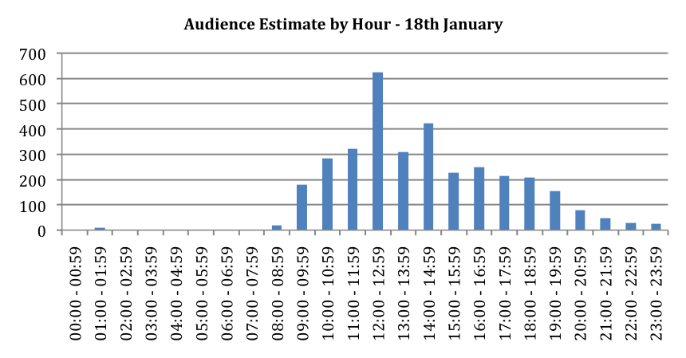

Table 1: Audience Estimates - Blade
Dates | Estimated Counts | Counts Estimated From
8 January | 4,143 | Estimated from manual counts while installation was being installed
9 – 13 January | 129,236 | Estimated from manual counts of all pedestrian entering Queen Victoria Square 11am - 11pm
14 – 22 January | 62,244 | Estimated from counts from camera footage
23 - 29 January | 35,154 | Estimated from counts from camera footage
30 January - 5 February | 36,144 | Estimated from counts from camera footage
6 - 12 February | 14,844 | Estimated from counts from camera footage
13 - 19 February | 29,204 | Estimated from counts from camera footage
20 - 26 February | 35,681 | Estimated from counts from camera footage
27 February - 5 March | 28,563 | Estimated from counts from camera footage
6 – 12 March | 25,477 | Estimated from counts from camera footage
13 - 19 March | 20,198 | 13 -16 estimated from counts from previous two weeks and 17th - 19th from manual counts onsite
Total | 420,888

The estimated audience at the Blade on Saturday 21st January was 9,700 people. A high audience was seen from 11:00 to 15:59, with the greatest audience at 13:00 to 13:59
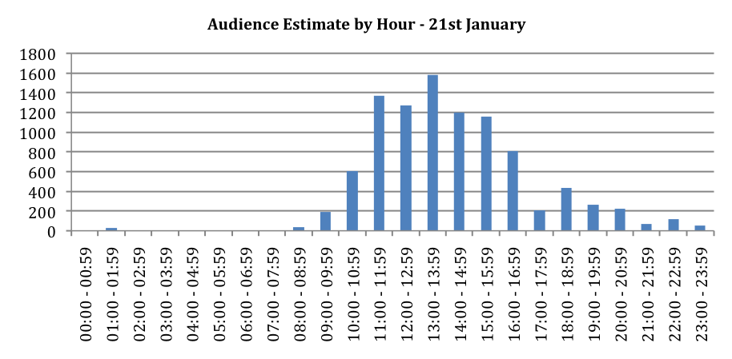
In total, 38% of respondents to the Blade post-event survey had been to look at Blade on more than one day and 69% thought they would go to look at Blade again. The mean number of days that respondents had been to look at Blade was 1.65 and the mean number of days respondents thought they would go to look at Blade again was 1.59. This gives two methods of estimating the number of individual visitors to Blade:
- Just using the figure for those who had visited on more than one day, indicates that an estimated 255,258 individual people visited Blade.
- Using the combined figure of those who had been to visit Blade on more than one occasion and those who thought they would visit Blade again, indicates that the mean number of visits to Blade would be an estimated 3.24. Using this figure indicates that an estimated 129,880 individual people visited Blade.
Using the two methods of estimating the number of individual visitors to Blade, the proportion of the population of Hull and East Riding who visited Blade can be estimated:
- Based on the estimate of 255,258 individual people who visited Blade, the proportion from each area and the mean number of visits to Blade by respondents from each area, the number of individual people who visited Blade from each area can be estimated. This shows that 105,052 individual people from Hull visited Blade, 41% of the population of Hull. 98,783 individual people from East Riding visited Blade, 29% of the population of East Riding. 51,423 individual people from outside of Hull and the East Riding visited Blade.
- Based on the estimate of 129,880 individual people who visited Blade, the proportion from each area and the mean number of visits to Blade by respondents from each area, the number of individual people who visited Blade from each area can again be estimated. Using this approach shows that 53,453 individual people from Hull visited Blade, 21% of the population of Hull. 50,262 individual people from East Riding visited Blade, 15% of the population of East Riding. 26,165 individual people from outside of Hull and the East Riding visited Blade.
The ‘true’ estimates of the proportion of residents who visited Blade is likely to lie in between the above two estimates. The difficulty in providing an accurate estimate is due to fieldwork for the survey taking place before Blade was removed (and so asking respondents for the ‘likely’ number of return visits). To provide ‘mid-way’ estimates for the proportion of residents visiting Blade, we can also use the audience count data up to the point when fieldwork was completed (18th February). This shows that the audience at Blade was 187,534 individual people – 88,750 from Hull (34% of the Hull population), 70,573 from the East Riding (21% of the population) and 28,211 from the rest of the UK outside of Hull and the East Riding.
  - Blade - Survey Findings
This section presents the results from analysis of the questions asked of the Blade audience in the post-event survey.
    - Key Audience Demographics
Forty-one percent (41%) of respondents from the audience survey were from Hull. 39% were from the East Riding and 20% were from the UK but outside of Hull and the East Riding. For comparison, in the Made in Hull audience survey, 15% of respondents were from outside of Hull and the East Riding.
Thirty-eight percent (38%) of respondents were male and 62% were female.
Sixty percent of respondents (60%) were employed either full or part-time and 7% were self-employed, with 22% retired.
Twenty-two percent (22%) of respondents were aged between 16 and 34, 61% were aged between 35 and 64 and 71% were aged 65 and over.
Ninety-eight (98%) of respondents were White British, 1.6% from other white ethnic groups and 0.8% were from other ethnic groups.
Four percent (4%) of respondents were ‘limited a lot’ and 4% ‘limited a little’ in their day-to-day activities because of a health problem or disability. 1% of respondents were wheelchair users.
    - Group Composition
Respondents were asked the composition of the group they attended with for each visit (up to three visits) to Blade. The mean number in the group for the first visit to Blade was 2.97, made up of 0.68 children and 2.29 adults. The mean number in the group for the second visit to Blade was 2.94, made up of 0.63 children and 2.31 adults. The mean number in the group for the third visit to Blade was 3.20, made up of 0.70 children and 2.50 adults.
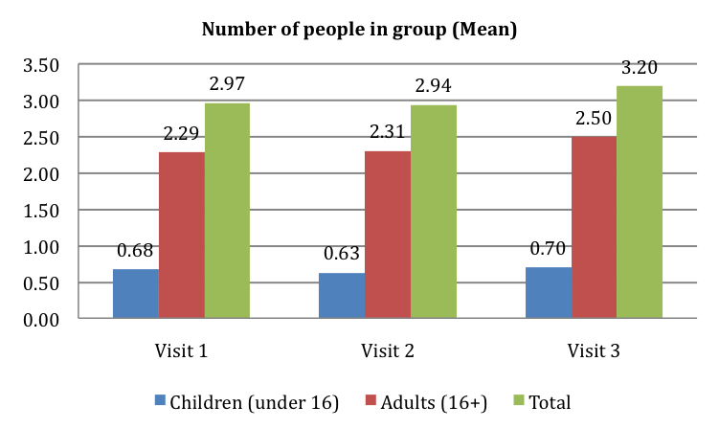
Base: Visit 1 = 600, Visit 2 = 230, Visit 3 = 89
    - Knowledge of Hull UK City of Culture 2017
Prior to attending Blade, 81% respondents knew that it was part of Hull UK City of Culture 2017. 19% did not know that Blade was part of the City of Culture programme. There were significant differences in knowledge that Blade was part of Hull UK City of Culture 2017 by age and IMD. Respondents aged 55 and over were less likely to know that Blade was part of the UK City of Culture 2017 and respondents from the least deprived areas of Hull were more likely to know that Blade was part of the UK City of Culture 2017.
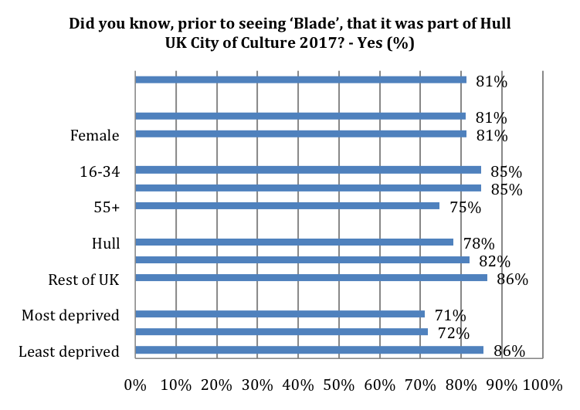
See Appendix B for Base Size
Significant differences by age and IMD
When asked if they were planning to attend or participate in other events and activities programmed for Hull UK City of Culture 2017, 87% of respondents were planning to attend or participate in other events and activities. 5% were not planning to attend or participate in other events and activities programmed for Hull UK City of Culture 2017 and 8% answered ‘don’t know’.
There was a significant difference in the proportion of respondents planning to attend or participate in other events and activities programmed for Hull UK City of Culture 2017 by area. Respondents from outside of Hull and the East Riding were less likely to be planning to attend or participate in other events and activities programmed for Hull UK City of Culture 2017. However, the results show that 70% of those from outside of the immediate Hull and East Riding area were planning to visit again for City of Culture activities.

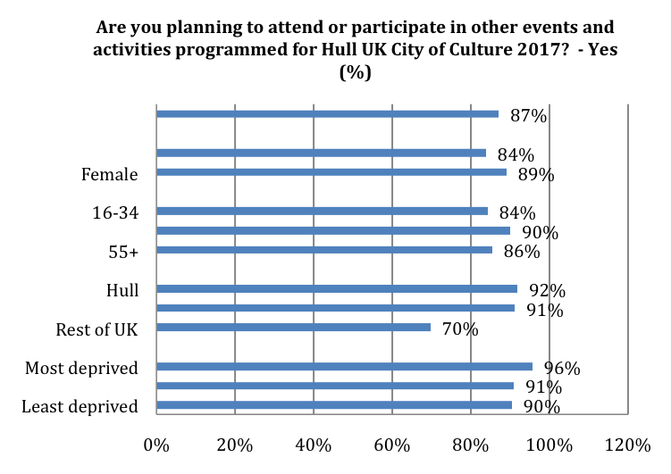
See Appendix B for Base Size
Significant differences by area
    - Number and Length of Visit
Respondents to the post-event survey were asked how many times they had been to look at Blade properly. 62% of respondents had been to look at Blade once, 23% had been twice and 15% had been three times or more. The mean number of times that respondents had been to look at Blade was 1.65. 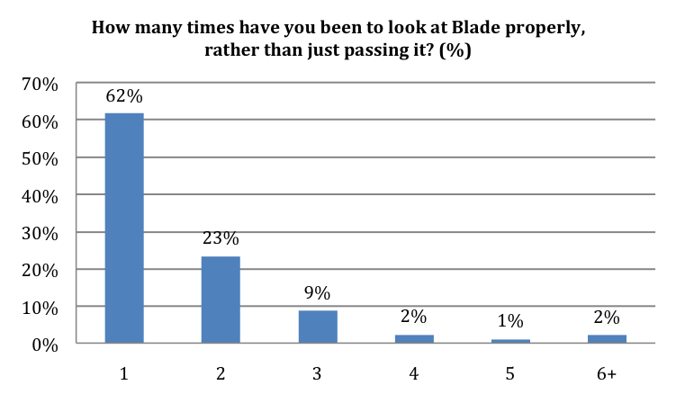
Base: 600

There were significant differences in the proportion of respondents who had looked at Blade more than once by area and IMD. As might be expected, respondents from outside of Hull and the East Riding were less likely to have been to see to Blade more than once than respondents from Hull and the East Riding. Respondents from the least deprived areas for Hull were also less likely to have been to see to Blade more than once.
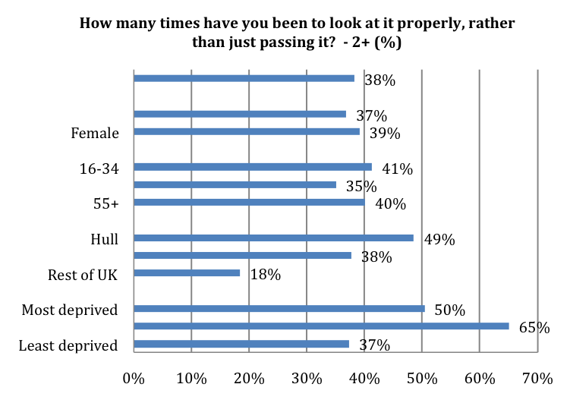
See Appendix B for Base Size
Significant differences by area and IMD
Respondents were asked how many times they think they will go to look at Blade properly again. 31% of respondents thought that they would not go to look at Blade again. 29% thought that they would go to look at Blade again once, 19% thought that they would go to look at Blade again twice and 21% thought that they would go to look at Blade again three times or more. The mean number of days that respondents thought that they would go to look at Blade again 1.59.

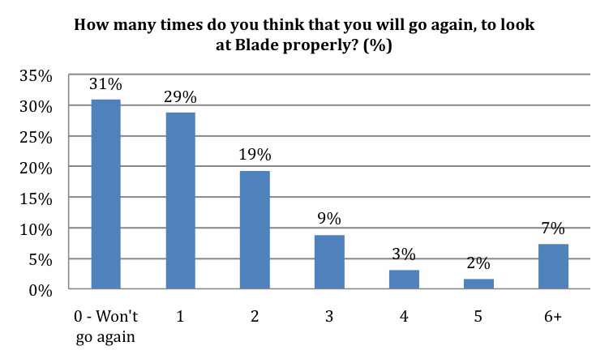
Base: 600
There were significant differences in the proportion of respondents who thought they would go to look at Blade again properly by age and area. Respondents aged 16 to 34 were more likely to think that they would go to look at Blade again. Respondents from outside of Hull and the East Riding were less likely to think that they would go to look at Blade again.
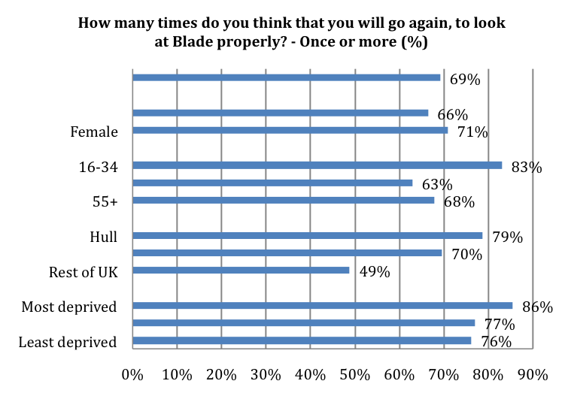
See Appendix B for Base Size
Significant differences by age and area
Respondents were asked how long they spent at Blade each time they went to look at it, for their first three visits. Respondents stayed at Blade the longest on their first visit, with respondents staying for an average of 25 minutes on their first visit. Respondents stayed at Blade for an average of 16 minutes on their second visit and for an average of 14 minutes on their third visit. Respondents who made their first visit to Blade on 8 January, when it was being installed, stayed longer on their first visit than respondents who made their first visit to Blade after this. Respondents who made their first visit to Blade on 8 January stayed for an average of 54 minutes on their first visit compared to respondents who made their first visit to Blade after this, who stayed for an average of 22 minutes on their first visit.
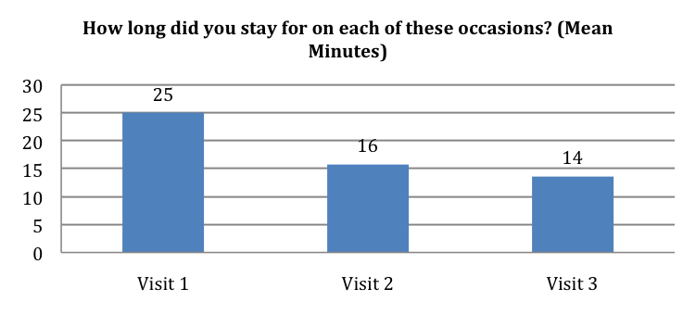
Base: Visit 1 = 600, Visit 2 = 230, Visit 3 = 89
    - Main Reason for Attending Blade
When asked what was the main reason for seeing Blade on the first occasion, 17% of respondents said it was because it was ‘a unique experience not to be missed’ and 17% of respondents said it was because they ‘wanted to see / do something creative’. 14% of respondents visited Blade because they had a ‘general interest in this type of event’ and 12% visited because they ‘were in town anyway’. 22% of respondents gave another reason as their main reason for seeing Blade on the first occasion. Many respondents who gave another reason said they had come to see Blade or come to see how big it was.
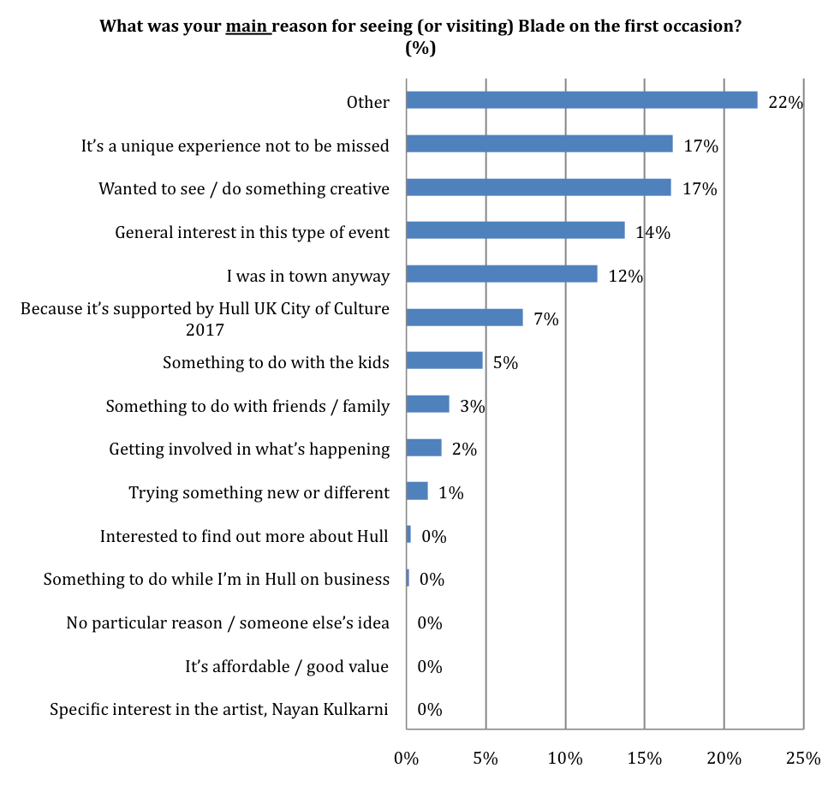
Base: 600
    - Recommendation
Seventy percent (70%) of respondents said that they were very likely to recommend a similar type of event to Blade to friends or relatives (a score of 9 or 10 on a 0-10 scale). Only 2% were very unlikely to recommend a similar type of event (a score of 0 or 1), and 29% gave a score of between 3 and 8. The mean score for recommendation was 8.96.
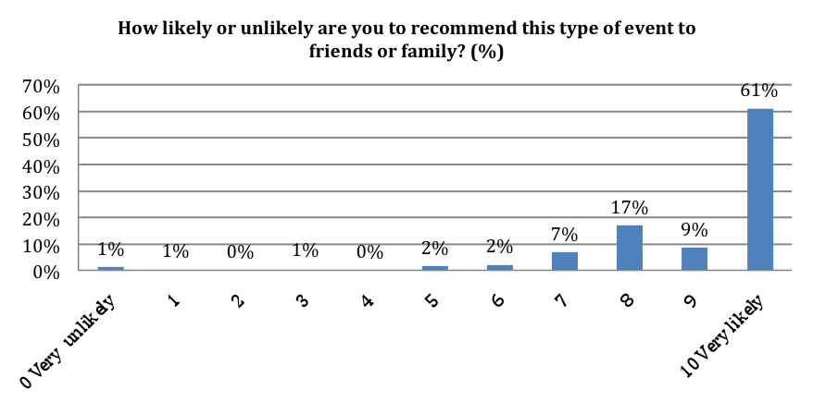
Base: 600
Examining recommendation of Blade by sub-group shows that there were significant differences in the proportion of respondents who gave a score of 9 or 10 (very likely to recommend) by gender, age and area. Men, respondents aged 16 to 34 and respondents from outside of Hull and the East Riding were less likely to give a score of 9 or 10.
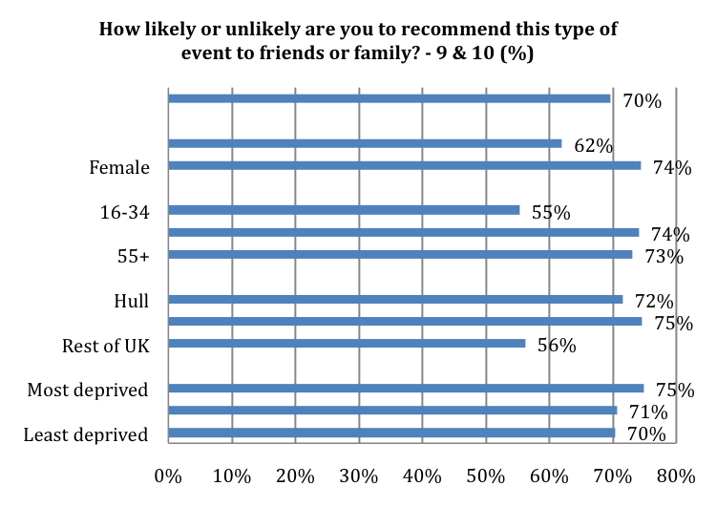
See Appendix B for Base Size
Significant differences by gender, age and area

    - Statements about Blade
Over 80% of respondents strongly agreed (a score of 9 or 10) with the statements ‘it is important it’s happening here in Hull’ and ‘it was an interesting idea’. 70% or more strongly agreed (a score of 9 or 10) with the statements ‘I would come to something like this again’, ‘it was different from things I’ve experienced before’ and ‘It is well produced and presented’.
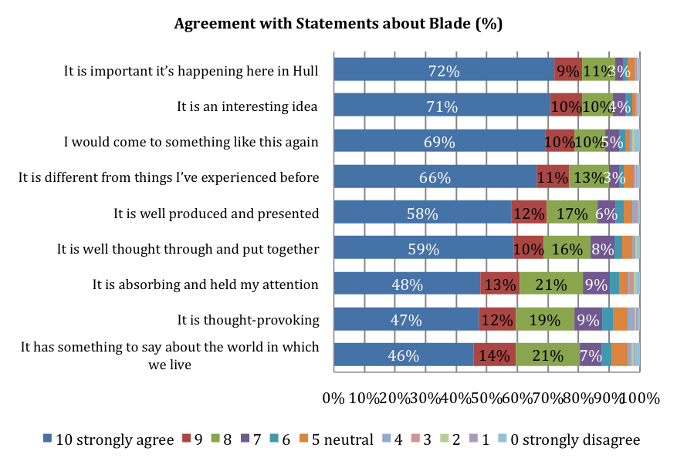
Base: 600
Agreement with the statements about Blade can also be presented as a mean score. The statements with the highest mean score were ‘it was an interesting idea’ and ‘it is important it’s happening here in Hull’ which both had a mean score of 9.31. The table below shows the mean score for each statement.
Table 2: ACE Quality Metrics - Blade
How much would you disagree or agree with the following statements about Blade? | Mean Score
It was an interesting idea | 9.11
It was well produced and presented | 8.29
It was different from things I’ve experienced before | 9.16
It was thought-provoking | 7.81
It was absorbing and held my attention | 7.75
I would come to something like this again | 8.66
It is important that it's happening here (in Hull) | 8.99
It has something to say about the world in which we live | 7.34
It was well thought through and put together | 8.37

There were significant differences in agreement with the statement ‘it was different from things I’ve experienced before’ by gender and age. Men and respondents in the 16 to 34 age group were less likely to strongly agree with the statement (a score of 9 or 10).
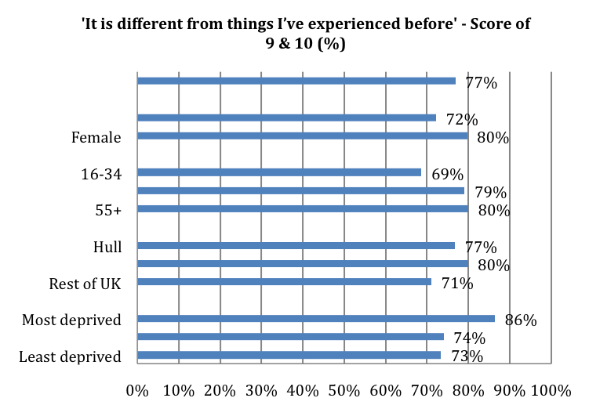
See Appendix B for Base Size
Significant differences by gender and age
There were significant differences in agreement with the statement ‘I would come to something like this again’ by gender and area. Men and respondents from outside of Hull and the East Riding were less likely to strongly agree with the statement (a score of 9 or 10).
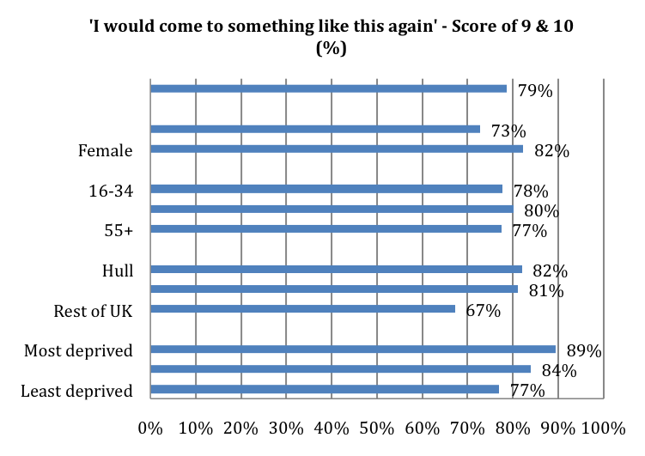
See Appendix B for Base Size
Significant differences by gender and area
There was also a significant difference by age in agreement with the statement ‘it is thought-provoking’. Respondents aged 55 and over were more like to strongly agree that Blade was thought-provoking with 59% of those aged 16 to 34, 53% of those aged 35 to 54 and 67% of those aged 55 and over strongly agreeing with the statement (a score of 9 or 10).
There were also significant differences in agreement with the statements ‘it is important it’s happening here in Hull’ and ‘it is well thought through and put together’ by area. Respondents from outside of Hull and the East Riding were less likely to strongly agree that ‘it is important it’s happening here in Hull’, with 82% of respondents from Hull, 87% from East Riding and 68% of respondents from outside of Hull and the East Riding strongly agreeing with the statement (a score of 9 or 10). Respondents from outside of Hull and the East Riding were also less likely to strongly agree that ‘it is well thought through and put together’, with 69% of respondents from Hull, 73% from East Riding and 59% of respondents from outside of Hull and the East Riding strongly agreeing with the statement (a score of 9 or 10).
There were differences in agreement with the statements ‘it is well produced and presented’ and ‘it has something to say about the world in which we live’ by IMD. Respondents from the least deprived areas of Hull were less likely to strongly agree that ‘it is well produced and presented’, with 79% of the most deprived Hull tercile, 80% of the second most deprived Hull tercile and 64% of the least deprived Hull tercile strongly agreeing with the statement (a score of 9 or 10). Respondents from the least deprived areas of Hull were also less likely to strongly agree that ‘it has something to say about the world in which we live’, with 74% of the most deprived Hull tercile, 62% of the second most deprived Hull tercile and 47% of the least deprived Hull tercile strongly agreeing with the statement (a score of 9 or 10).
Over 90% of respondents strongly agreed or agreed with the statements ‘the Blade was an enjoyable experience’, ‘Blade showed the aspirations of the City now and in the future’ and ‘Blade provided me with a different experience of the city’. Over 80% of respondents strongly agreed or agreed with the statements ‘Blade gave everyone the chance to share and celebrate together’ and ‘Blade made me think about Hull’s contribution to the world’.
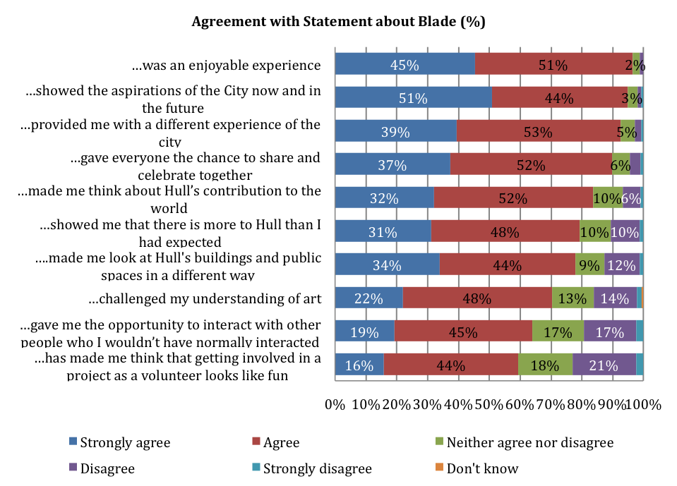
Base: 600
There were significant differences in agreement with the statement ‘Blade made me look at Hull's buildings and public spaces in a different way’ by gender and IMD. Women and respondents from the most deprived areas of Hull were more likely to strongly agree or agree with the statement.
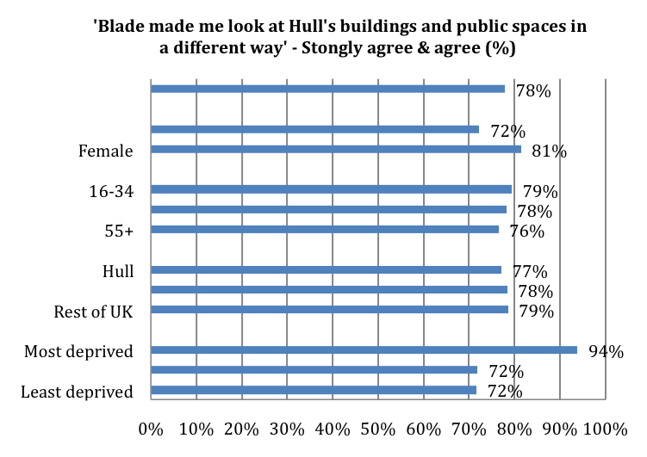
See Appendix B for Base Size
Significant differences by gender and IMD
There were significant differences in agreement with the statement ‘Blade gave me the opportunity to interact with other people who I wouldn’t have normally interacted with’ by age and area. Respondent aged 55 and over and those from Hull were more likely to strongly agree or agree with the statement.
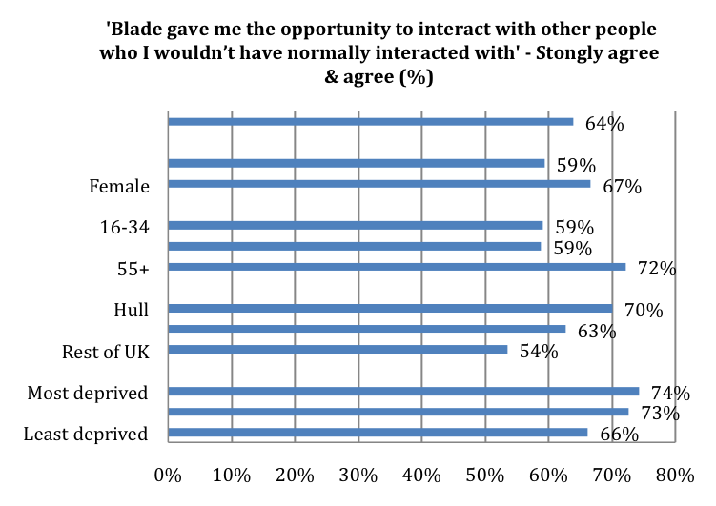
See Appendix B for Base Size
Significant differences by age and area

There were significant differences in agreement with the statement ‘Blade has made me think that getting involved in a project as a volunteer looks like fun’ by gender, area and IMD. Women and respondents from Hull were more like to strongly agree or agree with the statement while respondents from the least deprived areas of Hull were less likely to strongly agree or agree with the statement.
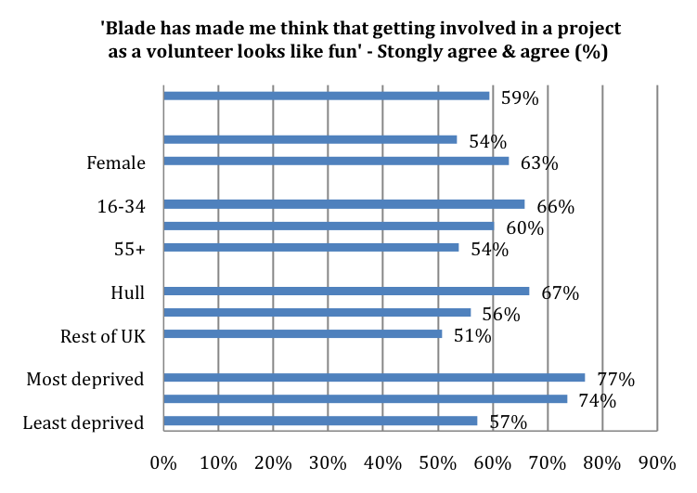
See Appendix B for Base Size
Significant differences by gender, area and IMD
There were also significant differences in agreement with the statements ‘Blade challenged my understanding of art’ and ‘Blade was an enjoyable experience’ by gender. Women were more likely to agree that ‘Blade challenged my understanding of art’, with 75% of women and 63% of men strongly agreeing or agreeing with the statement. Men were more likely to agree that ‘Blade was an enjoyable experience’ with 95% of women and 98% of men strongly agreeing or agreeing with the statement.
There was a significant difference in agreement with the statement ‘Blade gave everyone the chance to share and celebrate together’ by IMD. Respondents from the least deprived areas of Hull were less likely to agree with the statement, 87% of the least deprived Hull IMD tercile, 97% of the second most deprived Hull IMD tercile and 96% of the most deprived Hull IMD tercile strongly agreeing or agreeing with the statement.
    - Staff and Volunteers
The majority of respondents agreed that they had felt welcomed by Hull 2017 volunteers and staff. 92% strongly agreed or agreed that they had felt welcomed by Hull 2017 volunteers and 86% strongly agreed or agreed that they had felt welcomed by security and stewards. Only 1% strongly disagreed or disagreed that they had felt welcomed by Hull 2017 volunteers and 2% strongly disagreed or disagreed that they had felt welcomed by security and stewards.
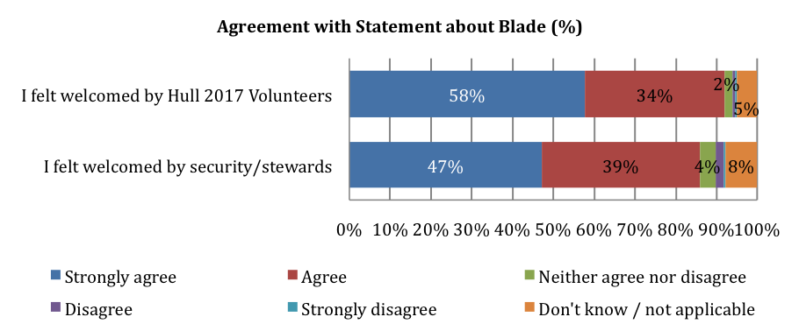
Base: 600
    - How respondents found out about Blade
The main ways respondents had found out about Blade was from TV with 36% finding out this way. 20% of respondents had found out about Blade from being told in person by friends, family and colleague, 17% from Hull 2017 social media, 13% from newspapers and 11% from social media or emails from friends, family and colleague.
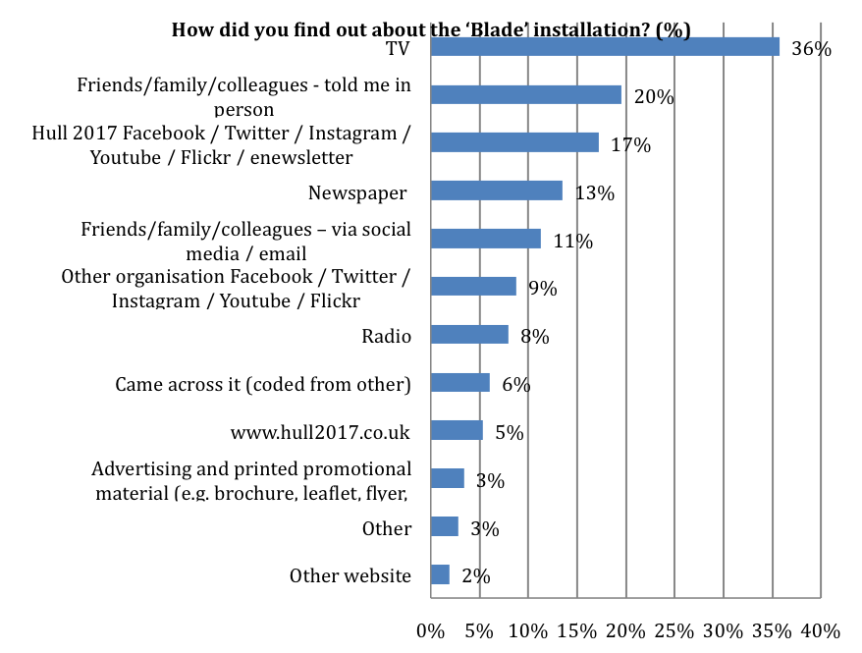
Base: 600
There were significant differences in the proportion of respondents who found out about Blade from Hull 2017 social media by gender, age and area. Men, those aged 55 and over and respondents from outside of Hull and the East Riding were less likely to have found out about Blade from Hull 2017 social media.
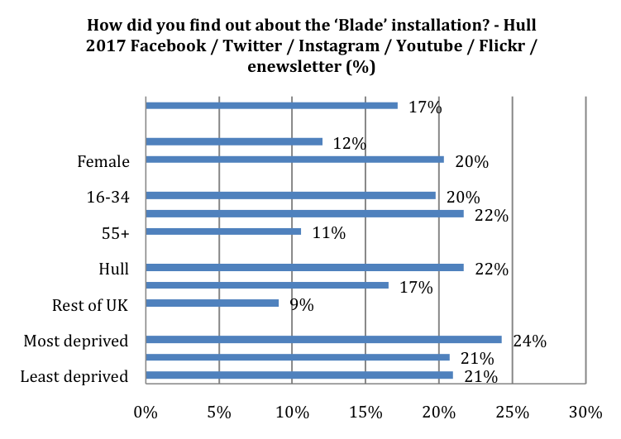
See Appendix B for Base Size
Significant differences by gender, age and area
There were significant differences in the proportion of respondents who found out about Blade from another organisation’s social media. Women, respondents aged 35 to 54 and respondents from the second most deprived area of Hull were more likely to have found out about Blade from another organisation’s social media.
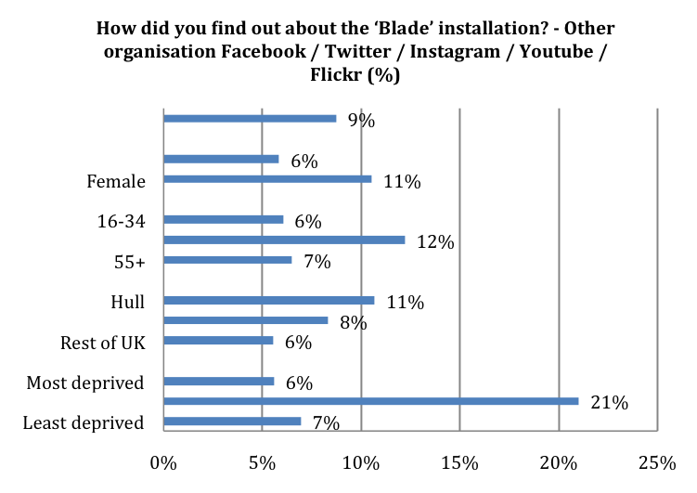
See Appendix B for Base Size
Significant differences by gender, age and IMD
There were significant differences in the proportion of respondents who found out about Blade from TV by age and area. Respondents aged 55 and over and respondents from the East Riding were more likely to have found out about Blade from TV.

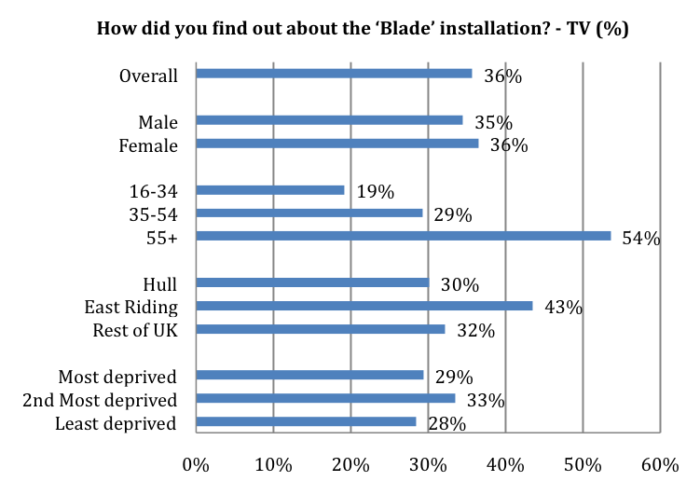
See Appendix B for Base Size
Significant differences by age and area
There were significant differences in the proportion of respondents who found out about Blade from radio by age and area. Respondents aged 55 and over and respondents from Hull and the East Riding were more likely to have found out about Blade from radio.
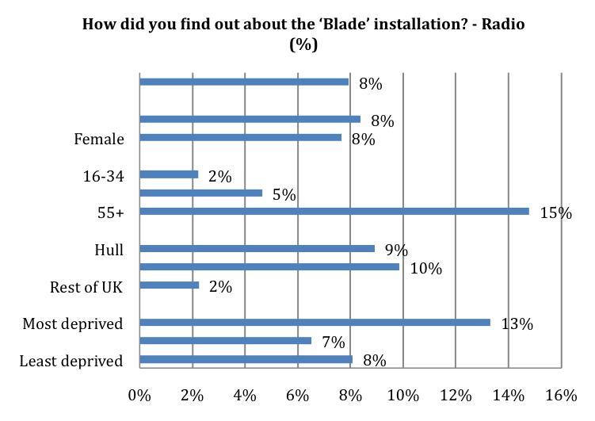
See Appendix B for Base Size
Significant differences by age and area

There was a significant difference in the proportion of respondents who found out about Blade from just coming across it by gender, age and area. Men, respondents aged 16 to 34 and respondents from outside of Hull and the East Riding were more likely to have found out about Blade by just coming across it.
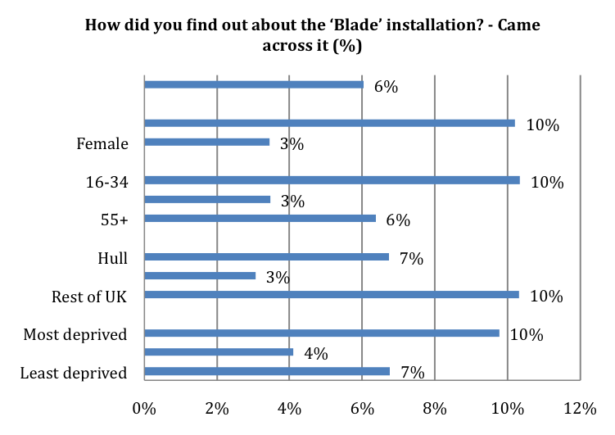
See Appendix B for Base Size
Significant differences by gender, age and area
There was a significant difference in the proportion of respondents who found out about Blade from being told in person by friends, family or colleague by area. Respondents from outside of Hull and the East Riding were more likely to have found out about Blade from being told in person by friends, family or colleague, with 20% of respondents from Hull, 12% of respondents from East Riding and 33% of respondents from outside of Hull and the East Riding who found out about Blade in this way. There was a significant difference in the proportion of respondents who found out about Blade from social media or emails from friends, family or colleague by age. Respondents age 55 and over were less likely to have found out about Blade from social media and emails from friends, family or colleague, with 15% of those aged 16 to 35, 14% of respondents aged 35 to 54 and 6% of respondents aged 55 and over who found out about Blade in this way. There was a significant difference in the proportion of respondents who found out about Blade from advertising and printed promotional material by gender. Men were more likely to have found out about Blade from advertising and printed promotional material with 5% of men and 2% of women having found out about Blade in this way.
    - Purpose of Visit to Hull City Centre
Respondents were asked if seeing Blade was the main purpose of their visit to Hull City Centre on the first three occasions they saw Blade. Just over half (51%) of respondents were mainly in Hull City Centre on the day they went to Blade due to Blade on their first visit. 42% of respondents were in Hull City Centre mainly to see Blade on their second visit and 41% of respondents in Hull City Centre mainly to see Blade on their third visit.
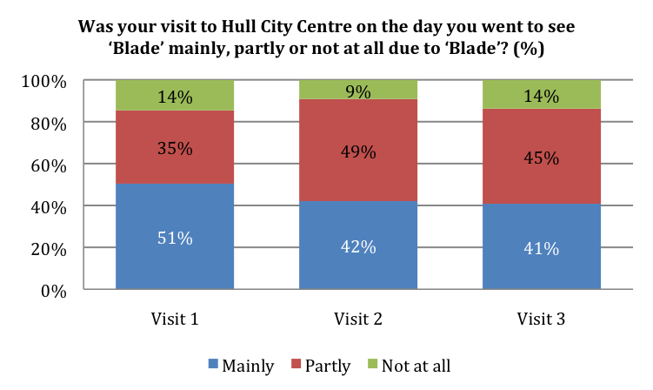
Base: Visit 1 = 600, Visit 2 = 230, Visit 3 = 89
Nearly two-fifths (39%) of respondents were in Hull ‘just for this event’ on the first occasion they visited Blade. Nearly a quarter (24%) were in Hull for general leisure purposes on their first visit to Blade.
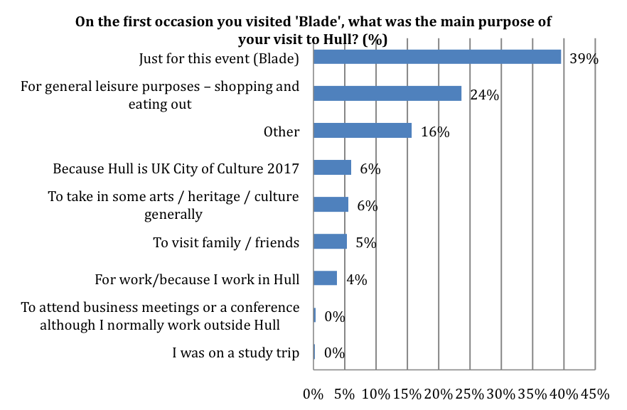
Base: 600
There were significant differences in the main purpose of respondent’s visits to Hull on the first occasion they visited Blade by age and area. Younger respondents were significantly less likely to have visited Hull ‘just for Blade’ with 29% of 16-34, 42% of 35-54 and 43% of 55+ stating this was the main purpose of their visit. Respondents from outside of Hull and the East Riding were significantly more likely to have visited Hull because they were visiting family and friends, with 2% of respondents from Hull, 2% of respondents from East Riding and 17% of respondents from the rest of the UK stating this was the main purpose of their visit.
    - Main Partners for Blade
When asked who were the two main partners for Blade, the majority of respondents (92%) knew that Siemens was one of the main partners. Just over a quarter (26%) of respondents knew that Green Port Hull was one of the main partners. 6% of respondents were not able to name any of the partners for Blade.
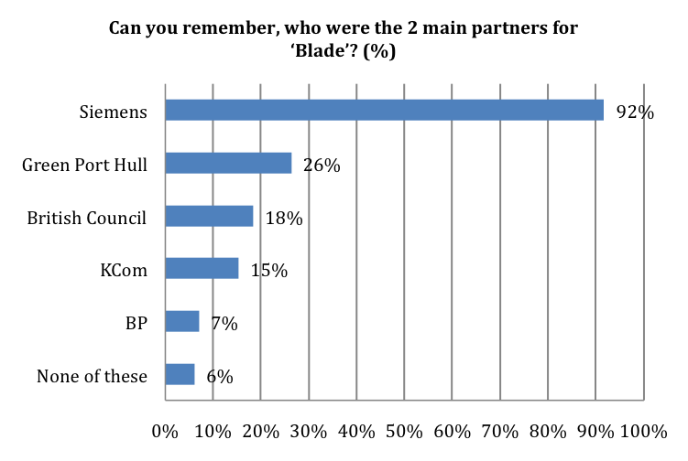
Base: 600
There were significant differences in the portion of respondents who named Green Port Hull as a main partner for Blade by gender and area. Women and respondents from outside of Hull and the East Riding were less likely to have named Green Port Hull as a main partner for Blade.
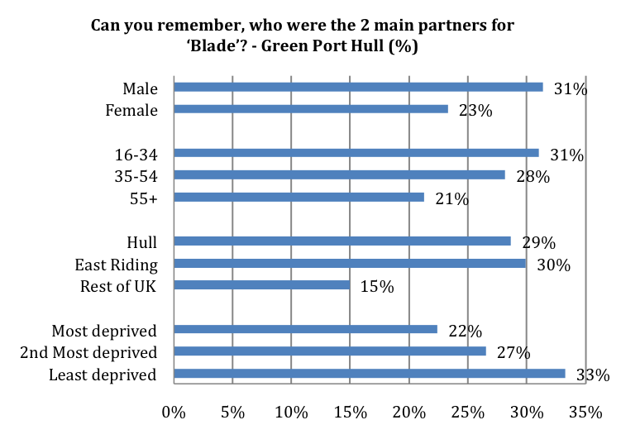
See Appendix B for Base Size
Significant differences by gender and area
There were significant differences in the portion of respondents who named Siemens as a main partner for Blade by age and area. Respondents are 16 to 34 and respondents from outside of Hull and the East Riding were less likely to have named Siemens as a main partner for Blade.
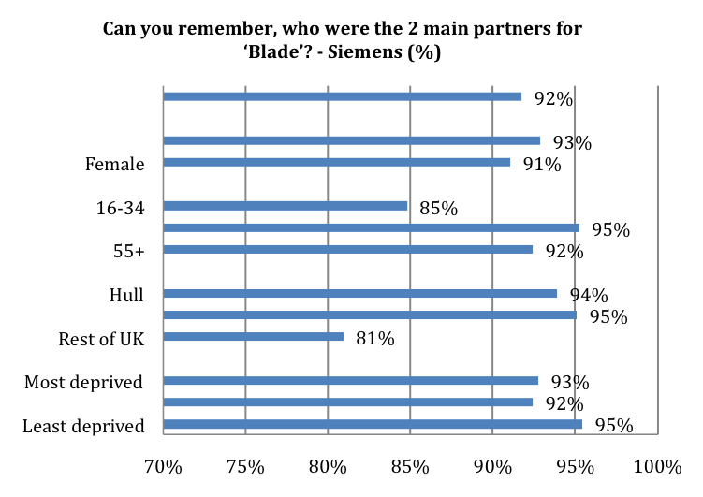
See Appendix B for Base Size
Significant differences by age and area

There were significant differences in the portion of respondents who named BP as a main partner by age. Younger respondents were more likely to have named BP as a main partner for Blade, with 12% of those aged 16 to 34, 4% of those aged 35 to 54 and 8% of those aged 55 and over naming BP. There was a significant difference in the proportion of respondents who were unable to name any of the main partners for Blade by area. Respondents from outside of Hull and the East Riding were more likely to have been unable to name any of the main partners for Blade, with 4% of respondents from Hull, 4% of respondents from East Riding and 16% of respondents from the rest of the UK unable to name any of the partners.
    - Information sources
Overall, 31% of respondents had seen information about Blade in Queen Victoria Square, with 21% having read information and 10% having seen information but not read it. 13% of respondents had seen information in a nearby shop window, with 6% having read the information and 7% having seen information but not read it. 21% of respondents had seen information boards, with 13% having read the information boards and 9% having seen the information board but not read them. 18% of respondents had seen information leaflets, with 11% having read the information leaflet and 7% having seen the information leaflets but not read them.
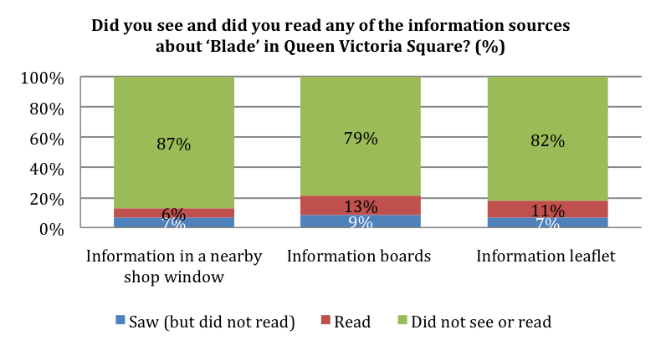
Base: 600
There was a significant difference in the proportion of respondents who had read at least one of the sources for information about Blade in Queen Victoria Square by age. Respondents aged 55 and over were more likely to have read one of the sources for information about Blade in Queen Victoria Square.
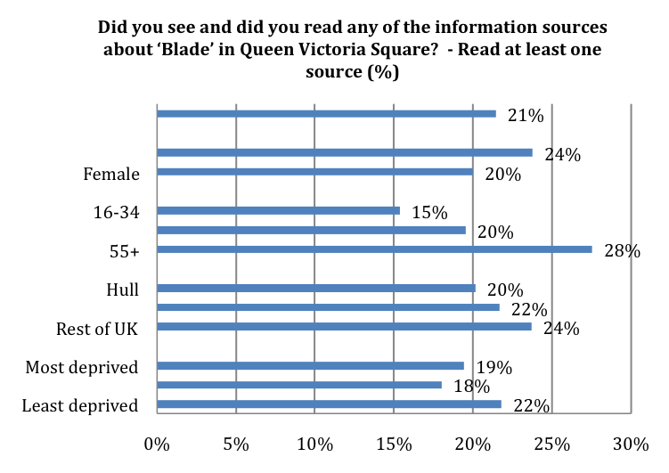
See Appendix B for Base Size
Significant differences by age
The majority of respondents who had read the information about Blade in shop windows, on information boards or on leaflets in Queen Victoria Square had found the information interesting, with 96% strongly agreeing or agreeing with the statement ‘the information boards / leaflets about Blade contained information that I found interesting’. 82% strongly agreed or agreed that ‘the information boards / leaflets about Blade helped me to understand the artwork better’ and two-thirds (67%) strongly agreed or agreed that ‘the information boards / leaflets about Blade made me think differently about the artwork’.
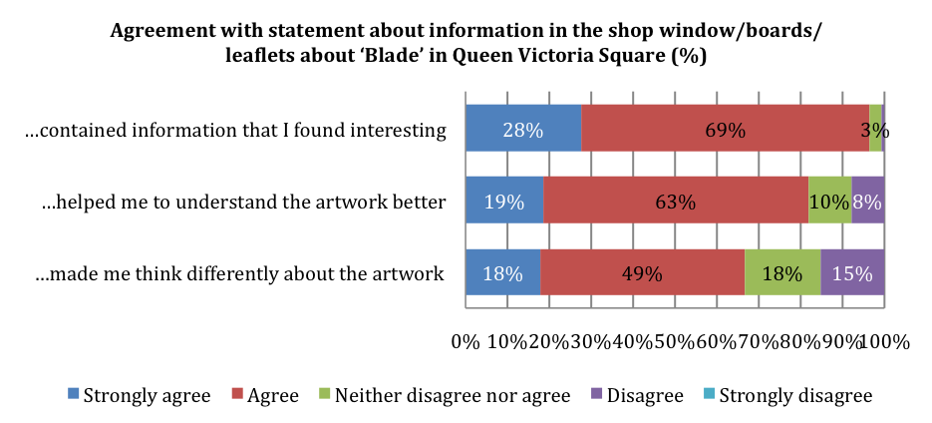
Base: 129

    - Visitors to Hull
Nearly three-fifths (59%) of respondents were from outside of Hull, with 39% from the East Riding and 20% from elsewhere in the UK. Of the respondents from outside of Hull, 95% had been to Hull before coming to Blade and 5% were visiting Hull for the first time when they came to Blade.
Respondents from outside of Hull were asked to rate how satisfied they were with various aspects of Hull as a visitor. Hull was rated highly on visitor welcome and overall value for money with 81% satisfied with the general visitor welcome (a score of 4 or 5 out of 5) and 79% of respondents satisfied with overall value for money. Over half of respondents were satisfied with the places to eat and drink (69%) and city centre signposting (55%) although around one-third of respondents answered ‘not-applicable’. A high proportion of respondents answered ‘not-applicable’ when asked to rate public transport and accommodation. Of the respondents who thought these aspects were applicable to them, 76% were satisfied with the quality of accommodation and 75% were satisfied with public transport – see analysis in following paragraph.
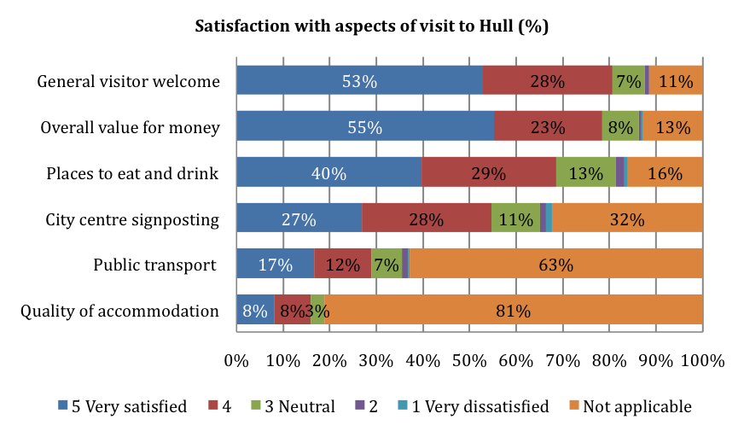
Base: 353
This paragraph considers the results on satisfaction with various aspects of Hull again, but with respondents who indicated ‘not applicable’ excluded from the analysis. Respondents from outside of Hull rated Hull highly on visitor welcome and overall value for money with 91% of respondents satisfied with the general visitor welcome and 90% satisfied with overall value for money (a score of 4 or 5). 85% of respondents were satisfied with the quality of accommodation, 82% were satisfied with the places to eat and drink 81% were satisfied with city centre signposting and 79% were satisfied with public transport.
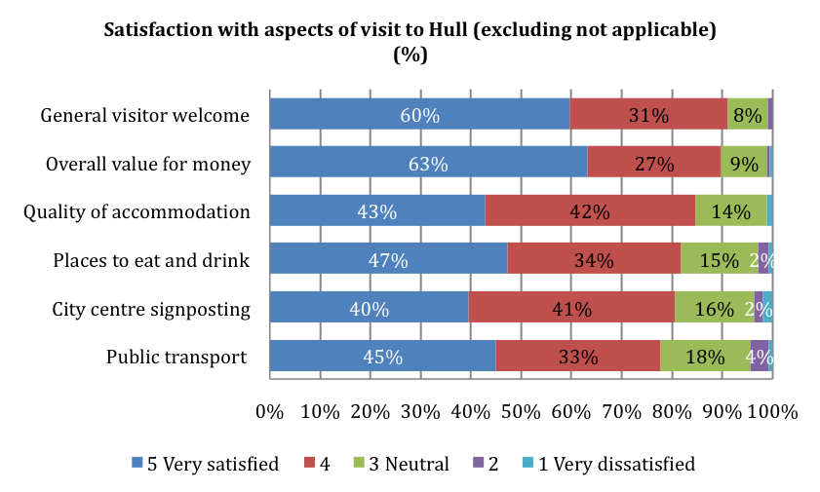
Base: 67 – 312
Of the respondents who were not residents of Hull, 86% were in Hull just for the day when they visited Blade and 14% were staying in Hull overnight.
Of the 14% of respondents who stayed in Hull overnight, the mean number of nights spent in Hull was 2.00 and the mean number of days spent in Hull was 2.83. Respondents staying in Hull overnight on average spent £46 on accommodation. 53% were staying with friends and family, 39% were staying in a hotel and 8% were staying in a bed and breakfast.
    - Estimated Spend
Respondents were asked to estimate how much they had spent in Hull on themselves and on others with them on the day they saw Blade as part of their visit. Respondents who had seen Blade on more than one day were asked to estimate how much they had spent each time for their first three visits.
Respondents estimated that they spent a mean of £47.24 on themselves and others with them in Hull on the day of their visit to Blade as part of their first visit. 44% of this spend was on shopping, 42% on food and drink and 8% was on travel and transport.
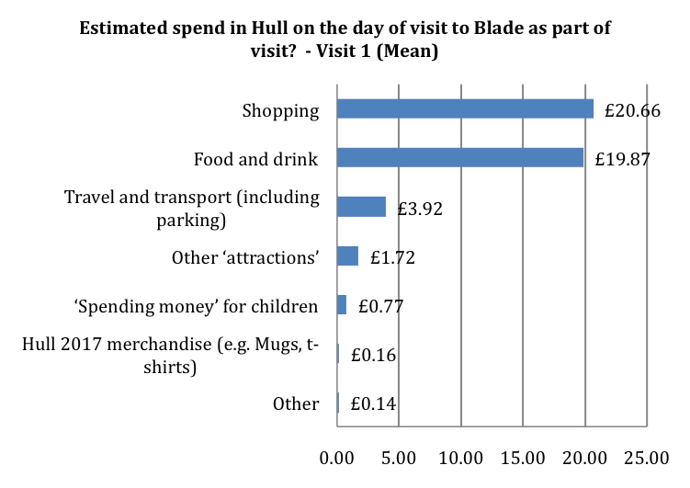
Base: 595
Respondents who visited Blade on two days estimated that they spent a mean of £40.95 on the day of their second visit. Respondents who visited Blade on three or more days estimated that they spent a mean of £31.30 on the day of their third visit.
The estimated spend on the first three days respondents had visited Blade can be combined to give an overall estimated spend including the spend on accommodation from respondents who were overnight visitors to Hull. Respondents estimated that they spent an overall mean of £71.21 on themselves and on others with them in Hull on the (up to) three days they attended Blade as part of their visit. 41% of this spend was on food and drink, 41% was on shopping and 8% was on travel and transport.
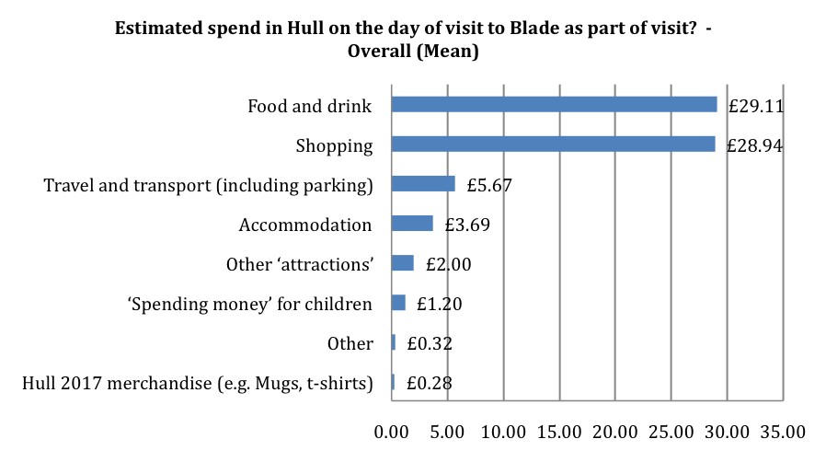
Base: 595
There was a significant difference in estimated spend on the days of Blade by age area. Respondents aged 55 and over had a lower mean estimated spend while those from outside of Hull and the East Riding had a higher mean estimated spend.
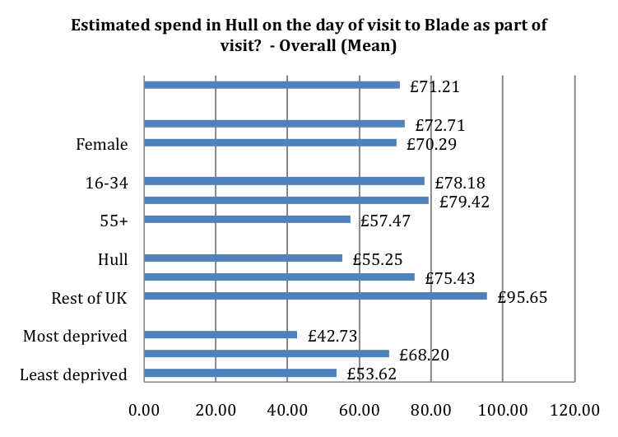
See Appendix B for Base Size
Significant difference by age and area

Within the estimated spend data, there are significant differences in estimated mean spend on different categories of spend by age and area. Respondents aged 55 and over had a lower mean estimated spend on food and drink and on shopping. Respondents aged 16 to 34 have a higher mean estimated spend on other ‘attractions’. Respondents from outside of Hull and the East Riding have higher mean estimated spend on food and drink, travel and transport and accommodation.
    - Substitution - Activity and Spend
Substitution is defined by the HM Treasury Green Book as the substitution of one activity for a similar activity. In this evaluation, we sought to discover whether the Blade audience would have undertaken other activities and spent elsewhere, or whether there was additional spending as a result of Blade itself.
Just under half of respondents (46%) would not have come into Hull City Centre on the first day they visited Blade if the installation was not on. 43% of respondents would not have come into Hull on the day of their second visit if Blade was not on and 39% of respondents would not have come into Hull on the day of their third visit if Blade was not on.
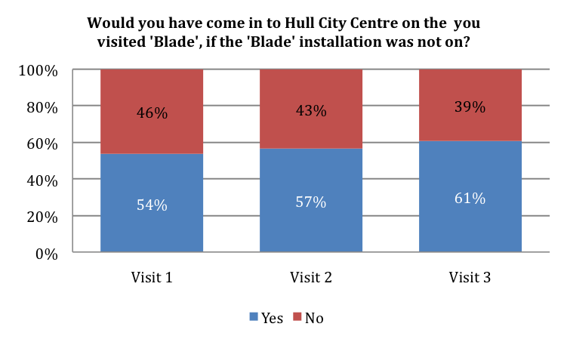
Base: Visit 1 = 600, Visit 2 = 230, Visit 3 = 89
There were significant differences in the proportion of respondents who would have come into Hull City Centre on the day of their first visit to Blade if Blade was not on by age and area. Respondents aged 16 to 34 and respondents who were not from the East Riding were more likely to have come into Hull City Centre on the day of their first visit to Blade if Blade was not on.
Table 3: Audience Spend by Socio-Demographics
 | Hull 2017 merchandise | Food and drink | Shopping | Travel and transport (including parking) | Other 'attractions' | Spending money' for children | Other
Male | 31.77 | 24.75 | 5.35 | 2.66 | 0.87 | 0.23 | 0.61
Female | 27.48 | 31.50 | 5.86 | 1.60 | 1.40 | 0.32 | 0.14
16-34 | 28.34 | 35.96 | 6.32 | 3.97 | 2.06 | 0.18 | 0.00
35-54 | 34.34 | 31.65 | 6.04 | 1.29 | 1.37 | 0.27 | 0.13
55+ | 23.49 | 21.46 | 4.88 | 1.61 | 0.48 | 0.37 | 0.73
Hull | 20.94 | 27.82 | 3.28 | 1.45 | 1.04 | 0.22 | 0.52
East Riding | 32.19 | 32.58 | 6.39 | 1.67 | 1.74 | 0.41 | 0.23
Rest of UK | 39.85 | 24.15 | 9.16 | 3.78 | 0.47 | 0.16 | 0.08
Most deprived | 17.18 | 20.85 | 2.35 | 0.68 | 1.33 | 0.15 | 0.18
2nd Most deprived | 25.86 | 34.36 | 4.25 | 0.23 | 1.55 | 0.34 | 1.62
Least deprived | 19.79 | 27.32 | 3.14 | 2.61 | 0.57 | 0.19 | 0.00

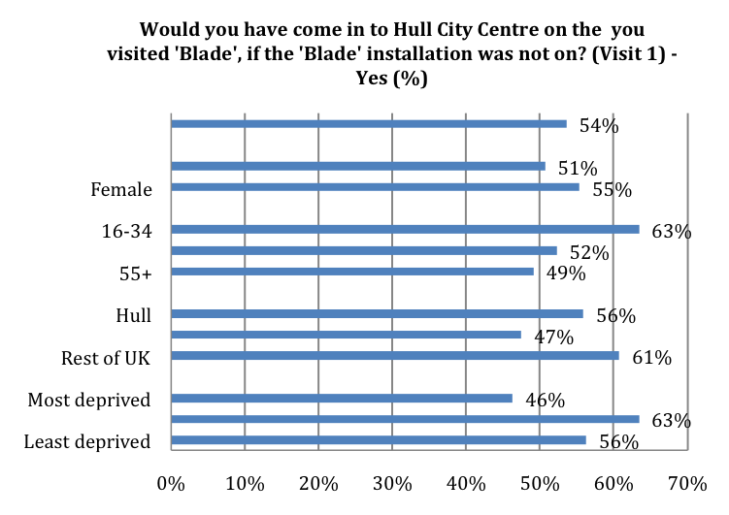
See Appendix B for Base Size
Significant differences by age and area
Respondents were asked what they would have done if they had not come to Blade. 30% of respondents would have stayed at home, 25% would have gone shopping in Hull and 23% would have visited another attraction in Hull on the day of their first visit to Blade if they had not come to Blade. 32% of respondents would have gone shopping in Hull, 24% would have stayed at home and 18% would have visited another attraction in Hull on the day of their second visit to Blade if they had not come to Blade. 30% of respondents would have gone shopping in Hull, 24% would have stayed at home and 22% would have visited another attraction in Hull on the day of their third visit to Blade if they had not come to Blade.
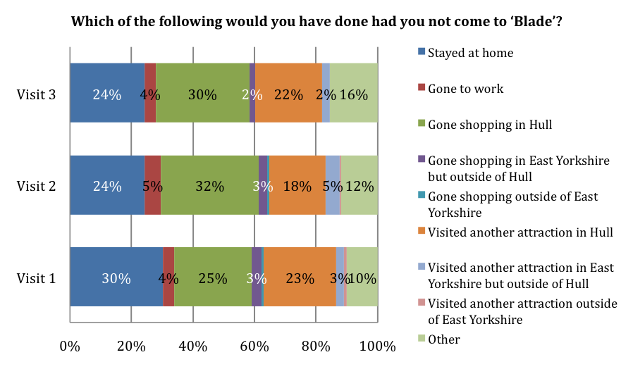
Base: Visit 1 = 600, Visit 2 = 230, Visit 3 = 89
There were significant differences in what respondents would have done if they had not come to Blade on the days of their first visit to Blade by age and area. Younger respondents were less likely to have stayed at home, with 22% of those aged 16 to 34, 32% of those aged 35 to 54 and 34% of these aged 55 and over who would have stayed at home if they had not come to Blade. Respondents from outside of Hull and the East Riding were more likely to have visited another attraction in Hull, with 18% of respondents from Hull, 21% of respondents from East Riding and 40% of respondents from the rest of the UK who would have visited another attraction in Hull if they had not come to Blade.
Respondents were asked to estimate how much they would have spent on themselves and on others with them on the day of their visit to Blade if they had not been to Blade. Respondents who had been to Blade on more than one day were asked to estimate how much they would have spent elsewhere on that day for their first three visits. The estimated spend (assuming respondents had not attended Blade) for the first three days can be combined to give an overall estimated spend. Respondents estimated that they would have spent an overall mean of £53.65 on themselves and on others with them on the (up to) three days they attended Blade if they have not attended Blade. This is £13.87 lower than the estimated spend of £67.52 recorded at Blade (excluding accommodation spend). Respondents estimated that they would have spent less on food and drink, shopping, travel and transport, spending money for children and Hull 2017 merchandise if they had not attended Blade. Respondents estimated that they would have spent £0.24 more on other ‘attractions’ and £0.23 more on ‘other’ if they had not attended Blade.
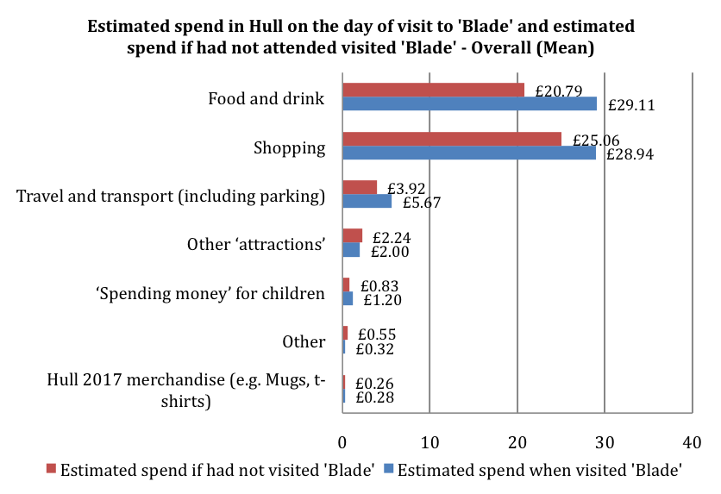
Base: 579
There were significant differences in respondents estimated spend assuming they had not attended Blade by age. Respondents aged 55 and over had a significantly lower mean estimated spend. Figures below exclude spend on accommodation.
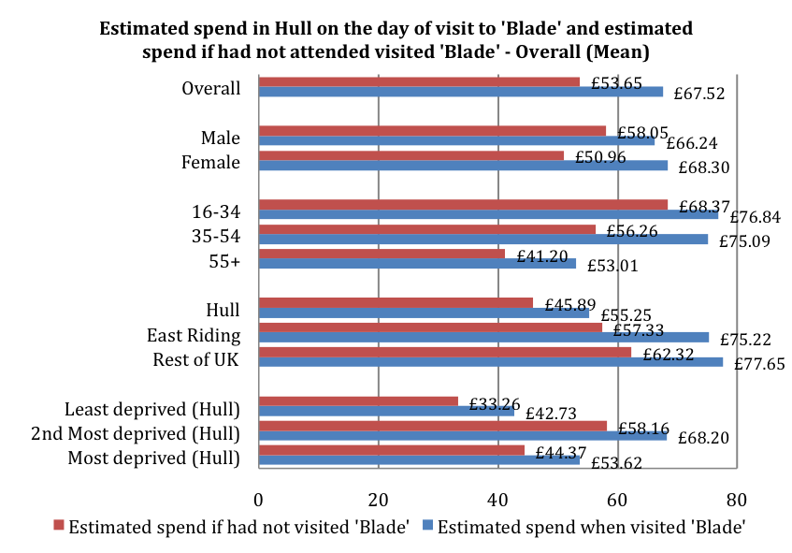
See Appendix B for Base Size
Significant differences in estimated spend if not visited Blade by age
Significant differences in estimated spend if visited Blade by age and area
    - Other Arts Participation
Respondents were asked about the type of events they had attended or participated in during the last 12 months, not including Blade. Nearly four-fifths (78%) of respondents had been to museums/historical attractions, 68% had attended films. Over 50% of respondents had attended outdoor events and music. Only 6% of respondents had not attended or participated any of the types of events asked about.
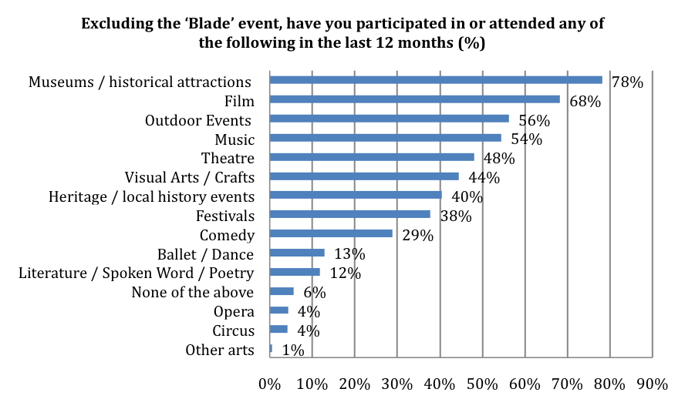
Base: 600
There were significant differences in arts attendance and participation by age. Respondents aged 35 to 54 were more likely to have attended or participated in film, outdoor events and music in the last 12 months. Respondents aged 16 to 34 were less likely to have attended or participated in visual arts and crafts in the last 12 months.
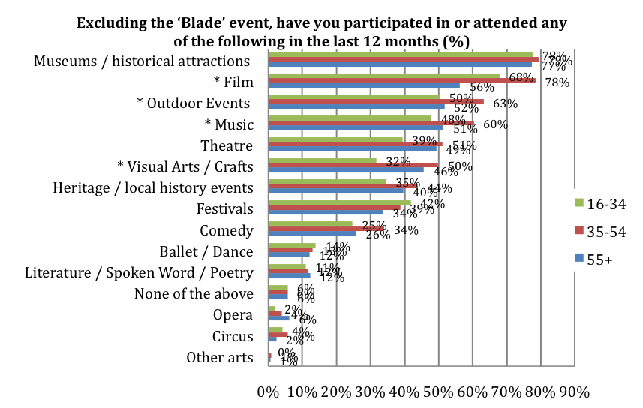
See Appendix B for Base Size
* = Significant difference by age
There were significant differences in arts attendance and participation by area. Respondents from Hull were less likely to have attended or participated in museums and historical attractions, film, music, theatre, and comedy in the last 12 months. Respondents from Hull were more likely to not have attended or participated in any of the type of art asked about.
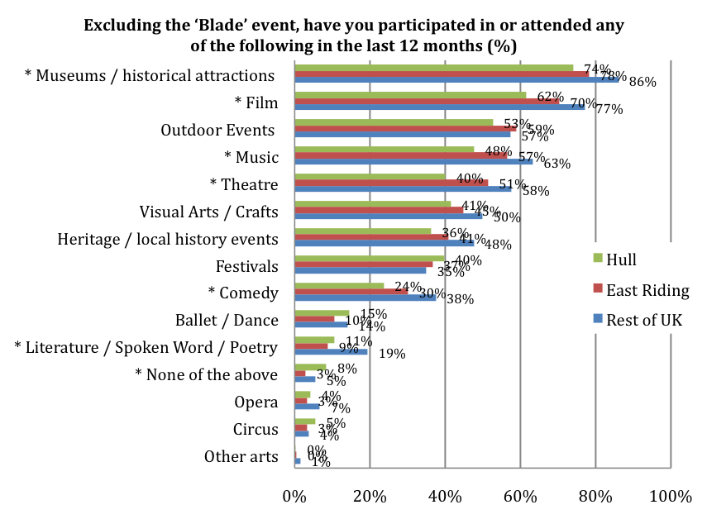
See Appendix B for Base Size
* = Significant difference by area
There was also a significant difference in attendance and participation of ballet and dance by gender. Women were significantly more likely to have attended or participated in ballet or dance in the last 12 months, with 16% of women and 7% of men having attended or participated in ballet or dance.
There were no significant differences in arts attendance and participation by Hull IMD.
    - Favourite Colour
Respondents were asked what their favourite colour was. The colour named as their favourite by most respondents was blue, with 32% selecting blue as their favourite colour.
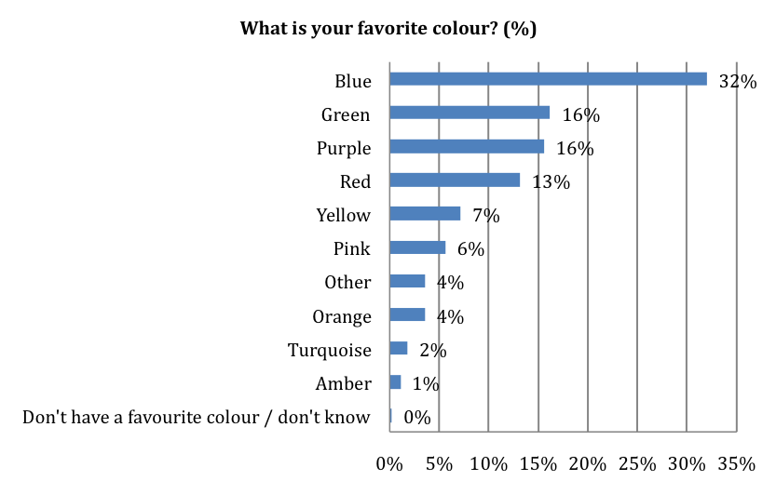
Base: 600
While there were some differences in the results by sub-group, blue was selected as the favourite colour by the greatest proportion of both men and women, all age groups and by residents of Hull, East Riding and the rest of the UK. Green was selected as the favourite colour by the greatest proportion respondents from the most deprived IMD tercile for Hull, whilst red was selected as the favourite colour by the greatest proportion of respondents from the second most deprived IMD tercile for Hull and blue was selected as the favourite colour by the greatest proportion of respondents the least deprived IMD tercile for Hull.

Table 4: Favourite Colour
 | Most Deprived |  | 2nd Most Deprived |  | Least Deprived
 | % | Rank | % | Rank | % | Rank
Blue | 24% | 2 | 21% | 2 | 28% | 1
Green | 24% | 1 | 12% | 4 | 19% | 2
Purple | 19% | 4 | 15% | 3 | 13% | 3
Red | 19% | 3 | 22% | 1 | 12% | 4
Yellow | 5% | 5 | 7% | 6 | 11% | 5
Pink | 5% | 6 | 9% | 5 | 5% | 7
Other | 2% | 8 | 4% | 8 | 4% | 8
Orange | 2% | 7 | 2% | 10 | 5% | 6
Turquoise | 0% | 10 | 2% | 9 | 2% | 9
Amber | 0% | 9 | 5% | 7 | 1% | 10
Don't have a favourite colour / don't know | 0% | 11 | 1% | 11 | 0% | 11

  - Conclusions
The results of this research show that Blade was highly successful in its objective to ‘transform Hull’s streetscape through the imposition of a single wind turbine blade’ and in providing its audience with ‘a spectacle, an obstacle and an object of wonder’. Blade had an estimated audience of over 400,000(visits), with an average of over 7,000 people visiting the structure each day of the two-month period it occupied Queen Victoria Square in the city.
The results also indicate that, during the period of Blade, the number of visitors from outside the immediate area of Hull and the East Riding increased. In the previous Made in Hull audience survey, 15% of respondents were from outside the area; this figure increased to 20% in this Blade audience survey. This increase in visitors from outside of Hull and the East Riding is likely to be due wider attractions offered by the City of Culture programme, rather than just Blade itself, as the research has shown that only 39% of visitors were here ‘just for this event’ and were more likely to state that they would have come to the city centre if this event had not been on. The results also show that the majority of those visiting from the immediate area are planning to come to Hull 2017 events in the future. For residents of Hull, over 90% of those interviewed at Blade said they were planning to attend or participate in other Hull 2017 events.

Audience members at Blade clearly saw the structure as a spectacle. ‘It’s a unique experience not to be missed’ was a key reason given for visiting Blade and many also came to see the artwork ‘to see how big it was’. Audience members spent on average 25 minutes at Blade on their first visit. However, a relatively small proportion (less than a third) had seen information about Blade in Queen Victoria Square and the visitor experience might have been enhanced by additional information notices, video or soundtrack close to the structure. Blade was also successful in one its key objectives of transforming the streetscape. Over three-quarters of those interviewed agreed that Blade made them ‘look at Hull’s buildings and public space in a different way’. This was particularly the case for women and those from the most deprived areas of the city. The Blade experience also had an impact on Hull residents in two other ways – the opportunity to interact with people they would not normally interact with, and increased thinking about possibly volunteering. For both of these, the results for Hull residents were significantly higher than those for respondents from other areas.
In slight contrast to the Made in Hull event, the main way in which people found out about Blade was via the TV. There was clearly considerable TV coverage of the artwork being installed and in the following days and this is likely to have impacted on attendance in the early period of the installation. As in the case of Made in Hull, there was again considerable difference in the mechanic used to find out about Blade, with younger age groups again more likely to use social media and older groups more likely to use the traditional methods of TV and radio. A larger proportion of Hull residents made use of Hull 2017 social media sites to find out about Blade.
Siemens was strongly recalled as one of the main partners for Blade – over 90% of respondents knew that Siemens was a partner, approximately a quarter knew that Green Port Hull was a partner.
In contrast to the Made in Hull event where the majority of the audience were in the city just for the event, for Blade larger proportions were in the city for other activities as well. As might be expected given that Blade was installed over a two-month period and could be visited at any time of the day, the key other activity drawing people in city was shopping. Because of this, the patterns of spend by audience members during their visits to Blade is very different from the earlier Made in Hull event. The estimated total average spend by audience members at Blade was £71.21 – higher than the average spend of £43.79 for Made in Hull. For Blade, 41% of the total spend was on shopping, compared to 16% at Made in Hull. For Blade, £29.11 was spent on average on food and drink. This is higher than in the earlier Made in Hull event in monetary terms, but lower in percentage terms (at Made in Hull audience members spent an average of £25.87 on food and drink – 59% of the total spend.
Formal audience spend resulting from Blade will form part of the economic evaluation of the City of Culture year. The audience estimates and spend figures from this research will assist in this. As an initial estimate, using the ‘mid-way’ estimates for the proportion of residents visiting Blade (see paragraph 2.11), the audience of 187,534 individual people had an estimated total spend of approximately £5 million (£5,006,512). Taking into account substitution (spend that would have occurred on activities instead of visiting Blade), the results show additional spend (additionality) of almost £1m (£885,774) for Blade. If the alternative estimates of the proportion of residents visiting Blade (see paragraph 2.10) are used, the additional spend is between £945k and £1.2m. These figures do not take into account any multiplier effect.
As in the Made in Hull evaluation, the data from this Blade audience survey highlights the lower cultural participation rates for Hull compared to areas outside of the city. In this case, for eight of the fifteen cultural activities listed, residents from Hull were less likely to have participated or attended in the last 12 months. One area of cultural activity where the results show an increase in participation between Made in Hull and Blade for Hull residents was in visual arts – residents from Hull were more likely to say they had attended or participated in visual arts in the last 12 months at Blade than they were at Made in Hull. This is likely to be partly due to the re-opening of the Ferens Art Gallery in January 2017.

Appendix A – Profile of Respondents – Weighted Data
Employment Status | Count | %
Employed / working full or part time | 358 | 60%
Self-employed | 44 | 7%
Unemployed | 15 | 3%
On a government scheme for employment training | 0 | 0%
Looking after family / home | 20 | 3%
Unable to work | 12 | 2%
Retired | 132 | 22%
Student | 17 | 3%
Prefer not to say | 2 | 0%
Total | 600 | 100%

Gender | Count | %
Male | 229 | 38%
Female | 371 | 62%
Transgender | 0 | 0%
Other | 0 | 0%
Prefer not to say | 0 | 0%
Total | 600 | 100%

Ethnic group | Count | %
White British | 585 | 98%
White Other | 10 | 2%
Mixed/multiple ethnic groups | 1 | 0%
Asian/Asian British | 3 | 0%
Black/ Black British: | 0 | 0%
Other ethnic background | 1 | 0%
Total | 600 | 100%

Age | Count | %
16-17 years | 2 | 0%
18-19 years | 5 | 1%
20-24 years | 34 | 6%
25-29 years | 40 | 7%
30-34 years | 52 | 9%
35-39 years | 127 | 21%
40-44 years | 120 | 20%
45-49 years | 117 | 19%
50-54 years | 84 | 14%
55-59 years | 17 | 3%
60-64 years | 2 | 0%
65-69 years | 600 | 100%
70-74 years | 2 | 0%
75+ years | 5 | 1%
Prefer not to say | 34 | 6%
Total | 40 | 7%

Day-to-day activities limited because of a health problem or disability
 | Count | %
Yes - limited a lot | 554 | 92%
Yes - limited a little | 22 | 4%
No | 24 | 4%
Prefer not to say | 0 | 0%
Total | 600 | 100%

Wheelchair user?
 | Count | %
Yes | 592 | 99%
No | 8 | 1%
Total | 600 | 100%

Appendix B – Base Sizes for Blade Audience Subgroups
Gender | Sample Size
Male | 229
Female | 371

Age | Sample Size
16-34 | 133
35-54 | 247
55+ | 217

Area | Sample Size
Hull | 798
East Riding | 479
Rest of UK | 324

Hull IMD | Sample Size
Most deprived | 60
2nd Most deprived | 71
Least deprived | 115

? HM Treasury. The Green Book. Appraisal and Evaluation in Central Government.

