**Transmigration Project**

proposal by Claire Barber

**Introduction**

This proposal is evidence of an investigation into the significance of Hull Railway Station as a meaningful site for a temporary artwork, with a working title *The Train Track and the Basket*,as part of the ‘Look Up’ series of art commissions taking place during Hull 2017.

Although I am dealing in this proposal with established processes of woven structures, in exploring them, I feel I am on new ground. Starting from the First World War memorial entrance at Hull railway station, I will express how the tangential subject of transmigration comes into view. Subsequently I will present the proposal concept and rationale, through a focus on the transmigration of craft skills including a consideration of the creative conjunction of two seemingly disparate objects - the basket and the train track. An outline of the method of fabrication and installation and a provisional budget for the work will follow. I conclude the proposal with a visual record of my sources of reference in the form of a portfolio of found images, drawings, studio shots and visualisations of my work. The images are a visual record of my sources of reference; numbered on the back and accompanied with short captions they give a visual narrative to the creative research and development phase of this proposal. These visual ideas should not be considered as a full stop; rather I hope to show how a work may reveal itself on panes of glass in Hull railway station to articulate a tangle of poetic metaphors relating to transmigration hovering over the railway track. Thus, I see this proposal as a work in progress as I continue to respond to the unique challenges this commission provides. While the content of the proposal can be traced back to my conceptually based approaches to textiles, it has been informed by new insights and discoveries that have emerged during the research and development phase of the proposal, which has been a very exciting and exploratory process.

In developing this proposal thanks go to Hazel Colquhoun and Andrew Knight for introducing me to Hull; Trevor Mayne, the biodiversity officer for Barnsley Metropolitan Borough Council for his insights into plants growing in the railway tracks in Yorkshire and Judy Giuriceo, the exhibit curator on Ellis Island, New York for presenting me with images of luggage baskets.

**Location: First World War memorial entrance with glass windows, Hull railway station**

The walls are painted white, interspersed by large arched windows, like the upturned shape of a woven basket.

The Hull Railway station provides an entrance designed for contemplation with the open glass doorways suggesting both beginnings and endings and entry to another space. The World War 1 memorial plaques installed on the walls reinforce this. At eye height, the list of names of people from Hull who never returned from war marks a shift in daily perception and offers an emotional introspection. It was in 1914 that transmigration abruptly stopped because of the war. The station entrance also serves a practical use as a busy in-between space as people pass through the glass doorways to get going towards their destination.

Approaching the space from the perspective of weaving, I see it as a location for understanding textile creation. The process could be compared with the action of double weaving composed of independently defined layers as countless patterns are created every time people enter and exit the building and move from the back to the front of the open glass doorways. The rhythm and continuous movement of warp and weft threads as they recede from view from the front, and then reappear on the back inspires similar ways of thinking about how communities navigate the space while retaining their individualism. The influence of this likeness stimulates further reflection on the migration of actual woven technique. Some migrants traveling through Hull from Northern Europe during the period 1836-1914 would have known the technique of double weaving well, taking the knowledge of how to make double-cloth with them on their journey, passing on the skill as well as absorbing those of others, adapting their own techniques to the materials available to them in a new country.

**Concept and rational: The transmigration of craft skills**

1. From railway track to woven abstraction

From railway to basket - out of the industrial hard material of railway track is born the transformation of human beings carrying their belongings in a basket.

(Journal extract, September 2016)

I am very interested in communicating textile processes diagrammatically and their fusion with the sequential documentation of train tracks. I have taken multiple photographs while walking systematically along train platforms. These images are then joined together to be used like a fibre through the work. The ensuing woven abstraction allows us to linger in the space of transmigration rather than through the personal and private space of a displaced person. Transmigration is thus carried metaphorically by the textile as people go through the arched windowed entrances into Hull railway station, inviting a consideration of terrain, context and material technological appropriation in the context of their life in transit.

During this process, I unexpectedly became curious about the weeds growing between the ballast developing my understanding of the role our mobility plays in the distribution of plants as seeds are picked up on the soles of our shoes or even carried in the air in train carriages (Dines 2013, pp. 110-113). The coarse stone used to form the bed of a railway track may seem inhospitable but I noticed plants flourish in their new homes often far from their original habitat. Through becoming more attuned to the different types of plants growing in the ballast, I encountered sources of meaning to inform my subject - perhaps these plants in an alien environment become a cultural story of transmigration. Trevor Mayne, the biodiversity officer for Barnsley Metropolitan Borough Council has an interest in the distribution of plants and insects along railway lines in West Yorkshire which he is keen to share. He explained how glow-worms have found their way to several disused railway sites – such as the Trans Pennine Trail at Thurgoland in Barnsley. Mayne suggests this occurs by ‘hitching a ride somehow on trains before the lines closed and colonising the limestone ballast on the tracksides’.

1. The woven luggage basket as a container of identity

As universal, formal and repetitive as weaving may be, it can also be very specific – each piece of woven structure representing a cultural tradition, geographic site, historic technology, generational trend, economic tradition, and individual intention. (Hixson 2011, p.223-224)

On my table, books and articles on textiles and basketry provide comprehensive chronicles of the traditions of world crafts. I learn that as immigration developed during the 19th century so did the exportation of various techniques of textile crafts and basket weaving (Barrat 1991, p.6; Gillow and Sentence 1999, p.95; Royer 1977, pp.22-34). I also watch archival film footage, of immigrants’ taking their first steps into their new country at Ellis Island. Passengers’ clutch their luggage, some in woven baskets. The basket depicts an unconscious, outward expression and reflection of the rural communities and craft-based traditions that they carry with them. The solid form of a basket may not give much away as to what lies within, but it clearly carries the identity of the culture and landscape from which the basket originated in the use of reeds and fibres sourced from the local environment and the use of regionally specific designs. I have explored a range of different styles of actual luggage baskets once used by immigrants during their journey to America. I discover that the basket, following one of the oldest skills in the world, was brought into tension within an increasingly industrialised society, and comes to represent the merging of two very different cultural worlds. Concurrently the development of synthetic leathers, mass- produced woven canvas and pressed cardboard gave rise to cheaper mass produced luggage trunks, contributing to the distancing between the materials from which commodities were made and the landscapes from which they were sourced.

The Sears Roebuck catalogue originally published in the United States in 1897 is like an Argos catalogue for the Victorian age; with thousands of hand drawn items for sale, it powerfully exemplifies a shift in cultural attitudes towards handcrafts (Israel 1968). In it are things that hover in the delicate relationship between the aspirational and necessities. Turning to page 250 we find a range of over fifty trunks and bags, however not one was created from basket weave; evidence of a limited commercial interest in woven luggage baskets. Such commodities presented in the Sears Roebuck catalogue promise, as they do today, a self-improving ethos that can tip over into a utopian ideology.

1. Reconceptualising my practice into the context of transmigration

Migrants landing at the former pier area on the banks of the Humber would have had their luggage trunks checked at the Customs House (Evans 2001, p.70). The luggage trunk is a symbol of an organised and planned journey, a prearranged voyage from one environment to another in search of opportunity. For many migrants the trunk is a container of personal belongings, including clothes, religious items and craft tools (Goldstein 1999). I imagine, in the blur of the days and nights and broken sleep, these tools cushioned in the luggage, held and rocked on in their migration, the shiny, well-used surfaces capturing the ingenuity of the hands that held them.

Many packed their belongings in baskets - with exhibits at Ellis Island and the Pilgrim Society Museum exposing me to the actual luggage baskets used by immigrants as they arrived into America. For example, Maria Rosa Marcella immigrated to Plymouth in the early 20th century and carried her embroidered trousseau in a basket created in a rectangular shape with a band of waling at the top to give it strength (Goldstein 1999). A luggage basket, as opposed to a leather trunk, has a network of spaces in between the woven fibre that provide small vignettes to the belongings inside. It can be used as a carrier of knowledge and understanding to other parts of the world as the transposition and relocation of traditional crafts created in one-landscape travels to other terrains and environments. Thus, as luggage flowed back and forth through Hull during the period 1836-1914, so did some of the histories and trans-national interconnections written in the developing patterns and construction of textiles.

Traditional modes of working with materials may have been a dominating and comforting connection to a previous life, while new materials and techniques would have been encountered on the passengers’ arrival in a realm beyond previous experience. I recognise a parallel in my own use of traditional crafted objects - like a piece of double weave or woven luggage basket - which is at once familiar and then deconstructed to create new meaning. Reconceptualising the method then places my practice into the exploratory context of transmigration.

**Method of fabrication and installation**

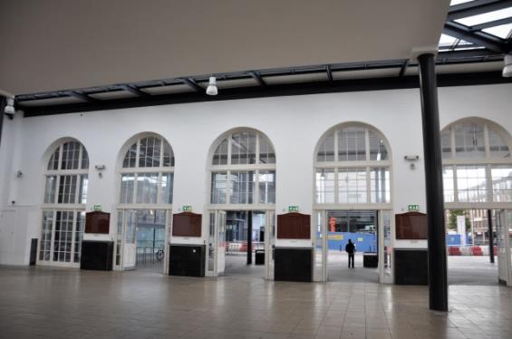 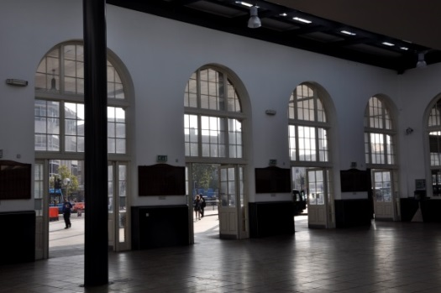

I propose full colour digitally printed vinyl panels to be installed in each of the nine exterior facing arched windows within the First World War memorial entrance at Hull railway station. I intend to work with Sign Express, a national signs and graphics company with a production centre based in Hull. The work will be completed locally, including the sampling phase and the custom printing of the vinyl panels to my specifications. The company will install the work on the windows and subsequently remove the vinyl involving the use of a small access tower. General public access needs, in liaison with David Hatfield, the station manager at Hull, will be critical to ensure the smooth running of the station. Currently he is very supportive of the proposal and the proposed site for the work. An extension to the proposal could be sited on the glass barrier opposite the main waiting room in Hull railway station, also involving custom printed vinyl produced by the Signs Express in Hull.

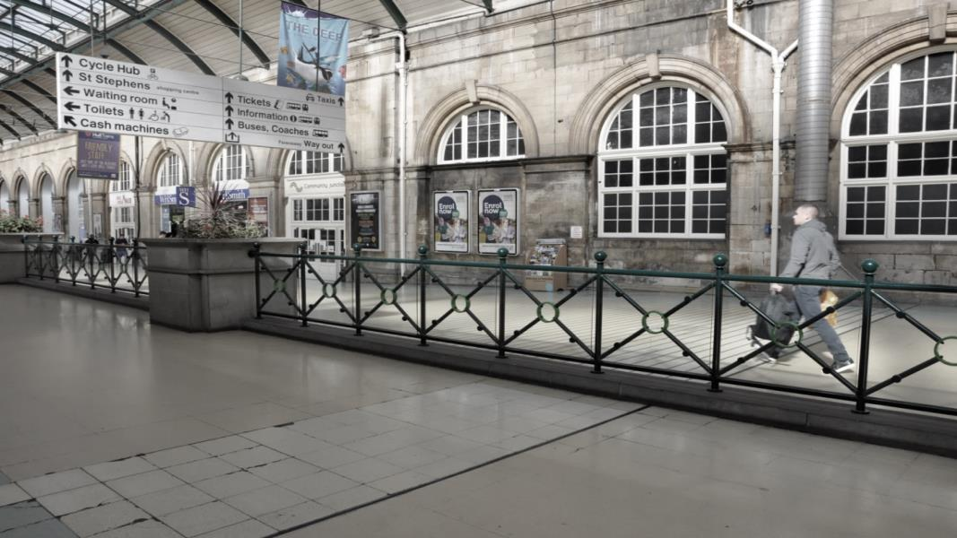

|  |  |  |
| --- | --- | --- |
| **Provisional Budget** | | |
| **Item** | **Cost**  **(including VAT)** | **Description** |
| **Artists fee** | £7040 | £220 per day x 32 days. |
| **Materials**   1. Full colour digital printed vinyl media panels.   Survey fee | £4956.01  £252 | Vinyl window covering for glass windows in First World War memorial entrance, Hull railway station. Estimate Size: 9 (6090mm x 3040mm)  Cost quote from Sign Express (Hull).  Survey fee to check all sizes prior to works being completed  Cost quote from Sign Express (Hull) |
| 1. Full colour digital printed vinyl media panels.   Survey fee | £1489.10  £252 | Vinyl window covering for glass barrier opposite the main waiting room, Hull railway station. Estimate size: 15 (610mm x 610mm)  Cost quote from Sign Express (Hull)  Survey fee to check all sizes prior to works being completed  Cost quote from Sign Express (Hull) |
| **Installation and removal**   1. Installation of the above vinyl at First World War memorial entrance   Removal of the above vinyl at First World War memorial entrance | £3024  £3024 | Team of two to install vinyl, including hire of small access tower.  Cost quote from Sign Express (Hull)  Team of two to remove vinyl, including hire of small access tower.  Cost quote from Sign Express (Hull) |
| 1. Installation of the above vinyl at the glass barriers opposite main waiting room at Hull Station   Removal of the above vinyl at the glass barriers opposite main waiting room at Hull Station | £900  £900 | Team of two to install vinyl  Cost quote from Sign Express (Hull)  Team of two to install vinyl  Cost quote from Sign Express (Hull) |
| **Artist Travel** | £638 | Based on second class rail tickets to Hull (x7), Liverpool, Southampton and Glasgow to photograph train tracks at station platforms. |
| **Consumable materials for prototype, work-in-progress** | £1500 | Research and sampling process, including costs of photographic paper, digitally printed vinyl, glass samples. |
| **5% Contingency** | £1500 |  |
| **Research and development**  Research trip to visit Ellis Island and study woven baskets | £884 | Based on BR flight, accommodation and entrance to Ellis Island hospital and museum. Research funds sought to cover this element from University of Huddersfield (tbc). |
| **Technical equipment / equipment hire** | Circa £1000 | In-Kind: University of Huddersfield photographic resource (digital Nikon camera and tripod, Photoshop plus technical support) |
| **Total** | **£25, 475.10** |  |

**References**

Barratt, O. E. (1991). *Basket making.* London: Charles Letts & Co Ltd.

Evans, N. J. (2001) Work in progress: Indirect passage from Europe Transmigration via the UK,

1836-1914*.* In *Journal for Maritime Research*, 3:1, 70-84.

Dines, T. (2013). *The wild things: Guide to the changing plant life of the British Isles.* London:

Transworld Publishers.

Gillow, J. and Sentence, B. (1999). *World textiles.* London: Thames & Hudson Ltd.

Goldstein, K. (Curator). (1999). *Packing for America: The prized and the practical* [exhibition].

Exhibited at Pilgrim Hall Museum, Massachusetts June 1999 - May 2001.

Hixson, K. (2011). Anna Wilson: Wind/Rewind/Weave*.* In *Textile*, Volume 9, Issue 2, pp.220-229.

Israel, F. L. (1968). *1897 Sears Roebuck catalogue*. New York: Chelsea House Publishers.

Royer, R. (1977). *Original fabric designs influenced by those imported by Scandinavian*

*immigrants.* Retrospective theses and dissertations, paper 7952. Iowa, USA: Iowa State University.