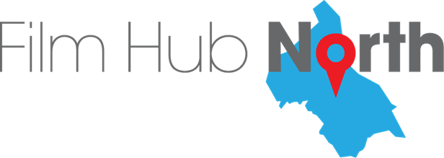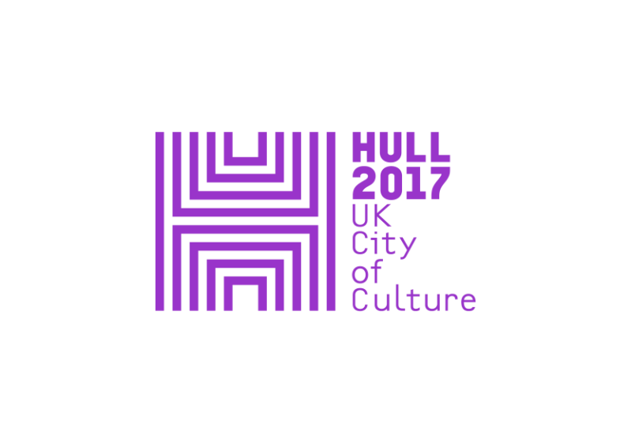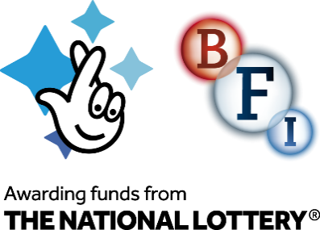

**PRESS RELEASE**

Tuesday 31 October 2017

***What does it mean to be Northern in a globalised world?***

***Substance Film Festival* curated by Aesthetica Magazine explores Northern identity as part of Hull 2017, 1 – 5 December 2017**

Hull 2017 marks the start of December with more than 10 days of music, art installations, performance and provocations with the title ***Substance*** (29 November – 10 December) celebrating this City of Culture year and exploring the culture, creativity and the future of the North.

One of the highlights will be***Substance Film Festival*,** curated by *Aesthetica* Magazine with support from Hull Independent Cinema, which will show sixteen films focused on the theme of *Industry. Innovation. Change* and will run from Friday 1 to Tuesday 5 December at Vue Cinema Princes Quay, Hull. Tickets cost £4 each night and there is a festival ticket for all films at the discounted rate of £10.

The film programme, taking its inspiration from the northern landscape, explores the themes through four strands: *Award Winning Films*; *Place is a State of Mind*; *Human Stories;* and *Complex Relationships.*

A host of film makers are set to attend the festival to feature in post screening discussions to further explore the one central question - *what does it mean to be Northern in a globalised world?*

Robert Hackett will be attending the festival with his award-winning **NIGHT MAIL PUBLICSERVICE BROADCASTING***and*BBC writersroom Future Talent Award winner Hannah Pike is bringing her first short film **HIT & RUN**as part of the Human Stories strand*.*

Award-winning documentary filmmaker **Ruth Grimberg** will bring **SOME WILL FORGE alongside** the BAFTA nominated Chris Shepherd with his film **THE RINGER** both of which are featuring in the Complex Relationships strand. Film makers Ashley Dean, Harry Sherriff and Ismar Badzic are confirmed to attend the festival too.

The festival will also showcase work *by* Italian master of music and image **Tommaso Pitta,** Oscar-winning Irish director **Benjamin Cleary**, and Hamburg-based **Joschka Laukeninks** who shot commercials for Samsung, Mercedes-Benz and Volkswagen.

The identity of northern England has been shaped by perpetual change as well as social and political upheaval: their roots run deep. The voice of the North is growing in complexities, entering new realms and inspiring the next generation of artists who brilliantly express their sense of locality and its place in the globalised world through the medium of film. The unique and challenging screenings of *Substance Film Festival* offer personal perspectives from both emerging and established film artists. Audiences will be moved by the breadth of emotions and appreciate the notion of the land as something far more complex than a geographical location.

Sam Hunt, Executive Producer at Hull 2017, commented: "*Substance* is bringing more than 10 days of art, ideas and questions focusing on the role that the North has in the nation's future and the centrality of culture to its success. As part of that, *Substance Film Festival* gives us a wide-range of perspectives about what the North is and the often mythologised, yet hard to pin down Northern identity."

**Substance Film Festival's four programme strands are:**

**Award-winning Films**

A programme of films that looks at some of the winners from the Aesthetica Short Film Festival from Best Drama and Best Documentary to Best Comedy and Best Music Video. Some of these films have gone on to win Oscars and BAFTAs. A magnificent programme of shorts all with connections to the North of England, featuring films by Fabio Palmieri, Tommaso Pitta, Benjamin Cleary and Robert Hackett.

**Place Is A State Of Mind**

A collection of shorts that challenges the notion of place. From a Dutch businessman on the verge of a breakdown and an elderly couple recalling their youth to understanding how sound accentuates a place and then back to the sea. This collection of films reminds viewers that place can be physical or abstract and is defined by a series of memories. Ultimately place is what you make of it. Filmmakers featured in this strand are Boris Kuijpers and Ruth Mellaerts, Stephen Johnson, Ismar Badzic, Tony Plant.

**Human Stories**

These films are rooted in the shared human experience. From the oldest married couple in the world to a portrait of a life, the narratives look at communal rights-of-passage that transcend place and remind us of our humanity and how individual stories help us to relate to one another in a complex world. Showcasing the talent of Glen Milner, Hannah Pike, Joschka Laukeninks, Benjamin Cleary and TJ O'Grady Peyton.

**Complex Relationships**

From stories about fathers and sons, the last colliery in Yorkshire and a young girl struggling with her upbringing, these films look at the breadth and dynamic nature of family relationships. They also offer a glimpse into the intricacy of the domestic whilst underpinning identity in the modern age from a northerner in London to a family in crisis. This strand features films by Chris Shepherd, Harry Sherriff, Ruth Grimberg & Ashley Dean.

Each evening will include a hosted Q&A and panel discussion around the theme of the film programme with the filmmakers and special guests. **ENDS**

[**www.hull2017.co.uk/substance**](http://www.hull2017.co.uk/substance)

**IMAGES AVAILABLE** [**HERE**](https://www.dropbox.com/sh/umtrsg3z9a0ed14/AAC4ovMgQY2j-ZAuTbjfKc4oa?dl=0)**. LISTINGS AND EDITORS NOTES BELOW**

**For further information please contact:**

Kate Bouchier-Hayes at The Corner Shop PR: [kate@thecornershoppr.com](mailto:kate@thecornershoppr.com) / 07825 335 489

Magda Paduch at The Corner Shop PR: [magda@thecornershoppr.com](mailto:magda@thecornershoppr.com) / 0758 316 4070

Ben McKnight at Hull 2017 / [ben.mcknight@hull2017.co.uk](mailto:ben.mcknight@hull2017.co.uk) / 07718 100 793

**LISTINGS**

**1 – 5 Dec, £4 each night or £10 festival pass available**

[**www.hull2017.co.uk/whatson/events/shorts-of-substance**](http://www.hull2017.co.uk/whatson/events/shorts-of-substance)

**Award Winning Films**

**Fri 1 Dec, 7:30pm**

**12+**

**1. IRREGULARS**

Dir Fabio Palmieri | Italy | 2015 | 9 mins | Documentary

Each year 40, 000 people try to enter Europe. They flee from war, persecution and poverty. Since the ways by land have been interrupted, they board overloaded vessels and face a dangerous and often deadly voyage across the Mediterranean.

**2. HOW I DIDN’T BECOME A PIANO PLAYER**

Dir Tommaso Pitta | UK | 2015 | 18 mins | Comedy

Ted, 9 year old, is the clumsiest boy in the world. Desperately searching for his vocation, he cannot find anything he is good at. The breakthrough arrives the day his father comes home with an old monstrous piano. Ted has the revelation: he will become the next Mozart. Based on the short story 'Every Good Boy' by David Nicholls.

**3. STUTTERER**

Dir Benjamin Cleary | UK/Ireland | 2015 | 13 mins | Drama

A man with a debilitating speech problem must face his worst fear.

**4. NIGHT MAIL – PUBLIC SERVICE BROADCASTING**

Dir Robert Hackett | UK | 2013 | 3 mins | Music Video

Shot at night, this promo is characterised by images from the original *Night Mail* GPO Film unit film featuring WH Auden's poem, projected onto a disused train station.

**Place Is A State Of Mind**

**Sat 2 Dec, 7:30pm**

**12+**

**1. ALLEGORY OF A JAM JAR**

Dir Boris Kuijpers & Ruth Mellaerts | Belgium | 2015 | 17 mins | Drama

Hans is a 50-year old businessman. He has a challenging job, a wonderful collection of ties and a pristine apartment. One day, when a crack appears on the perfect walls of his home, Hans slowly starts losing control of his seemingly perfect life.

**2. THE MAPMAKER**

Dir Stephen Johnson | UK | 2011 | 18 mins | Drama

When Rowan and Isabel return to the coastline where they spent a blissful summer, almost fifty years before, it is with a very different purpose. Isabel is dying; she wants it to be here, now. As darkness falls, their past collides with the present and Rowan is called upon to make a sacrifice that will preserve their unity forever. Passionate, searing and poetic 'The Mapmaker' examines a life and love that, just like all of ours, is all too fleeting.

**3. A LONG WALK TO GRIMETHORPE**

Dir Ismar Badzic | UK | 2016 | 25 mins | Documentary

Composer Joe Snape takes a sonic journey from Sheffield to Grimethorpe. Armed with a tuba and sound recorder, he searches for sounds and inspiration for a new piece of music; exploring the nature and history of brass along the way.

**4. FOREVER**

Dir Tony Plant | UK | 2017 | 3 mins | Artist’s Film

Site Specific Drawing. 1 tide, 12,000+ steps, 3 years waiting. Walking on the last beach in the UK before setting foot on the first beach in America. A drawing in landscape, of landscape.

**Human Stories**

**Mon 4 Dec, 7:30pm**

**15+**

**1. ELDERS**

Dir Glen Milner | UK | 2015 | 7 mins | Documentary

After leaving India for the industrial north of England in the 1960's, Karim and Katari Chand never imagined they would end up being married longer than any other couple in the world. Their personal story of family, immigration, love, and the working-class is both inspiring and honest as we gain a valuable insight into how different cultures respect their elders.

**2. HIT & RUN**

Dir Hannah Pike | UK | 2016 | 20 mins | Drama

If Tennent's Super did Pretty Woman. In Stockport... An alcoholic desperate to end his life encounters a prostitute desperate to start hers. Despite an initial repulsion to each other they soon realise that each has something to offer the other.

**3. BACKSTORY**

Dir Joschka Laukeninks | Germany | 2016 | 8 mins | Drama

As a young child our protagonist is left by his mother and has to live with his violent

father. He fights his way through adolescence and falls in love with the woman of his

dreams and just as everything seems to be finally working out for him, a sudden event

changes the course of his life forever. A story about how everything we love, everything

we learn, everything we build, everything we fear, will one day be gone.

**4. WAVE**

Dir Benjamin Cleary & TJ O'Grady Peyton | Ireland | 2017 | 14 mins | Drama

A man wakes from a coma speaking a fully formed but unrecognizable language, baffling linguistic experts from around the globe. Narrated by Jarvis Cocker.

**Complex Relationships**

**Tues 5 Dec, 7:30pm**

**12+**

**1. THE RINGER**

Dir Chris Shepherd | UK/France | 2013| 17 mins |Drama

A son is reunited with his long lost father for the first time. You might imagine it's time to discover everything about where he's come from and where he's going. But he's about to get a surprise...

**2. HITS LIKE A GIRL**

Dir Harry Sherriff | UK | 2014 | 11 mins | Drama

HITS LIKE A GIRL, a raw coming of age story that follows Kay McKenna, a 19-year-old fighter from Toxteth who has a serious anger problem and a fractious relationship with her agoraphobic mother, Kathy.

**3. SOME WILL FORGET**

Dir Ruth Grimberg | UK | 2016 | 15 mins | Documentary

One of the last coalmines in the UK faces closure and 30 years after the defeat of the Miners’ strike Les struggles with its toll on his family.

**4. LET IT GO – FOSSIL COLLECTIVE**

Dir Ashley Dean | UK | 2015 | 5 mins | Music Video

A tale of tragedy, heartbreak, hope and determination, inspired by Minecraft and Desert Island Discs.

**NOTES TO EDITORS**

**Substance**

*Substance* follows in the footsteps of WOW – Women of the World, Neu Reekie's Where Are We Now? and the Freedom Talks, to get artists, thinkers, commentators and the general public talking and thinking about key issues of the day. With the acknowledged success of Hull UK City of Culture 2017 locally and nationally, *Substance* mixes debate, music, art, film and performance celebrating the future of Hull and the North as a dynamic creative and cultural powerhouse. Substance Future Forum (7 December) will bring together a wide and diverse range of cultural influencers including artists, creative industries, businesses, digital pioneers and social commentators to discuss the culture, creativity and future of the north. [www.hull2017.co.uk/substance](http://www.hull2017.co.uk/substance)

**Hull UK City of Culture 2017**

Hull UK City of Culture 2017 is a 365 day programme of cultural events and creativity inspired by the city and told to the world. Hull secured the title of UK City of Culture 2017 in November 2013. It is only the second city to hold the title and the first in England. Divided into four seasons, this nationally significant event draws on the distinctive spirit of the city and the artists, writers, directors, musicians, revolutionaries and thinkers that have contributed to the development of art and ideas.

The Culture Company was set up to deliver the Hull 2017 programme and is an independent organisation with charitable status. It has raised £32 million, with over 70 partners supporting the project, including public bodies, trusts and foundations and local and national businesses. Key contributions are coming from: Host City – Hull City Council; Principal Partners - Arts Council England, BBC, Big Lottery Fund, East Riding of Yorkshire Council, Heritage Lottery Fund, KCOM, KWL, Spirit of 2012, Yorkshire Water and the University of Hull; Major Partners –Associated British Ports, Arco, BP, the British Council, British Film Institute, Green Port Hull, Hull Clinical Commissioning Group, MKM Building Supplies, P&O Ferries, Paul Hamlyn Foundation, Sewell Group, Siemens, Smith & Nephew and Wykeland Group. The National Lottery has contributed more than £10m of this funding, making it the largest single funding body for Hull 2017.

For information go to www.hull2017.co.uk Follow us on Twitter @2017Hull Instagram @2017hull Facebook HullCityofCulture

**BAFTA-Recognised Aesthetica Short Film Festival**

ASFF is a celebration of independent film from across the world, and an outlet for supporting and championing filmmaking. This year’s festival marks the seventh edition with an even bigger programme, featuring over 300 films, industry sessions, marketplace screenings and networking opportunities. ASFF will take place in 18 iconic venues across the historic city of York from 8-12 November 2017.

The films span a diverse range of genres and filmic styles: Advertising, Animation, Artists’ Film, Comedy, Dance, Documentary, Drama, Experimental, Fashion, Music Video and Thriller. ASFF’s dynamic Masterclasses and Industry Sessions return with speakers from the BBC, Industrial Light & Magic, BFI Net.Work and other leading organisations. Topics include directing, cinematography, funding, VFX and more. These provide you with the chance to gain top advice from those shaping the film world today, expand your professional network and explore current industry developments. For more information visit [**www.asff.co.uk**](http://www.asff.co.uk/)

**Hull Independent Cinema**

Hull Independent Cinema (HIC) is a registered charity which works to bring independent, art and world cinema to new audiences. HIC has been screening films in a range of venues across the city since July 2014, and is working towards a long-term goal of creating a new independent cinema in the city. HIC is the key local delivery partner for the Transformative Film Culture for Hull Project.

**Aesthetica Magazine**

The BAFTA-Recognised Aesthetica Short Film Festival (ASFF) is organised by Aesthetica Magazine. Intelligent, beautiful and informative, Aesthetica is one of the leading publications for art, design and photography. The magazine covers the latest exhibitions, reviews, films and photography alongside stimulating features and critical debate. It is an essential resource for readers looking to keep up-to-date with contemporary art and visual culture with a print and digital readership of 311,000. Find out more at [**www.aestheticamagazine.com**](http://www.aestheticamagazine.com)

**BFI / Film Hub North**

The BFI is supporting Hull City of Culture with a programme of film activity in the city and region in partnership with Film Hub North, and as part of the BFI’s Film Audience Network led by Showroom Workstation. The Transformative Film Culture for Hull programme, supported by the BFI with National Lottery funding, will bring a packed programme of more than 400 screenings, one-off events and film festivals throughout the year to Hull and the region.

The BFI is funding ‘Transformative Film Culture For Hull', as part of its National Lottery-funded BFI Film Audience Network and led by its lead partner BFI Film Hub North. Delivered through Hull 2017 and by Hull Independent Cinema and a unique partnership of film festival, educational and archive partners from across the north, the film programme will bring a packed programme of more than 400 screenings, one-off events and film festivals throughout the year to Hull and the region. The programme reflects the BFI’s activities across the UK to bring film to audiences where there is less opportunity for them to experience and engage in film, and to support local film networks and audience initiatives. There will be much to explore, celebrate and enjoy.