The Gold Nose of Green Ginger
OPENING PROCESSION
Schedule – Saturday 17th June 2017

Contacts:
Adam Long, TG Events adam@tgevents.co.uk 07754 728316
Daniel Thomson, Music culturemusichull@gmail.com 07980 317111
Elizabeth Bergeron, Hull 2017 elizabeth.bergeron@hull2017.co.uk 07928 751270
Jacob Taylor Durant, Trumpeter 1 J.taylordurant@btinternet.com 07511 577605
Jade Wasling, Nose Guardian jade.wasling@hotmail.co.uk 07973 544245
Jennifer Littlehales, Trumpeter 2 jennifer.littlehales@outlook.com 07964 087528
Jess Aylen, Assistant Nose Guardian 1 jessicaaylen@hotmail.com 07973 576438
Joshua Sofaer, Artist (Main Contact) Assistant Nose Guardian 2 joshua@joshuasofaer.com 07870187504
Josie Drury, Banner Bearer 2 c/o Louise Yates louise.yates@hull2017.co.uk 07753 171181
Karen Bassett, Horse and Carriage karenbassettcarriagedriving@aol.co.uk 07831 277778
Louise Yates, Hull 2017 Producer louise.yates@hull2017.co.uk 07753 171181
Nanci Yates, Banner Bearer 1 c/o Louise Yates louise.yates@hull2017.co.uk 07753 171181
tbc Volunteer 1
tbc Volunteer 2
Tsai-Chun Huang, Costumes tsai-chun.huang@network.rca.ac.uk 07597 646402

Call Times:
 | Time | Meeting Point | Items to bring / wear
Adam Long | 0900 | The Gold Nose of Green Ginger* | n/a
Elizabeth Bergeron | 0900 | The Gold Nose of Green Ginger* | n/a
Jacob Taylor Durant | 0945 | The Gold Nose of Green Ginger* | blue jeans, white tshirt or top, black sneakers or shoes
Jade Wasling | 0930 | The Gold Nose of Green Ginger* | blue jeans, white tshirt or top, black sneakers or shoes
Jennifer Littlehales | 0945 | The Gold Nose of Green Ginger* | blue jeans, white tshirt or top, black sneakers or shoes
Jess Aylen | 0930 | The Gold Nose of Green Ginger* | blue jeans, white tshirt or top, black sneakers or shoes
Joshua Sofaer | 0900 | The Gold Nose of Green Ginger* | blue jeans, white tshirt or top, black sneakers or shoes
Josie Drury | 0945 | The Gold Nose of Green Ginger* | blue jeans, white tshirt or top, black sneakers or shoes
Karen Bassett | 0900 | Service Area 2 | formal riding suit
Louise Smith | 0900 | Service Area 2 | n/a
Nanci Yates | 0945 | The Gold Nose of Green Ginger* | blue jeans, white tshirt or top, black sneakers or shoes
Tsai-Chun Huang | 0900 | The Gold Nose of Green Ginger* | n/a
Volunteer 1 | 1000 | The Gold Nose of Green Ginger* | blue jeans, white tshirt or top, black sneakers or shoes
Volunteer 2 | 1000 | The Gold Nose of Green Ginger* | blue jeans, white tshirt or top, black sneakers or shoes

*The Gold Nose of Green Ginger is at Unit 15 North Point Shopping Centre, 5 Goodhart Road, Hull HU7 4EE. It’s the unit next to the market entrance. We will not be opening the grill, so head down the side of the unit towards the market, take the first left through the glass double doors to the back entrance, which will be open.
Service Area 2 is located to the left of the main entrance of 15 North Point Shopping Centre, 5 Goodhart Road, Hull HU7 4EE. It can be accessed through the same entrance as the Co-op Funerals Car Park. See images 1 and 2.

Schedule:
Time | What | How |  |  | Who
0900-1015 | Carriage set-up and Preparation | The carriage is set up and prepared. The route is confirmed. The Nose Guardian readies herself. |  |  | Karen Bassett  Jade Wasling  Louise Yates
1000-1030 | Welcome Rehearsal / Walk through | The Banner Bearers, Nose Guardian Assistants and Trumpeters rehearse the arrival of the Gold Nose of Green Ginger. |  |  | Nanci Yates  Josie <Surname>  Jessica Aylen  Joshua Sofaer  Jacob Taylor Durant  Jennifer Littlehales
1015-1100 | Carriage Procession | Horse and Carriage leaves Service Area 2 and travels around Bransholme on accessible roads with the Nose Guardian carrying the Gold Nose of Green Ginger on its staff. The route is suggested as follows: Holwell Road, Honiton Road, left to Wawne Rd, left Holwell Road, left Honiton right Wawne right Barnstable right Holwell, North Point. |  |  | Karen Bassett  Jade Wasling
1030-1055 | Welcoming party prepare | The welcoming party for the Gold Nose of Green Ginger get into costume. |  |  | Tsai-Chun Huang  Nanci Yates  Josie <Surname>  Jessica Aylen  Joshua Sofaer  Jacob Taylor Durant  Jennifer Littlehales
1055 | Preparing for arrival of carriage | The Banner Bearers, Nose Guardian Assistants and Trumpeters walk silently and solemnly through the back entrance of the Gold Nose of Green Ginger, through the Health Centre car park and onto Goodhart Road at Bransholme Library. They walk around to the front of North Point Shopping Centre and await the arrival of the carriage at the Foredyke Pub. (See image 3.) |  |  | Nanci Yates  Josie <Surname>  Jessica Aylen  Joshua Sofaer  Jacob Taylor Durant  Trumpeter 2
1055 | Waiting in GNGG | The 2 volunteers wait in the Gold Nose of Green Ginger on radios, preparing to open the front grill. |  |  | Volunteer 1  Volunteer 2
1100 | Arrival of the Gold Nose of Green Ginger | The carriage arrives at the Foredyke Pub. (See image 3.) It stops. Nose Guardian Assistant 1 opens the door of the carriage. The trumpeters perform the first fanfare. Once it is finished (1 min) The Nose Guardian steps out of the carriage and the assembled group form a line up as follows, with Banner Bearers in the lead: |  |  | Karen Bassett  Jade Wasling  Nanci Yates  Josie <Surname>  Jessica Aylen  Joshua Sofaer  Jacob Taylor Durant  Jennifer Littlehales
 |  | Banner Bearer 1 |  | Banner Bearer 2
 |  | Trumpeter 1 |  | Trumpeter 2
 |  |  | The Nose Guardian
 |  | Assistant 1 |  | Assistant 2
 |  | The trumpeters begin the second fanfare and the group slowly processes through the shopping centre to the Gold Nose of Green Ginger space.
1105 | Raising of the grid | The 2 volunteers listen out on radios for instructions to open the grid of the shop. They also remove the window coverings and stand by the cordon. |  |  | Volunteer 1  Volunteer 2
1105 | Carriage departs | Once the procession is out of sight, the horse and carriage can return to Service Area 2 and can pack up. |  |  | Karen Bassett
1105 | The Gold Nose of Green Ginger is open | The volunteers temporarily remove the cordon to allow the procession group to enter the Gold Nose of Green Ginger before putting the cordon back in place. The Nose Guardian and Assistant 2 move to the back of the space. Assistant 2 places the Gold Nose of Green Ginger in its vessel. The Nose Guardian moves to the podium. The Trumpeters, Banner Bearers, and Assistants stand either side of the space. The fanfare plays for a third time. Then the Nose Guardian makes the maiden speech, telling the story of the Gold Nose of Green Ginger and officially opening the space.  The formal ceremony has now ended. The Nose Guardian and Assistants give out leaflets (and tea and biscuits?). |  |  | Nanci Yates  Josie <Surname>  Jessica Aylen  Joshua Sofaer  Jacob Taylor Durant  Jennifer Littlehales
1130 | Normal function | The trumpeters and banner bearers can now leave. Normal function of the space commences. |  |  | Nanci Yates  Josie <Surname>  Jacob Taylor Durant  Jennifer Littlehales

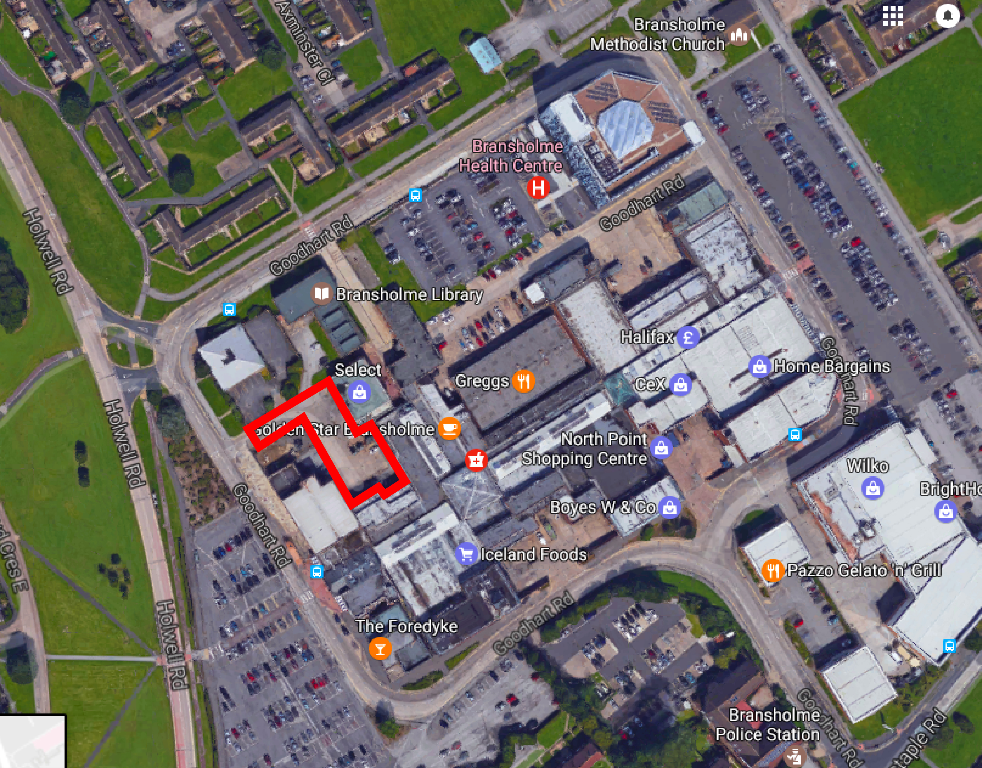

Image 1. The red outlined area shows Service Area 2.
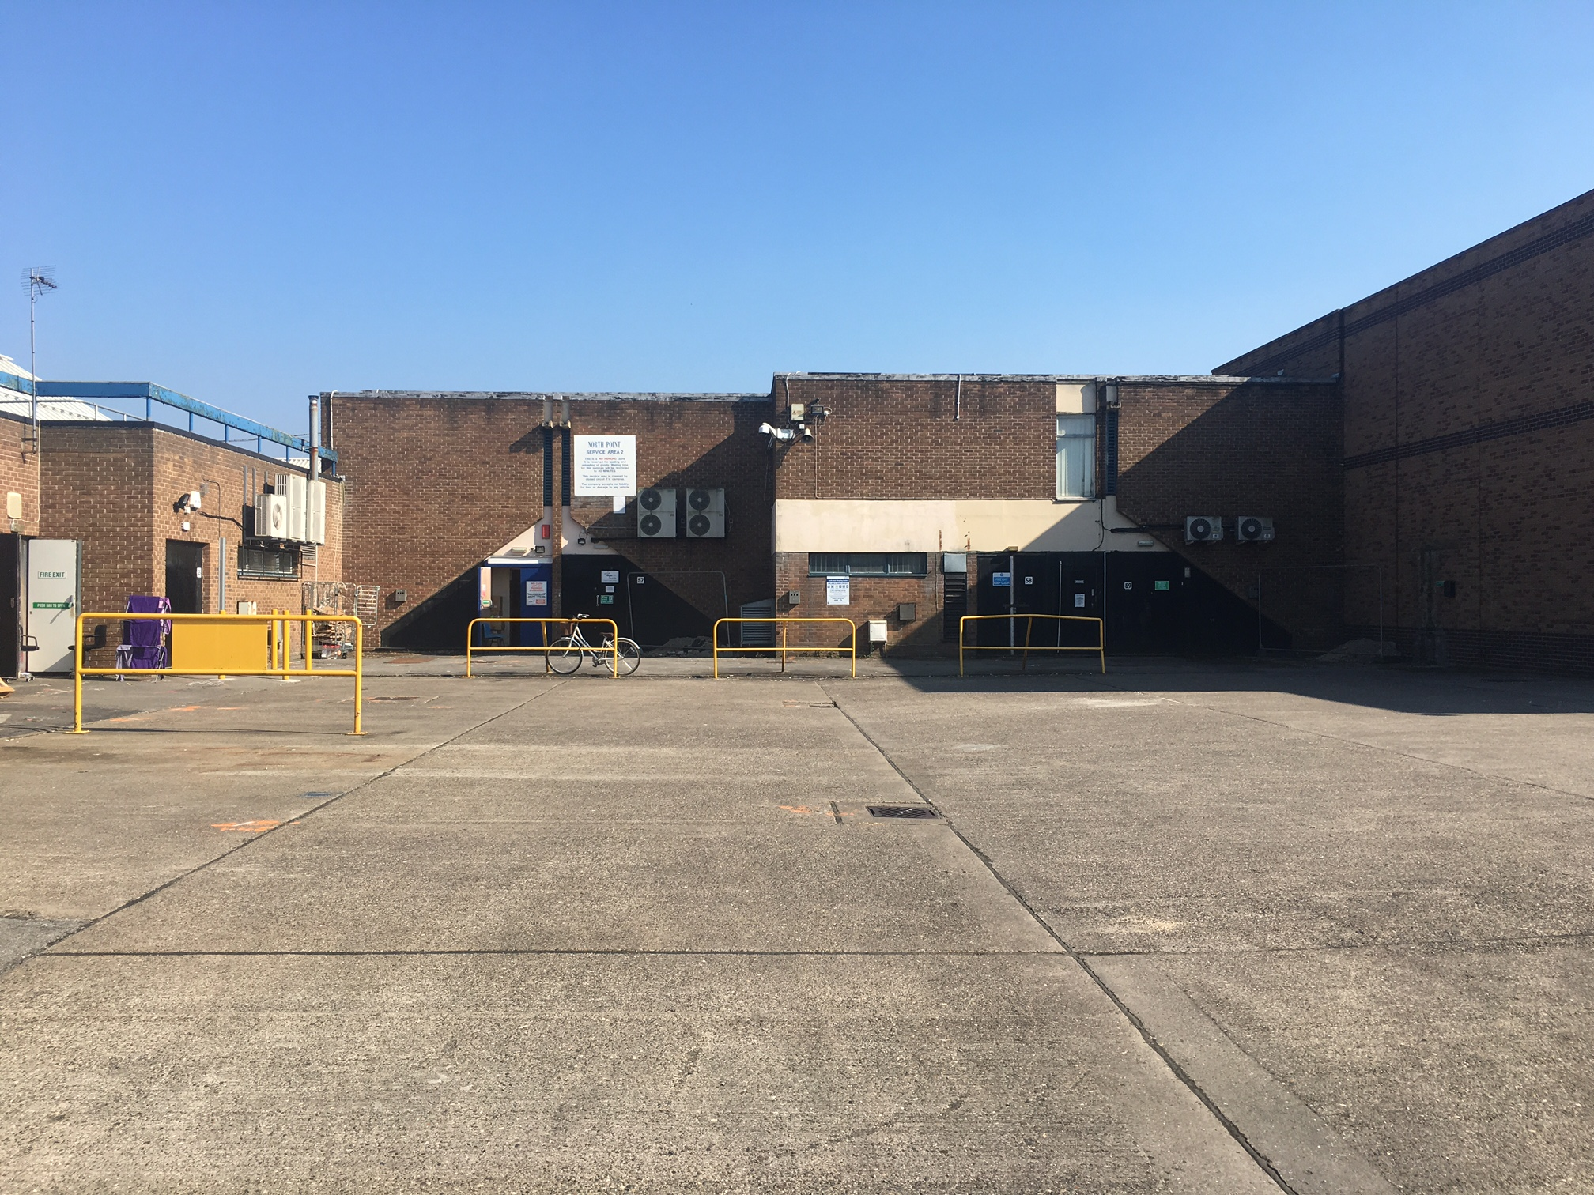

Image 2. Service Area 2

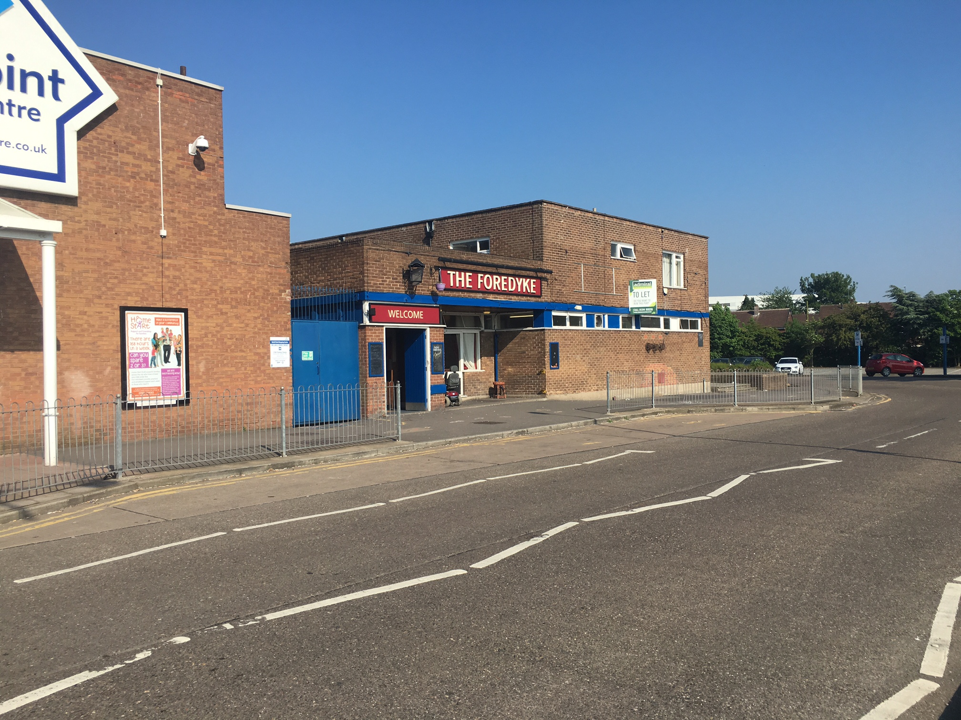

Image 3. Outside the Foredyke pub, showing carriage stopping area.

