Transformative Film Culture Hull BFI Accreditation Guidelines

BFI and Film Hub North will be credited within all publicity and marketing material relating to supported activity taking place as part of Hull UK City of Culture 2017. The prominence and status of this credit shall be:

* For National announcements, press releases, Hull UK City of Culture 2017 core programme print and web credit, the **BFI** shall be credited as a principal partner of the Hull UK City of Culture 2017 programme.
* For project specific announcements, publicity and marketing materials, a ‘locked up’ presentation of **BFI and Film Hub North logos** (as supplied below) will be used in proportion equal to other supporters OR where support varies, shall be in reasonable proportion to the level that our investment bears to that of other supporters.

British Film Institute (BFI) logo and Film Hub North logo to be included on project specific materials and publicity in ‘locked up’ form on all marketing materials and publicity.

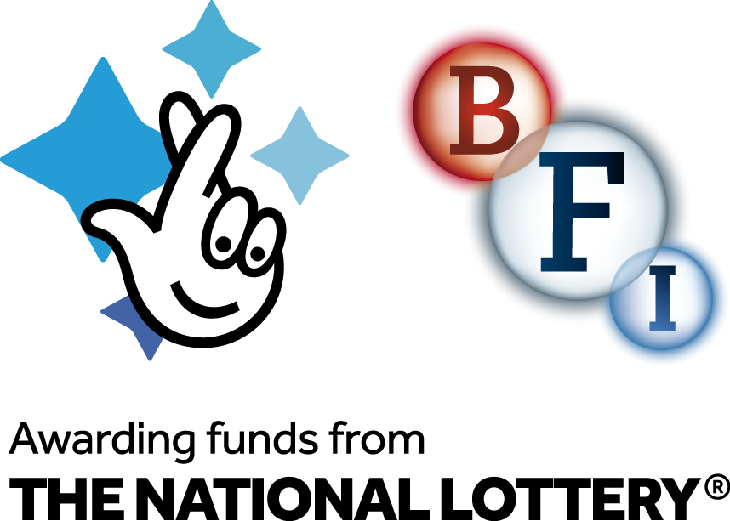



You will credit the BFI’s support for the project with the following text credit on core marketing materials and publicity:

*The BFI is supporting Hull City of Culture with a programme of film activity in the city and region in partnership with Film Hub North, and as part of the BFI’s Film Audience Network led by Showroom Workstation.  The Transformative Film Culture for Hull programme, supported by the BFI with National Lottery funding, will bring a packed programme of more than 400 screenings, one-off events and film festivals throughout the year to Hull and the region.*

You will ensure partners managing the individual projects contained within this contract  include the following ‘boilerplate’ on project specific marketing materials and publicity

*The BFI is funding ‘Transformative Film Culture For Hull', as part of its National Lottery-funded BFI Film Audience Network and led by its lead partner BFI Film Hub North.  Delivered through Hull 2017 and by Hull Independent Cinema and a unique partnership of film festival,  educational and archive partners from across the north, the film programme will bring a packed programme of more than 400 screenings, one-off events and film festivals throughout the year to Hull and the region.   The programme reflects the BFI’s activities across the UK to bring film to audiences where there is less opportunity for them to experience and engage in film, and to support local film networks and audience initiatives. There will be much to explore, celebrate and enjoy.*