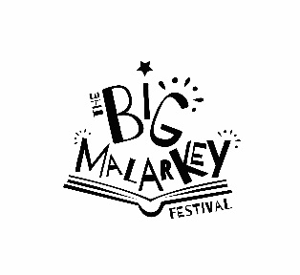

**SATURDAY AUDIENCE FEEDBACK QUESTIONNAIRE**

1. **What motivated you to attend this event?** *(Tick all that apply)*

|  |  |
| --- | --- |
|  | Because it’s part of Hull UK City of Culture 2017 |
|  | Because I’m a regular attender of Hull Libraries events |
|  | It’s a unique experience not to be missed |
|  | General interest in this type of event |
|  | Wanted to see / do something creative |
|  | Specific interest in a group / performer involved (please specify which artists below) |
|  | Getting involved in what’s happening |
|  | Trying something new or different |
|  | Something to do while I’m in Hull on business |
|  | It’s affordable / good value |
|  | Something to do with friends / family |
|  | Something to do with the kids |
|  | Interested to find out more about Hull |
|  | No particular reason / someone else’s idea |
|  | Other (please specify below) |

1. **Are you a member of Hull Libraries** Yes/No
2. **Would you attend another event like this**? Yes/ No
3. **Which events/activities did you attend today ? ………………………………………………………………**

**…………………………………………………………………………………………………………………………………………**

**……………………………………………………………………………………………………………………………………….**

1. **How did you find out about the festival?**

|  |  |
| --- | --- |
|  | Friends/family/colleagues - told me in person |
|  | Friends/family colleagues – via social media / email |
|  | www.hull2017.co.uk |
|  | Other website (please specify) |
|  | Hull 2017 Social Media |
|  | Other organisation Social media (please specify) |
|  | Advertising and printed promotional material (e.g. brochure, leaflet, flyer, billboard) |
|  | Newspaper |
|  | TV |
|  | Radio |
|  | Don’t remember |
|  | Other (please specify) |

1. **Please let us know your thoughts on today’s event by ticking the relevant boxes below**:

**Excellent Good Satisfactory Poor**

**Event organisation**

**Event promotion**

**Event location**

**Information available**

**Overall quality of the event**

1. **Any other comments about today’s event?**

**Would you be willing to be contacted by Hull 2017 or the University of Hull to take part in further research?** Yes/No

**Your name:**……………………………………………………………………………………………………………….

**Email address:**…………………………………………………………………………………………………**Postcode**……………….

Please tell us your age group? □ 16-17  □18-19 □ 20-24 □25-29 □30-34

□35-44 □45-49 □ 50-54 □ 55-59 □ 60-64 □ 65-69 □ 70-74 □ 75+

***Thank you for taking the time to fill in this form. Your feedback will be very useful to us for planning for next year.***