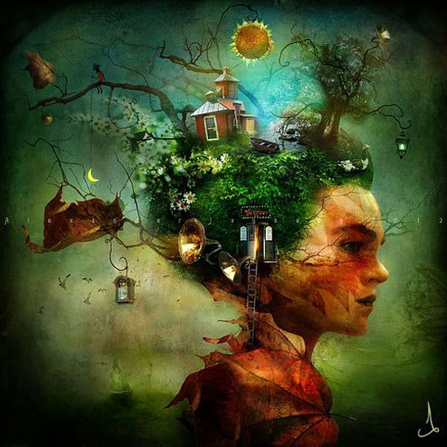

Thinking a giant with elements of the project in his/her hair? (not sure about this one!)
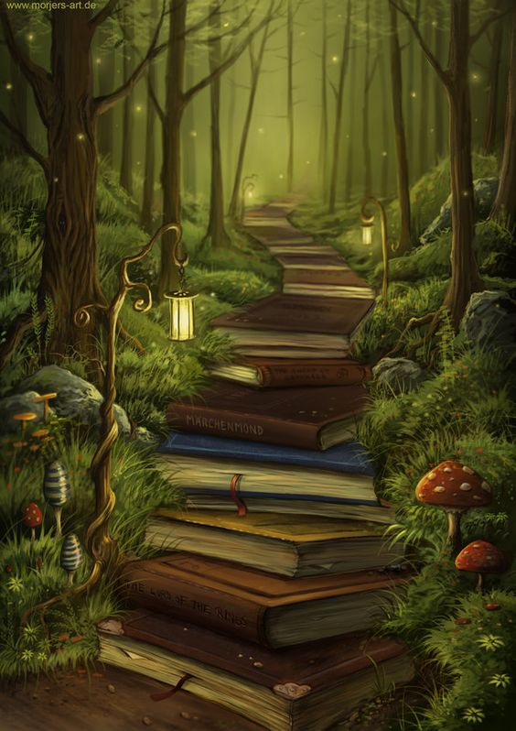

Walking over books to the Land of Green Ginger?
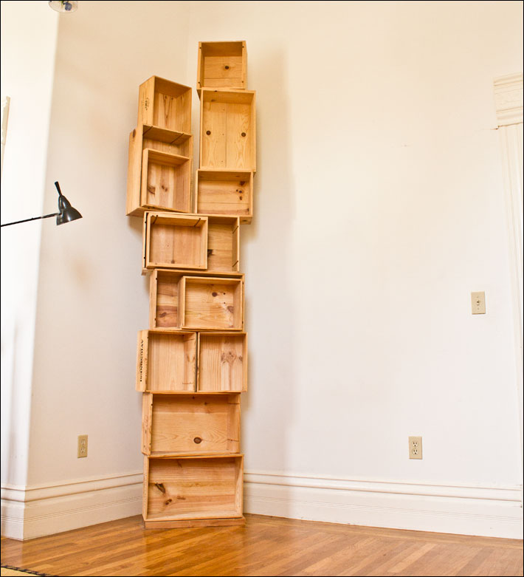

A towering pile of crates (representing the giants) with elements of every project in each?
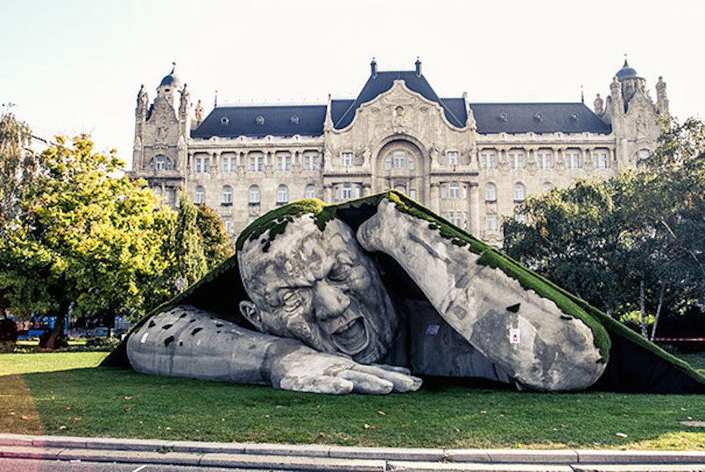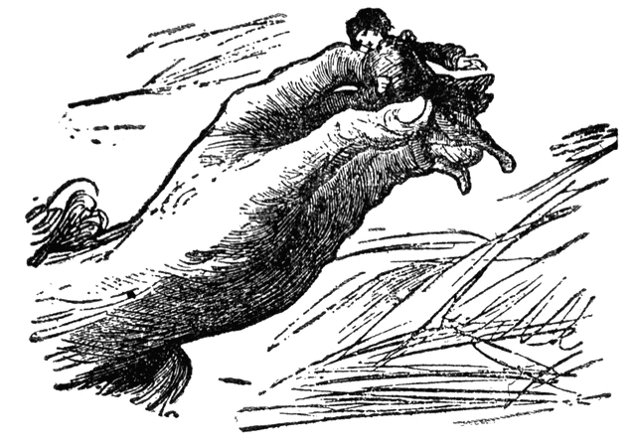

Some variations on these image – a giant crawling out of a crate / giant’s hand grasping the GG book?

