Appendix 6: Artist Consultation

  - Introduction

The Artists were responsible for responding to the creative briefs for Look Up, which were created by the CPT and co-commissioning partners; presenting ideas based on Research and Development (R&D); and designing, making, delivering and installing the ideas selected by the CPT.
There were two exceptions to the above – Blade and A Hall for Hull. In the case of Blade, the artist had previously pitched this idea to members of the CPT. A Hall for Hull was run as a competition, where an open call was made internationally by RIBA and selected by an external panel.
    - The Artists
In order to gain feedback from all artists involved in Look Up, consultation was undertaken both before and after delivery of their artworks.
Data was collected via online surveys, supplemented by in-depth telephone interviews, reflecting the research with the CPT. The templates for the surveys and discussion guide are provided in Appendices 7–9:
- Artist (Pre-Event) Survey: carried out as an online survey;
- Artist (Post-Event) Survey: carried out as an online survey; and
- Artist (Post-Event) Depth Interview Discussion Guide: carried out as a one-to-one telephone interview.
The focus of this research was to undertake two types of evaluation:
- Process Evaluation: motivations; creative development, including highlights, challenges and key learnings; exploration of Hull’s history and heritage; location of artworks; and project and production management.
- Outcomes Evaluation: artistic quality of the event; the presentation, interpretation and learning linked Hull’s history and heritage; audience outcomes; skills and knowledge development; collaboration and partnership development; and perception changes towards Hull.
It was not possible to consult with all the artists on each occasion - 16 responded to the pre-event survey, 16 to the post-event survey, and 10 participated in a post-event telephone depth interview.
  - Artists Profile
    - Demographic Profile
As a key funder of Hull 2017, Arts Council England (ACE) are not only interested in the demographic profile of the audiences for Look Up. They also wish to know the demographic profile of the artists involved in delivering the event, to inform the Creative Case for Diversity. As such, all 19 individual artists were asked to complete an Equal Opportunities Monitoring Form. 10 provided a response.
Artists who responded were from across the UK, though over half (six) were from London (north, east, south west, south east and west). Other places where artists resided were Gateshead, Manchester, Colchester and Honiton.
The responses show that there was a good mix of age groups, with three aged 30-34 years; two aged 35-39 years; two 45-49 years; two 50-54 years; and one 70-74 years. The majority of respondent artists were male (six).
Diversity was lacking in terms of disability and ethnicity. No one self-identified as disabled (as per the definition provided by the Equal Opportunities Act 2010), although one artist stated they had a sensory impairment. Almost all were ‘White: Welsh / English / Scottish / Northern Irish / British’, with one artist stating ‘White: Any other white background’.
Figure 1: Age of Core Project Team
Figure 2: Gender of Core Project Team
    - Profile Working on Similar Events
Experience was mixed when looking at artists’ previous work on projects where heritage or commemoration, and Hull (the city and/or its people) were a source of inspiration:
- 11 stated they had previously worked on projects where heritage or commemoration were a source of inspiration;
- Seven stated they had previously worked on projects where Hull (the city and/or its people) were a source of inspiration; and
- Six stated they had both worked on projects where heritage or commemoration were a source of inspiration and on projects where Hull (the city and/or its people) were a source of inspiration.
    - Personal Connections to Hull
Six of the 16 artists that responded to the Pre-Event Survey had previous or existing personal connections to Hull:
- Three had worked in Hull;
- Two had grandparents from the area;
- One had studied in Hull;
- One had lived in Hull; and
- One had friends living in the city.
Eight stated they had no personal connections to the city, and two skipped the question.
Figure 3: Artist Personal Connections to Hull
‘We worked on a project with Hull Time Based Arts in 1996.’
(Artist)

‘My grandfather has a farm near Hull and as a child I used to join him on trips to Hull to buy parts for his farm machinery. In 2011 I also worked with a terrazzo manufacturer in Hull called Toffolo & Son Ltd.’
(Artist)
‘I have exhibited in Hull before and gave a conference presentation in 2016.’
(Artist)
  - Process Evaluation
To inform the planning, development and delivery of future projects, a series of questions were asked linked to the process of Look Up. These concentrated primarily on:
- Motivations: What attracts the calibre of creative professionals required to deliver a project such as Look Up?
- Creative Development: How was the concept conceived and how did this change over time? What were the key highlights, challenges and learnings taken from this?
- Key Measures of Success: What were the key measures of success for artists and to what extent were these met?
- Exploration of Hull’s History and Heritage: How did artists find out about Hull’s history and heritage (i.e. the information and resources accessed)? How this was used to inform or within the artwork?
- Locations: How inspiring and suitable were the selected locations for the artworks?
- Project and Production Management: What were the strengths and weaknesses in relation to project and production management and supporting activities, and what could have been done differently?
    - What Was It About Look Up?
Ten of the 15 artists, who responded to the Pre-Event Survey, reported that knew Hull was UK City of Culture 2017 before being involved in the project (see Figure 4).
The artists who were aware of Hull having been awarded UK City of Culture status were asked what their thoughts were on this decision. Several spoke of the great opportunity it provided the city. Overall, all ten felt it was a good and exciting decision.
‘Hull is a somewhat geographically isolated city when looking at the map of the UK but still very much connected to Europe across the North Sea, so I thought it was a fantastic opportunity for Hull to become more centrally located on the map from a cultural perspective.’
(Artist)
‘Fantastic opportunity for the city to gain credit and acknowledgement for what it has.’
(Artist)
‘Clearly a valuable catalyst for the city, providing an impetus for some regeneration and pride and reflection about what makes Hull the place it is and can be. Can see all this is having an impact throughout the city, and beyond in terms of how people regard Hull.’
(Artist)
‘It was a humorous reaction. My reaction was quite personal because I have a personal relationship with Hull City of Culture. In some ways it is anti-culture reaction to Hull because what we think of as culture, because culture is so real, it is not ‘arty-farty’.’
(Artist)
Figure 4: Artists’ Awareness of Hull as UK City of Culture
When asked how much the city’s “status” influenced their decision to work on the project, the average score was 6.4 out of 10, where the scale was 0 (Not at all) to 10 (Completely). Six selected 8 to 10, which indicates it was a significant motivation; whilst for the majority it had an influence, but was not necessarily and main motivation (see Figure 5). As one artist stated:
‘If I was asked to do a commission, I would have done it, even if it had not been City of Culture.’
(Artist)
Figure 5: Hull UK City of Culture as a motivation
Artists were asked to share their other key motivations for working on the project, with the opportunity to provide up to three key motivations:
- The most frequently cited motivation, by seven artists, was the brief and specifically the freedom provided within it; the research element within the brief; and the brief being interesting and exciting.
- Five artists spoke of the influence of the co-commissioner and their reputation.
- Four artists spoke of the site or location for the project being inspirational and somewhere that they wished to respond to.
- Memories or personal connections to Hull; the material/media with which they were to work; contributing to Hull’s year; and a properly resourced project in terms of staff and budget were all mentioned by three artists.
- New audiences (local and national); curiosity; and the team running the project were also mentioned by more than on artist.
‘Artistic freedom (open brief).’
(Artist)
‘[The brief] hasn’t had so many constraints as other projects I’ve been involved in.’
(Artist)
‘[Freedom was] what we were being offered the minute you take away a financial constraint - you are given that material and you won’t have to pay for it - as an artist that is the most fantastic gift, in the form of freedom, really well thought through.’
(Artist)
‘In a way what they did was that they said, “We would just like you to do your thing”. That is how we translated it and I think it really benefitted the work.’
(Artist)
‘Creatively an exciting opportunity.’
(Artist)
‘I quite like working to briefs, thinking in different ways about my practice; and a brief to deal with that had a research element to it. I also enjoy working on site-specific projects ... These things are in tune with the way I work and are stretching me and it has a practical edge to it … It seemed to be a genuine commission that was authentic and trustworthy, so I could invest my energy in it.’
(Artist)
‘I admire [the co-commissioner] and the products they make, so was excited to work with them.’
(Artist)
‘Site specific nature of the project.’
(Artist)
‘I have fond memories of Hull from my childhood as my grandfather's farm in located near to Hull.’
(Artist)
‘Awareness of what materials can do [and] be.’
(Artist)
‘Genuinely want to help do our bit to place Hull on map.’
(Artist)
‘Well organised, properly funded.’
(Artist)
‘I had worked with the public arts consultants, Hazel and Andrew, before and knew that the quality of projects that they normally do is high. I was interested to work with them again.’
(Artist)
‘A lot of my work is based in galleries and I haven’t done as much work on public art or public art commissions in recent years. It was an excellent opportunity to work on a large scale. This type of public art commission releases some of the restrictions that there might be if it was a more permanent piece of work.’
(Artist)
‘The audience for the work is both local and national.’
(Artist)
There were also a couple of instances where the artists had approached Hull 2017 and the CPT with their idea, and based on this been invited to further develop their idea.

‘I was looking at Humber Street and the Tidal Barrier and thought it would be good to have a piece there using the technology that I was using for the benches [elsewhere in Hull]. So I then approached Hull 2017 with the idea and as it turned out Andrew Knight got the job … and I have worked with Andrew before on a couple of projects. So he knew my work and he was excited and so was Hull 2017 to pursue this idea.’
(Artist)
‘It came out of a conversation with Hazel and Andrew when we met up … We were discussing Hull generally … and they were thinking “what does it mean to make work in Hull?” This particular conversation was about what does it mean to be made in Hull … and the idea that this major multinational company was considering a massive strategic investment in the UK was there in the back of my head … and what was happening in the public realm and it was instant.’
(Artist)
    - Creative Process for Look Up
Artists were asked to explain how the concept for their artwork came about. Most artists spoke of it being a direct response to the site they visited; the result of an invitation by the commissioners; a direct response to the material they were working with; or a direct response to the city – either its past, present or future – which in some cases was based on direct research undertaken by the artist.
‘I was most inspired by our visit to the G.F Smith factory and the qualities of the Colorplan paper itself … I decided to use the paper as a raw material and celebrate the standardised formats and colours.’
(Artist)
‘The area where the work is to be shown is moving from one function to another, a whole new era for this part of the city. No one knows quite how it will settle … I [worked] with colour relationships and shapes that interact with each other. A work that needs fine tuning to succeed. Just like plans for a city.’
(Artist)
‘I visited the site and was intrigued by the gentrification that was present. I liked the idea of using paper to join in with the renovation.’
(Artist)
‘They invited me … I was wowed [they] invited me to work there … I was given feedback from [the commissioners] to [include certain elements] in my artwork.’
(Artist)
‘Through experimentation with the material paper, finding a formal language with it while thinking about the very specific quality of light in Hull and how that could be reflected in the work.’
(Artist)
‘The concept grew from the building, its form and the function of the amazing work that goes on there, particularly behind the scenes.’
(Artist)
‘It evolved through a process of research into the site both from an architectural perspective and looking at its current function … the symbolism of architecture and how that relates to natural processes.’
(Artist)
‘There was a brief given but it was very open. There were certain elements that needed to be ‘hit’ … but it was quite loose to say you can do something that reflects Hull and play around with the material … I wanted to really research the history of Hull and what was going on around the venue where it was happening, which is why I started to look at the fishing industry and things.’
(Artist)
At a deeper level, artists were also thinking of the narrative that they wished to present through the work, and how they could make this relevant to today’s audiences.
‘I was interested in thinking how I could pull on something quite positive I suppose that might have passed through Hull at that time - what people and the kind of skills that they would have carried with them … things like tools and knowledge … that people had … the migration of skills and crafts. But I was also interested in contemporary audiences and users … and actually how they would entwine themselves in the work and how they might become part of the work … to do artwork that I thought would be quite interactive rather than a static framework or a picture on a wall.’
(Artist)
Artists involved in the Look Up programme aimed to achieve several things with the work (see Figure 6). Particularly important were:
- To challenge people's interpretation of art;
- To encourage people to discover a different experience of the city; and
- To make people look at Hull’s buildings and public spaces in a different way.
‘I mean my goal with my work is to change perceptions about what the public realm can be … disrupting and questioning what public space can be and should be … There is a reason to be in town as well.’
(Artist)
Also of importance, to several artists were:
- To provide a response to the history of Hull;
- To present the ambitions and aspirations of the City now and in future;
- To explore Hull’s contribution to the world; and
- To tell the story of Hull's past and its people.
Figure 6: Approach by Artists

‘That Hull can host something that ambitious and … that things of value are quite often hidden and it is not the grass is greener on the other side question, but if you look for work-value outside of your place or placement then you are not in the position of autonomy.’
(Artist)
Other things that artists mentioned they would like to achieve with their artworks were:
- Celebrating the co-commissioner’s company and product;
- Addressing environmental issues; and
- Exploring the more intangible parts of a place.
‘To explore the interconnected forces that run through a place and our role within this.’
(Artist)
Collaborative Process
Artists were asked how they collaborated with the CPT during the creation and delivery of their work. Common answers linked to introducing artists to the city; facilitating partnerships with venues and locations; bouncing ideas off them; and assistance and direction with research.
‘They showed me around the city.’
(Artist)
‘[The curators] showed me the site … and then I spent a bit of time going round the city immediately after the site visit. We visited the Maritime Museum and the idea came about after that and trying to do a little bit of research on the history of the city at the same time.’
(Artist)
‘What I think was terrific about Sam was that as soon as Hazel and Andrew had gone through it and he had committed to it he couldn’t be more committed. It was almost like he had done all his own evaluations, his risk assessment, his own worries and he went completely out, committed to pull it off … you felt as though your primary people are protecting you from the world and that is really lovely and have all three for me.’
(Artist)
‘There wasn’t a great deal of research available, but they did direct me towards a PhD written on the subject.’
(Artist)
‘In terms of research, they helped me with an aspect of my work which involved a trip to New York … [to access] a particular basket that I wanted and they gave me a lead on that.’
(Artist)
‘To do a project of that scale together [with the curators] legitimised the last twenty years of conversations … I was so glad it was with them.’
(Artist)
In some instances, the CPT had also provided critical feedback on initial proposals made by the artists, which had led to changes in their approach.
‘We had worked up some visuals and some ideas and the idea of the building as a biological process. The feedback was very positive, but that they wanted [more of one aspect of the piece] and we took this on board.’
(Artist)
‘They questioned the ambition, because it was very large artwork and whether the sculpture would stand-up … So I gave further details of the analytics of the sculpture to demonstrate that it would stand up.’
(Artist)
‘So the challenge was to legitimise my suggestions … There was a lot of challenge and it makes a lot of sense because when it goes public or goes to the next stage everyone in the team is totally exposed … If there isn’t a really solid aesthetic and conceptual argument that underpins the closing down of a city centre for a bit then it wouldn’t happen.’
(Artist)
Budget constraints had also led to changes on other artworks. This led to slight changes in approach, as well as pushing artists to innovative solutions. One artist spoke of how his budget came in too high originally. One of the curators made suggestions around scaling back the work to reduce the cost. Keen not to compromise the idea too much, the artist found a way to ensure his vision could be realised sufficiently. Savings were also found in making use of existing street furniture for other parts of the project.
In addition, artists were also asked how they collaborated with other partners during the creation and delivery of their work. Answers included:
- Technical and operations support;
- Project management support;
- Administrative support;
- Logistical support; and
- Production support.
‘The electricians were great, getting work done really well. My partner, a company … which I work with at home helped with phone calls, organising –part of project management.’
(Artist)
‘I worked with [a supplier] to translate my digital images [on to vinyl] … I showed them my work and designs and logistically made sure the space was ok and we made sure the space was ok and the [venue] manager … It was a three way process really.’
(Artist)
‘We established quite a collaborative working relationship with QED Productions, an audio-visual production company who did all of the technical set-up … We sort of agreed ‘a path’ where we could allocate information and we talked through different processes and they supported us in processes … they were able to give us advice in what file formats to do [things] and we were able to test with them which was really good.’
(Artist)
‘We did a behind the scene tour of the [venue], which was absolutely great. The enthusiasm of the staff was quite infectious as well … we visited the [venue] on a number of occasions. I really think that those visits and that research really fed into the work and we filmed at the [venue] which we directly used in the [artwork].’
(Artist)
‘We developed a relationship with a fabricator company and structural engineer to understand the limitations of the structure of the piece.’
(Artist)
‘The people in C4Di … they were really helpful in facilitating that set-up. I think it would have been quite difficult trying to realise the project within that budget, so their support was really appreciated.’
(Artist)
‘I used a company based in London that I have worked with before on a couple of projects … Ideally I normally work with companies that are local to where I am putting a piece of work, but in this case they had the expertise and I had worked with them before, so I decided it was a safer option … They sub-contracted some of the software development to another company in Manchester and another company I had worked with before in Weymouth.’
(Artist)
‘‘[Employing people in the manufacture of the work] was a really positive experience. Installing it, with every stage of the collaboration I always had to be making the decisions. I had to evolve the clarity of thought and in the end it was very intense.’
(Artist)
Working collaboratively was a challenge for some artists, with one speaking of how they feel if they do not do everything themselves then they cannot take full ownership of the project. However, the artist realised it was a necessity, given timescales. Equally, another artist also had to change the approach to their artwork because of safety considerations at the venue.
‘It has helped me become simpler in my collaborations; it has given me confidence to put a bit more of the art into the general discussion about the art; and confidence about doing my artwork.’
(Artist)
‘My original proposal was that [the artwork] would be made out of thousands of pieces of torn up shopping bags related directly to the shopping centre and commercial side of it, but I had to change it because it was not possible to fireproof these pieces of shopping bag and it had to be fireproof, so I had to change it to paper.’
(Artist)
Highlights of the Project
Artists were asked what the most exciting aspects had been in regard t working on Look Up. Most answers related to the artwork they had made, in terms of the making process; the media they had used within the making; the voyage of discovery some had gone on, responding to new challenges that arose in creating work; and the inspiration created by the site.
‘Transforming a two-dimensional sheet of paper into a three-dimensional piece … whilst maintaining the original format of the material.’
(Artist)
‘Making a piece of work that changes constantly and will only come into existence when it is installed.’
(Artist)
‘Responding and working with such an interesting site.’
(Artist)
"The film-making.’
(Artist)
‘I suppose it was all those elements which were so challenging because it was such an opportunity for me to think about my career … To have that sort of core of the subject … rather than just what I tend to do as an artist, so the work isn’t really about me and it is not a personal piece … It is very much derived from the research and exploring other people … It did address issues in my own practice which were quite personal.’
(Artist)
‘[A] new opportunity to make a work that addresses my concerns in collaboration with [the co-commissioner].’
‘Being given the opportunity to work with a material I haven't worked with before in a city that is new to me.’
(Artist)
The R&D period was key for some artists, and delivered in a way that differed from their previous experience on other projects.
‘What I really appreciated with this commission was quite a long R&D period. I think it was about three to four months. It was good that there was emphasis on that aspect and that had been really prioritised as a critical and important element of the commission … So it wasn’t about fast results. It gave me an opportunity to probe into the subject and in an honest way. Yeah to be paid for this period of time, rather than be ‘lumped together’ was quite unique in my experience.’
(Artist)
One artist also referenced some of the supporting activity that made up their project, which was more participatory in nature.
‘The developing of workshops.’
(Artist)
Challenges of the Project
Conversely, the challenges of working on Look Up were also explored with the artists. The main challenge, mentioned by a number of artists, linked to the timescales to which they had to work.
‘Quite short timescale for development and production of work.’
(Artist)
‘It was quite an intense period of working time because we had lost time at the beginning, but it did mean that the work was much better because we were able to feel that we were doing.’
(Artist)
‘The aesthetic of the support for the artwork … was disappointing. My only regret in the whole process was not having another four weeks to finesse the whole process.’
(Artist)
‘More time would allow more testing in advance of opening a work to the public.’
(Artist)
Locating the correct space into which the artwork would be installed was also a challenge for some artists – predominantly those working on Paper City, where the area was know, but the exact building location was not.
‘It took a while to find the right space for the work.’
(Artist)
‘It wasn't possible to know in advance of making the work where it was going to be situated.’
(Artist)
A few artists also referenced challenges linked to the making of the work, whether this be the artwork itself or supporting activities surrounding the project.
‘The developing of workshops.’
(Artist)
‘Translating the concept to a functioning design that could be installed.’
(Artist)
Thinking outside of the box when working with such a familiar material.
(Artist)
Other challenges, which seemed to be individual to single projects, were delays in payment and the general level of expectation that there was, with the project being part of Hull UK City of Culture 2017.
‘Budget took a long time to come through which meant I could not start fabricating the work till later than I had planned.’
(Artist)
‘That sense of anticipation, with City of Culture, there is also a lot of expectation with that, with people coming along, and we were aware of that and you have to ‘park that’ a little.’
(Artist)
Key Learnings
When asked what the key learnings were from their experience working on Look Up, which they would take into future projects, there was a variety of responses from artists.
A common theme that came up amongst artists was the unique opportunity that City of Culture seemed to offer artists. The approach by the commissioning team had provided a freedom and way to reach audiences not previously experienced.
‘City of Culture is a rare opportunity … It is quite unusual that you don’t have to worry about what is happening … because there is a really cool crew just doing it. It allowed me to think about the art. That was a first for me.’
(Artist)
‘It gave us a lot of freedom to express what we wanted with a lack of constraints.’
(Artist)
‘The thing I have always found frustrating is the barrier between art and ordinary people … the way art presents itself … it says that it is exclusive from stuff written on the wall … My feeling is that Hull 2017 has been an open invitation for people … they allowed people another way in and a way that was comfortable for them … people were taking the risk that they might not be interested and that I was there was incidental.’
(Artist)
‘It is only events like City of Culture that give artists like me an opportunity to be listened to. I am too small to lever the kinds of things that they have managed to lever –for work like that … you don’t get to this stuff unless people are listening to ‘un-known’ artists.’
(Artist)
‘Value of these sorts of opportunities beyond just chance to make a work, as what an artist can do to feed into a whole programme of cultural energy and city lift.’
(Artist)
A couple of artists spoke of the need to ensure protection of the artwork from the surroundings, in terms of regular activity going on within the space interfering with the impact and presence of the art.
‘The only aspect of it, which kind of caused a problem … was the site was so busy visually, there was so much advertising … which is basically part of the nature of the site. It meant that the installation was competing for the space … In photographs into didn’t come across as well as it maybe could because of the two-dimensionality of it and as a photograph as well.’
(Artist)
‘I saw that they had planned festoon lights for Humber Street and I said “ok that is fine, but they can’t be switched on whilst my work is in place because you won’t able to see it anymore” … I am getting Instagram images coming up and the lights are still being switched on and you can’t see the work anymore.’
(Artist)
In relation to using the arts as a way to present heritage, versus more traditional approaches, artists felt that it offered a different way in and an alternative way for people to learn.
‘It highlights the cultural value of heritage and aims to bring expressive interpretation that is relevant to contemporary times. As an artist it is important to consider the audience and who the artist is, and through the cultural and artistic practice they are able to meditate on a work in a different way from which an audience might absorb a paper or a book.’
(Artist)
Artists also shared how it would have been good to get feedback on how audiences had been reacting to the artworks, where they were not able to be in Hull themselves.
‘You install it and you go. Yes people go to the opening and that’s the only real feedback. I went up to Hull to do a repair and up to that point I had no idea if it had worked or not. I could have done more feedback really – there wasn’t a lot on social media.’
(Artist)
‘There weren’t any post-installation events, so I didn’t do any artist talk, so there wasn’t that really that opportunity for interaction [with audiences].’
(Artist)
‘That engagement with the audience is important.’
(Artist)
The systems and procedures of Hull 2017 and the pressures on them managing such a large programme, often means that some opportunities are missed on an individual project level.
‘Trying to get [Hull 2017] to understand the social media aspect has been quite difficult … A piece that I did … which was clearly marked with a hash tag generated thousands and thousands of instagrams where this was sort of in the twenties and thirties … Another thing is that there is masses of outreach scope for work like this that working with schools, writers and poets looking at the text coming out of that and public speaking … It’s a capacity issue basically.’
(Artist)
Artists had also learnt to have confidence in themselves and their work through working on Look Up, as well as discovering new ways of working that they enjoyed and would look for further opportunities to do again.
‘There is more to a humble sheet of paper than first meets the eye.’
(Artist)
‘I can do public art.’
(Artist)
‘I will take a little bit of confidence on working on a project of this scale.’
(Artist)
‘Have faith in your vision, allow it to take you on a journey and hold on tight.’
(Artist)
‘That working within a brief with a given material is a challenge I enjoyed.’
(Artist)
‘So there were a few things I was unhappy with in terms of the finishing, but it didn’t matter and that is something I have learned, sometimes it just doesn’t matter.’
(Artist)
‘How to work with an unusual building.’
(Artist)
    - Key Measures of Success
Audience response was one of the most frequently mentioned measures of success amongst artists, both in terms of the number of people it attracted and what they got from the experiencing of interacting with the artwork.
‘I went to the launch of the Freedom Festival. A young man looked at me strangely, in a way I haven’t been looked at before and said “are you are the artist who did [x]” ? and said, “Thank you”. Priceless!’
(Artist)
‘I suppose audience response and audience numbers … The thing that left me feeing happy about it was hearing people independently commenting on it in intelligent ways and saying “yeah yeah” and I think getting good responses really.’
(Artist)
‘Audience response, because you are not sure if people are going to find it … This was part of the charm and also the content of the work had to have some depth to … it had an intellectual element and not just a wow factor. I’m one of those old fashioned people, who doesn’t just give people what they want, but what they need and what is good for them. So I don’t care if my work was a bit educational … I deliberately made this work with the quality of the experience in mind and it being revelatory.’
(Artist)
‘The other aspect is the audience and making that work for the people of Hull … That is very much what I am thinking of when I make the work.’
(Artist)
‘Audience reaction is important. Imagine if it hadn’t gone down … it definitely would have affected how we felt about it.’
(Artist)
‘In terms of footfall it was amazing and it was well signposted.’
(Artist)
‘People were really generous and I don’t think it is just in relation to Hull … there were sceptical voices, I was expecting, because the question was ‘How is this art’? and what I picked up was people were suspending that question, which was very generous of them.’
(Artist)
‘The day it opened a little party school kids came in and were very excited about it and one of things that surprised me about the work was that it was a mass of stars. It seems strange, but I hadn’t observed that it was. It was only when the work was installed … That was quite big thing for these children and I was very impressed that they spotted it straight away and talked about … that sense of the audiences gave me something back … the audiences were astonishing and I thought it was wonderful.’
(Artist)
‘I have done some big public arts projects and I can’t say that work hasn’t had large audiences, but in terms of gallery work I have never had such an enormous audience for my work.’
(Artist)
Artists being happy with, and learning new things from the artwork they produce were also important as measures of success. This was particularly in relation to the quality of the final piece.
‘I guess it is a good artwork and I don’t know how you evaluate that particularly.’
(Artist)
‘For me it was good to have done it and the technical side that I have developed as a result of will definitely go into another project.’
(Artist)
Others spoke of how a project successfully raises the profile of the artist(s) involved. It was believed that this could open up new opportunities.
‘It builds up my profile and it might instigate new and exciting projects, from a selfish point of view.’
(Artist)
‘Press coverage was great and I think that has had a positive response on me and Paper City as a whole.’
(Artist)
‘The engagement of media and how much publicity our artworks got on local and regional news … was good overall but was lacking in respect to individual publicity for artists.’
(Artist)
    - Exploration of Hull’s History and Heritage
Within the concept development for Look Up, the presentation and interpretation of the city’s history and heritage was a key element. 11 of the 13 artists responding to the question, felt their work explored the history and heritage of Hull.
Figure 7: Artworks Exploring Heritage
When asked to explain how their work would explore the history and heritage of Hull artists spoke of the city’s industrial heritage; maritime and fishing history; the geological and ecological past of the city; connections to transmigration and human rights; acknowledgement of a site’s previous uses; and connecting directly with the city’s built heritage.
‘My work explores the industrial history of Hull, but on a broader scale explores the developments in industrial raw materials and the evolution of standardisation.’
(Artist)
‘An exploration in to transmigration and the notion that craft skills and belongings also cross routes of passage, as well as people.’
(Artist)
‘Geological history - deep time … in the last ice age the ice sheet terminated in this area … Alluding to Hull's maritime connections going back to whaling.’
(Artist)
‘It was the site of Hull citadel, so there is a sense of a strong structure having a place in this spectacular part of the city.’
(Artist)
‘I wanted to make a piece that interacts with the smoke house, working with all the existing hanging bars to recreate the smoking of food.’
(Artist)
‘The work focuses the attention onto an architectural type that is the focus of regeneration.’
(Artist)
    - Locations of Artwork
As explained within the CPT interviews, the locations were more often than not the starting point for the artwork – with artists being asked to respond to the chosen location. In the case of Paper City the various artists were shown the whole site and asked to put forward their preferred location within this, whilst The Train Track and the Basket was a response to a theme and the artists empowered to select a location.
‘The location was chosen in response to the artwork. We went on a site visit to Hull as a group and we were shown sites as a group and the possibility of different spaces for the artwork and we were asked to propose which site we wanted for our artwork. We were asked for the concept design to submit images and a supporting statement to say why the artwork we were proposing should go in that space.’
(Artist)
‘I just think [the artwork] would not have existed if I hadn’t seen that as a location. It was not like “I have a piece of work I would like to bring it to Hull oh where should I put it”, I saw that view point and that was actually the driver for the whole piece of work. It was like a hallelujah moment.’
(Artist)

‘I proposed that the art work be situated in the place it was because of the size and dimensions and it had open windows on three sides of the artwork … It was also situated on the harbour next to [The Deep] and I thought there a lot similarities to the aquatic centre and aquatic life in terms of its structural forms.’
(Artist)
Nearly all artists appeared to be fully or mostly satisfied with the location chosen for them to respond to, with more than half stating it was Very Good. Only one artist stated it was neither poor nor good (see Figure 8).
Figure 8: Rating of Location for Artwork
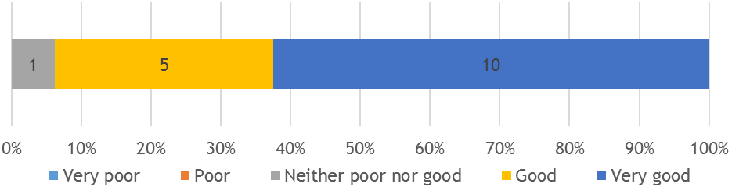
In providing reasons for their positivity towards the locations, artists had a variety of responses. Some related to the physical nature of the space; others the context provided by the space; and on the accessibility it had.
‘The space I ended up being shown in was absolutely brilliant for all kinds of slightly perverse reasons. I made work that was flexible for different spaces … What was interesting with the shop I was allocated it was finished up to a point but for some reason there was a slope on the floor and what that created was literally a perspective within the work, because I worked on the floor, and it gave you a greater sense of space … And at the back of the space, there was a raised platform … this other ‘present’ in people being able to look down on the work.’
(Artist)
‘It was a pertinent place to make a piece of work. The work was very site specific … [it placed the theme] in a context where it started from and where people were still journeying themselves, so it was important conceptually and historically … The idea of glass doorways of spaces suggesting beginnings and entrances … It has offered an interesting doorway for people trying to get to their destination.’
(Artist)
‘But in terms of the site that was selected for idea for the project; the installation came from the site … so it was a suitable site if you see what I mean. I suppose visually there were challenges in terms of what the space is used for but … in terms of the concept behind it, it worked really well.’
(Artist)

‘I think it was a great venue for what I was doing for the piece, the retractive aspect of the studio with the open shutters gave great access to the work … The only one weakness was that there were a couple of leaks and there was torrential rain, but it didn’t damage anything.’
(Artist)
    - Project and Production Management
Overall, feedback on the project and production management of Look Up was positive.
Project Management
Artists were asked to rate the project management of Look Up. An average rating of 4.5 out of 5 stars (n=12) was awarded.
Top-level aspects of the project management of Look Up were assessed at pre-event delivery stage, as were some of the more detailed aspects (see Figure 9).
At the top-level, all aspects received an average score of approximately 4.5 out of 5 (good to excellent).
Figure 9: Project Management – Top Level Feedback
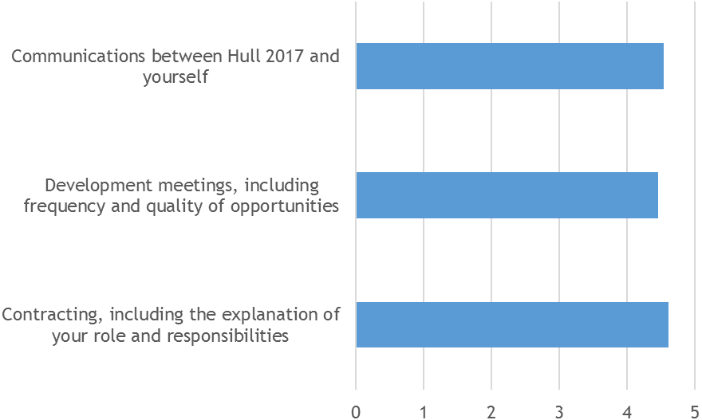
In providing further details for their answers, a couple of artists mentioned that communications with the curators were well balanced:

‘I met and worked with Hazel Colquhoun and was shown Hull by Andrew Knight and had contact when relevant. I contacted them when I needed them and I didn’t feel they were pestering me, which worked well for me … I felt I had that freedom and space. I didn’t want that interaction to be honest, and when I did have it was positive and I went away feeling positive and I could just get back on with the work.’
(Artist)
‘’[The CPT] were really involved when they needed to be and not involved when they didn’t need to be involved. They don’t try and influence stuff. I have certainly been in situations before where a project manager, curators push it in a certain way that wasn’t in line with how I wanted it to be presented … They are really good at not doing that which really contributes to the quality of their projects.’
(Artist)
The more detailed exploration of the Project Management also showed that the CPT had handled this well (see Figure 10). The explanation of the Look Up project (concept, aims and objectives) by Hull 2017; Hull 2017’s facilitation of communication between artists and partners; and Hull 2017’s enabling of artists to contact other key people who could inform their work was praised.
Aspects receiving slightly lower levels of agreement, though still good overall, were the extent to which artists felt the support Hull 2017 gave them had enabled them to deliver their work to a high standard; and that Hull 2017 had provided sufficient time to produce their artwork.
Feedback on how the Project Management of Look Up could have been improved was through having:
- Opportunities for different artists across the programme to meet and share their experience, disseminating information and learning from one another.
‘There haven’t been many opportunities to sort of disseminate the project or discuss it with people and other artists.’
(Artist)
‘After that post-production there might have been something in place to have conversations with other artists.’
(Artist)
- More time, or a more defined delivery schedule, to ensure that planning could have been stronger.
‘A more established and committed time schedule for the final stages of the project would have helped with planning and logistics.’
(Artist)
‘We were on a bit of a tight deadline - this happens sometimes and we are used to it.’
(Artist)
‘I would have liked slightly longer to work on the project, as I had other work commitments and I wanted to give the project more time.’
(Artist)
‘To have an update / reminder of the opening events and any schedule changes a month before install date.’
(Artist)
- Quicker processes in terms of finalising the location for the artwork, and releasing payments, as this created bottlenecks for some artists.
‘It would have been good to know the space for the work earlier as this impacted on the scale of production.’
(Artist)
‘The contract process took a long time which had an impact on the timelines, so budget took too long to be released and this impacted on fabrication time.’
(Artist)
‘The location was confirmed quite late on and could have been sorted earlier.’
(Artist)
- Higher levels of media coverage for some of the projects.
‘Perhaps publicity in relationship with the City of Culture and national press could be more developed.’
(Artist)

Figure 10: Project Management – The Detail
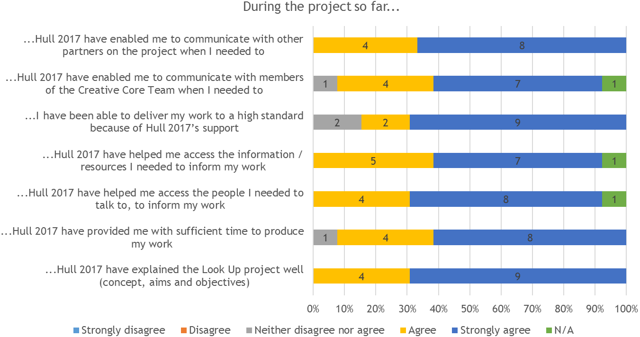

Production Management
After the event was delivered, artists were asked to rate the Production of their project, where ‘Production’ referred to the live delivery of the project. An average rating of 4.6 out of 5 stars (n=16) was awarded.
All aspects of the production of the project, with the exception of lighting, were given at least 4 .5 out of 5. The sound quality of artworks was the highest scoring (though only applicable to three artists), whilst the installation of the artworks; support and professionalism of the technical and operations crew; and the standard of the interpretation were also praised (see Figure 11).
The lighting of artworks was of relevance to nine artists and just under half selected neither disagree nor agree or disagree that it was excellent.
In providing reasons for their answers, artists outlined a range of ways that the Hull 2017 team and additional partners had provided on the ground support, getting much of the essentials in place without the need to involve the artists. Hull 2017 Volunteers were singled out for their contribution.
‘Communication between the [venue manager] and Hazel Colquhoun was excellent and enabled permissions to be sought and acquired for the project installation. Planning and logistics enabled the work to be completed on time, including the pre-installation.’
(Artist)
‘The support on the ground at Hull during the event was brilliant, particularly the volunteers, but also the less conspicuous people who organised things such as the power … and partners and [curators]. We had a tight deadline but were able to make and deliver an artwork that was uncompromised in scale, quality and scope.’
(Artist)
"The installation of the work was my responsibility, but I was given support during the installation and during the exhibition which was invaluable.’
(Artist)
‘Both the quality of the production of my work itself and the supporting paper plinths provided by [the co-commissioner] was made to very high standard and the installation team were very organised, knowledgeable and professional. They couldn’t have been more helpful.’
(Artist)
Artists also complemented staff at the venue where their artwork was located, or external suppliers that they had contracted as part of their project.
‘The [venue] enabled a high degree of technical expertise especially in the design and installation of the sign.’
(Artist)
Figure 11: Production of Look Up – The Detail
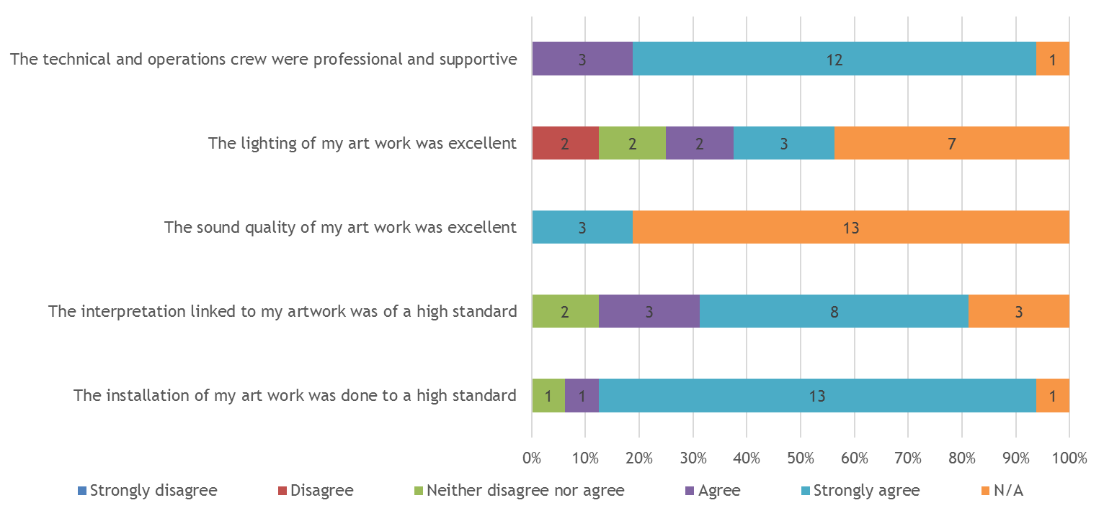
‘During the installation of the work … we required assistance from the electricians [at the venue]. More than once we were amazed their efficiency and speed.’
(Artist)
‘We worked with [an external supplier] to deliver, install and run the projection and sound. They were absolutely brilliant at their job and the [artwork] looked spectacular and immersive, the sound clear and loud enough to feel, the equipment set up as discretely as was possible and the attention to detail second to none.’
(Artist)
In regards to the lighting of pieces and where this had not quite worked, often linked to the size and complexity of the space and not having thought sufficiently of this aspect in the development stage.
‘The only thing about the installation that was not totally successful is that it was very hard to light. The rigging company who assisted with the install were also to take care of the lighting and in the end they underestimated the complexity of what was needed. In the end a solution was found but it was not as good as it could have been.’
(Artist)
  - Expectations & Outcomes
During the pre-event consultation process, the CPT were asked about their expectations for the event regarding a range of outcomes and impacts, whilst post-event they were asked about what they believed had been delivered in terms of outcomes and impacts.
The key areas of focus were:
- Artistic Quality: To what extent artists were satisfied with the quality of the work they produced.
- Hull’s Heritage and History: How did artists interpret and present Hull’s history and heritage in their artwork? How successful do they feel this was done?
- Audiences: What were artists’ perceptions of the impact their artwork had on audiences?
- Skills and knowledge development: What new and existing skills, knowledge and learning had they gained in regard to professional skills and the heritage and history of Hull, as a result of working on Look Up?
- Collaboration and partnerships: What new and existing collaborations and partnerships were built or developed working on Look Up?
- Perceptions of Hull: How did artists’ perceptions of Hull amongst artists change, as a result of working on Look Up.
    - Artistic Quality
Arts Council England (ACE) has developed several metrics to measure the artistic quality of an event. These were not asked of artists, however, within their depth interviews questions were asked that linked to some of the metrics.
Concept
Some artists spoke of how they felt the concept and ideas behind their work had been well informed by research.
‘I had a lot of time with the project … pushing it in my studio, going for it as much as I could possibly could, using research actively in the work. So I think artistically really pushing the ideas and the composition and trying to communicate craft processes and avoid too much sentimentality, whilst being compassionate about what I had been reading.’
(Artist)
‘I was really happy with the concept and how it related to the site. It was challenging in some ways but it didn’t kind of deter people from appreciating it and the scale was impressive’
(Artist)
Risk
The size of some artworks and the nature some artworks had led to challenges in terms of knowing how it would look ahead of being installed.
‘It was difficult to anticipate beforehand, because of the scale of it, it was very hard to see all of it all at once. … I am not sure how I would do that differently in the future … It was really frustrating it wasn’t possible to see it all at once.’
(Artist)
‘Regardless of the amount of time we had, we would not have seen the final output until we set it up on the night.’
(Artist)
Working with new techniques and approaches had been extremely challenging for some artists. This highlighted the extent to which a number were challenging themselves with the work being produced for Look Up, and how this development of their artistic practice would be used in future.
‘We were using very different technology from that we have used in the past. It was a big project, not just in terms of the size of the building, but we hadn’t worked with 8K resolution, you know really massive file size and that was quite kind of a challenge for us because we had to use computers on a high level that could render these files.’
(Artist)
‘I was working hard to develop the photography and the drawing to develop the artwork, and hope it was presented in the artwork itself.’
(Artist)
‘It was using technology that hadn’t been used before - that voice to text recognition has only really become usable in the last couple of years … I hadn’t used it before because you had to learn how to speak to the computer, rather the other way round. So that has been really exciting working on that. It has been the first piece that I have developed live processing, where the main brain of it is online.’
(Artist)
‘I think that the artwork was ambitious with the size and technical aspects of the work. It was ambitious and challenging me in terms technical aspects.’
(Artist)
‘I mean it is very nice to do a piece like this a nice interactive work. It is very ambitious … It is good in that it is pushing forward in a certain area of my practice, which has been quite satisfying.’
(Artist)
‘I took a mobile studio along with me and during the exhibition people could participate with me and make things. This is what changed my outlook on things because initially I was going to go in a different direction and then I ended up making it more accessible for more people, and in the end over two thousand people interacted … It has had an effect what I’m going to do over the next coming years really in terms of the a mobile studio and interactive pieces.’
(Artist)
There was also an element of risk in terms of the expectation that had built up around Hull 2017 and its artistic programme.
‘Expectation is an interesting one, because bound up in the scale of the site itself you really don’t want it to be a ‘damp-squib’ … you don’t want to produce a piece of work in a site like that whimpers. It forced us to step up quite considerably, which we were ‘up for’- but there is always a risk … But it also makes for interesting results if you pull it off.’
(Artist)
‘Ok the challenge was to have faith in my idea. The challenge was to accept that most of my work is quiet. Most people don’t know it is artwork. The paradox of working outside of galleries is that you become anonymous and there is no way I would be anonymous … But [with] this piece there was nowhere to hide.’
(Artist)

Presentation
In terms of how well the artworks were produced and presented, artists overall were happy. However, there was a sense that there was always room for improvement, but the nature of the project had meant this was not always possible.
‘In terms of the presentation onsite, it was the first time that I worked with vinyl. I had some samples and they were developed pretty well by [the supplier]. It is something that could be developed and pushed further. I really wanted to work with a company in Hull, but the disadvantage was a lot of communication had to be by e-mail or telephone … It is always important to work closely in that production phase.’
(Artist)
‘Strengths of what we did we were able to tell the story of the work and the processes involved. The weaknesses were not understanding how the structure would create wrinkles, which could have been “ironed out”.’
(Artist)
    - Presentation and Interpretation of History and Heritage
Amongst the artists exploring history and heritage with their artworks, there were high hopes that Look Up would have an impact on proving the value of heritage inspired arts projects, both from the viewpoint of the cultural sector and audiences. Ten artists responded to statements linked to this (see Figure 12). An average score of 8.6 to 9.1 out of 10 for level of agreement (where 10 was Strongly Agree) was awarded to all statements:
- Look will demonstrate new ways of interpreting the history and heritage of a city through the arts (8.6 out of 10);
- Look will present audiences with new ways of engaging with the history and heritage of a city through the arts (9.1 out of 10);
- Look Up will contribute to the development of artistic practice in celebrating a city's history and heritage (9.1 out of 10).
Post-event, the fourteen artists responding to the statements felt that Look Up had successfully delivered against these statements (see Figure 12), although to a slightly lesser extent than was envisioned pre-event:
- My contribution to Look Up (i.e. my artwork) presented Hull's history and heritage in a way that enhanced audiences' understanding of the city's past (7.5 out of 10);
- My contribution to Look Up (i.e. my artwork) presented Hull's history and heritage in a way that improved audiences' experience of engaging with the city's past (7.6 out of 10);
- My contribution to Look Up (i.e. my artwork) presented Hull's history and heritage in a way that contributed to the development of artistic practice in celebrating the city's past (8.4 out of 10).
Figure 12: Look Up – Interpretation and Presentation of History and Heritage (Pre-Event)
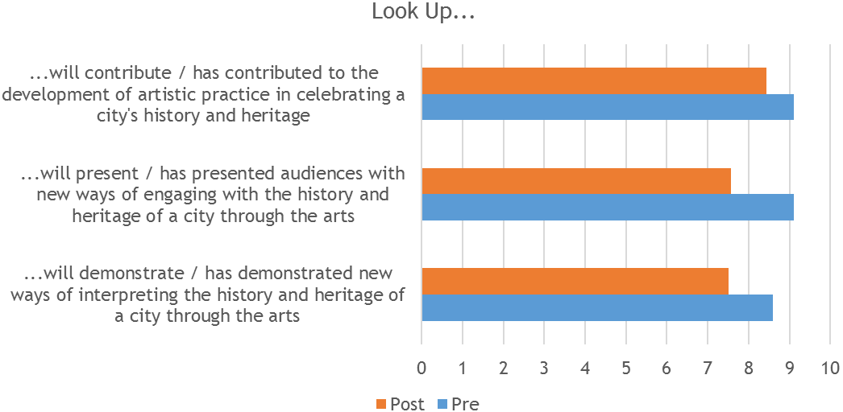

When asked what about Hull’s history and heritage they wished to communicate to audiences through their artwork, artists spoke of connecting people to the various major industries from Hull’s past; celebrating the built heritage within the city; highlighting the city’s connection to the sea; as well as some lesser known histories.
‘I'd like the audience to remember Hull's importance as a trading post of stock materials (such as a ream of paper), and connection with the rest of the world.’
(Artist)
‘Connect the audience to their maritime history and responsibilities, engage people in how important it is to try and look after our oceans and seas now and in the future.’
(Artist)
‘That Hull is a very particular place, with its long associations with the sea.’
(Artist)
‘The history of the art school.’
(Artist)
‘I hope the viewers will think about the buildings that surround them and how the buildings change with their uses and demands.’
(Artist)
‘The transmigration phenomena of 1840-1914 (people from Northern European Countries, Sweden, Russia Switzerland) … it was a commercial business done on a large scale … it was more economical for people to travel through Hull rather than travel.’
(Artist)
When asked to give a star rating out of 5 for the project’s success in presenting Hull’s history and heritage to audiences, artists gave an average score of 4.4 out of 5 (n=14).
    - Audience Outcomes
Artists were keen to provide audiences with a new perspective of Hull, particularly in terms of using the artwork to:
- Raise awareness of different parts of the city and its industries;
- Think anew about the sites where artworks were located and challenge ideas about these sites in terms of other functions they could have, as well as what is possible within the public realm;
- Use the site and artworks to provide audiences with an insight into the heritage of the location, as well as how it connects to its surroundings.

‘Personally I am always heavily inspired by local industries and raw materials … I hope it might inspire people to look at the other industries, skills and materials Hull has to offer.’
(Artist)
‘I think this project forms a part of the whole, making people aware of different parts of the city, different manufacturing companies and most of all looking to the future with optimism.’
(Artist)
‘The work is an invitation to enter a building and think about the [it] in a new way.’
(Artist)
‘The location of the exhibition in the Fruit Market gave an understanding of what the spaces could achieve with the input of creative industries.’
(Artist)
‘To bring interest to the smoke house and how it can be used for a different function.’
(Artist)
‘I hope it will increase people expectations about what can happen culturally in the public realm.’
(Artist)
‘Activate Hull's maritime culture and heritage.’
(Artist)
‘To think of this iconic building at the heart of the city's architectural identity as connected to the force of nature. That this place is greater than the sum of its parts.’
(Artist)
After delivering their artworks, there was a general sense from artists that many of them had achieved what they set out to do in regard to the three audience outcomes listed above.
‘If nothing else, [the project] revealed an undervalued and underexposed part of Hull’s history.’
(Artist)
‘I think people were totally surprised that there was this international paper company on their doorstep … that was a big surprise for locals more than anyone … It opened up discussion and awareness for them.’
(Artist)
‘I think it opened up peoples’ eyes to paper and the material as a whole, and to look at things differently in the city as a whole.’
(Artist)

‘I do think there was a good response to it when we were installing there was a lot of attention … When I was on site there were positive responses from people and the staff … I also got a few messages on my Facebook from individuals who weren’t interested in art but they really loved it.’
(Artist)
In addition to the above outcomes, a couple of artists also just spoke of the way that the audiences had engaged directly with the artwork at an emotional level.
‘It’s a bit of a myth - we have found this with projections in the past –where there is an assumption that you have to tell people everything. If you chat to people for a while you realise that they know it already, they can sense it and feel it … Something like this in the public realm, it’s not trying to advertise something, it’s an installation of some sort and it gave off a feeling of something … One person was saying, I’m paraphrasing “I like the way you have got this wildness and this controlled architectural thing going on”, and they had almost summed up what we wanted it to be about but in their own words.’
(Artist)
‘Volunteers who were there were saying that the feedback was really positive and one thing they noticed was that people were really silent when they were watching it and almost hypnotised by it and would stay not just for one show but another one-bearing in mind it was very cold.’
(Artist)
    - Skills and Knowledge
Professional Skills and Knowledge
All artists said they had increased existing skills/knowledge through working on their Look Up project; whilst most (14 of 16) said they had also gained new skills and knowledge (see Figure 13). One artist was not sure they had gained new skills or knowledge, whilst the other remaining artists said they had not gained new skills or knowledge.
Artists were most likely to have gained or developed creative/artistic skills; production and/or technical skills; project development skills; and project management skills. One other skill mentioned was in relation to working with specific materials.
In explaining their answers to the above question, artists cited the following rationale:
- Working with new media/materials;
- Introducing new subjects to the artists’ artistic practice;
- Working within public spaces vs. gallery setting;
- Higher level of involvement in project management than previously;
- The focus on providing audiences with new experiences of Hull; and
- Contracting external suppliers to their project, which they managed.
Figure 13: Skills and Knowledge Gained and / or Developed
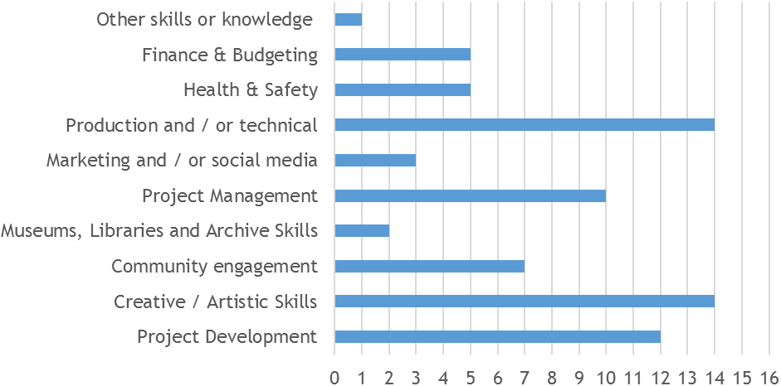
Creative / Artistic Skills
‘I developed my interest in some artefacts during visits to archives and museums which then led me to explore new techniques to express my findings creatively using digital drawing and collage. Their translation onto vinyl was a new medium that I had not investigated before.’
(Artist)
‘It was an enormous challenge because … there was a lot of digital drawings so I needed to acquire software to produce the work … I hadn’t really worked with CAD before … I had used photography and developed photographs for books but never in an installation. So there were lots of new processes which I was unfamiliar.’
(Artist)
‘This was a new way of projecting large scale using digital moving imagery at 8K resolution … previously we had mapped still image sequences to architecture. We adapted to a new work flow, learnt two new software packages, and worked really successfully with the production company.’
(Artist)
‘The form of the work was complicated and required me to adopt a new artistic process while planning the work. I worked with a sub-contractor and learned about the processes, possibilities and restrictions involved in their side of the project. Both will be useful in future.’
(Artist)
‘Technical skills were increased as a result of using new techniques and methods (albeit within a medium I am familiar with) and on a larger scale than I have worked previously, which brought different production challenges which I've certainly learned from.’
(Artist)
‘The project encompassed working with a material new to me … increased my making skills and creative ideas through working with a material in the context of the City of Hull.’
(Artist)
‘The project challenged me to build on existing skills and knowledge in the design, research and delivery of the installation. It was technically challenging and required learning new knowledge about the material through experimentation. It was artistically challenging required refining a technique that could delivery a consistent high quality project.’
(Artist)
‘I used some equipment I hadn't used before including a movement sensor operated media player.’
(Artist)
‘I had never worked with paper in this capacity so the learning curve was steep and was a good text of my project development skills. My first couple of ideas worked in theory but in practice there were some technical difficulties due to the behaviour of the paper which I didn't predict, so I had to keep improvising and changing the production method.’
(Artist)
‘Because the technology to do this is now available … we have been wanting to do this for some time, but in our way … The short time we had to do this … people sort of left us to get on with it which was great. ‘One is in terms of contracting, I kept the contracting very simple.’
(Artist)
Project and Financial Management
‘Because I controlled most of the budget for the exhibition I had to manage more aspects than usual.’
(Artist)
‘Working site specifically from afar within a period increased my experience of project management and budgeting.’
(Artist)
‘As well as for financial reasons I have always avoided using a technician for artistic reasons as I felt this undermined the authenticity and integrity of the work. The scale and timetable of this project however left no other option. Subsequently I had these preconceptions challenged which is always a good thing.’
(Artist)
Audience Engagement
‘Producing work that would engage a wide audience, being part of the city of culture attracted people that wouldn't normally go to art exhibitions.’
(Artist)
‘It helped me understand how important user/public engagement is.’
(Artist)
Other
Other types of skill and knowledge gained linked to working on a new subject matter, or delving deeper into one already on their radar.
‘It has introduced a completely new subject into my work … it has involved an historical element in the research that was quite unique to me prior to doing this project.’
(Artist)
‘The commission presented an opportunity to engage in an intriguing new subject … I was so pleased to have been provided with this as a starting point, it provided an anchorage to my research, and was refreshing - creatively pushing me to look reoccurring themes in my practice anew.’
(Artist)
‘We also made a strong and direct connection between the built environment and processes and forces of nature, elemental and geological which we have been developing for some time.’
(Artist)
Also, working in different and unfamiliar spaces had also brought its own learnings.
‘I don’t do so many site-specific temporary public art things. There is a sort of different set of parameters with those projects. It is really nice to have the opportunity to work on something like this again and the scale is very very large compared to the work I usually do. It is probably one of the biggest in terms of height that I normally do.’
(Artist)
‘The site … provided an exciting element of community engagement as implicit in the work, where participants, if they were aware of it or not, were interacting with the piece during their journey.’
(Artist)
‘Seeing work installed in different places enables you to work in a completely different way. [My artwork] is a work that will never settle wherever it goes, and it I hope it does go somewhere else.’
(Artist)
One artists also spoke of how they were sharing the knowledge of what they had learnt from the process with others.
‘I have disseminated some of the working methods adopted during this commission during PowerPoint presentations at universities and art schools in Barcelona and Plymouth.’
(Artist)
    - Knowledge of Hull’s History and Heritage
In developing their artworks for Look Up, artists who had explored the history and heritage of Hull through their work gave an average score of 8.2 out of 10 for the amount they had learnt about the history and heritage of Hull through the development and delivery of their project.
Figure 14: Learning About Hull’s History and Heritage
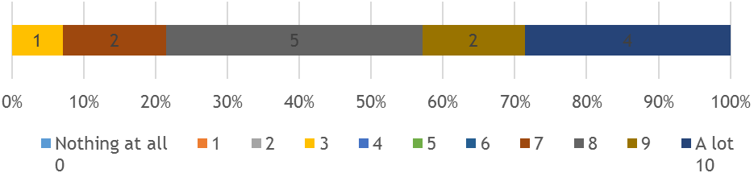
Knowledge gained about Hull’s past included the trading history of the city; transmigration from Europe to the New World; Hull’s maritime past; the life and work of William Wilberforce; the Civil War; the art collections held within the city’s institutions; and aspects of its arts and cultural history.
‘First there was the Hull fishing industry and later the traders established Hull as a prime trading post with Scotland and the Baltic nations, and later further afield. The trading of products both natural and manmade is the area I have been most interested in during the project.’
(Artist)
‘I learnt about Hull's role in the civil war.’
(Artist)
‘For me discovering the whaling heritage of the place - I didn’t know the history beforehand. Andrew pushed me to go and look to the Maritime Museum and other places just to get some background to the city … When I was sitting on the train I immediately thought I’m going to put a whale in that space as it is the same size as a whale. It came as a result of finding out about that history and that could be passed on to other people as well.’
There were a variety of different ways artists had accessed heritage based information and resources in researching and developing their artwork. This included visits to Hull’s museums and educational institutions; reading of published research; research trips; and exploration of the city’s built heritage;
‘Learnt more about Hull's maritime heritage through the Maritime Museum; also Hull's art collection at the University, and other exhibitions that focus on Hull's alternative cultural history, e.g. Cosey Fanni Tutti at Humber Street Gallery. Enjoyed the architectural city landscape and feature buildings in Hull and around.’
(Artist)
‘Nicholas Evans produced work on [the subject] and a PhD … I had access to that. I did a little bit of looking at the Maritime Museum and exploring. I was in New York on a research trip connected to this commission primarily to go Elis Island National Museum of Immigration to see 3 luggage baskets in their collection. They were the only genuine baskets. I went to the museum to photograph some drawings in the collection ... While I was in New York I was also interested in early American painting of the time … I was really interested in seeing this work when I was there …I went to Somerset because I wanted to go to a place they make the baskets and grow the reeds and they have the whole process … I wanted to see the styles of trying to explain process in a very diagrammatic way and I wanted to show the diagrammatic style in the work … There was a mix of archival work in New York and reading.’
(Artist)
‘When we did our research on the building itself, obviously we had the architects briefs … the things that influenced the architect, we used that to be the starting point to do our own research and we were quite intrigued by geological time and determined that the ice-sheet terminated in this area in the ice age. Also by visiting Hull Maritime Museum we came across all these paintings that were not too dissimilar to Caspar David Friedrich’s ‘Sea of Ice’ and it was coming from a Hull perspective with whaling vessels.’
‘It became quite ‘Hull-ish’ didn’t it which was quite nice because we knew we were on the right track then. That whole connection of the whaling and the trawlers and the arctic, that really fed into the work.’
One artist’s research also led to an exploration of other types of migratory behaviour linked to movement and travel.
‘I also did a bit of reading about weeds and the migration of seeds along railway tracks and seeds in the air that flow in the train and along the track. I looked at a lot of train tracks in the UK to research the seeds that are growing in track.’
(Artist)
10 out of 14 said they would like to work on heritage inspired projects in future, with a further four saying they were not sure (n=14).
Figure 15: Further Interest in Heritage Inspired Projects
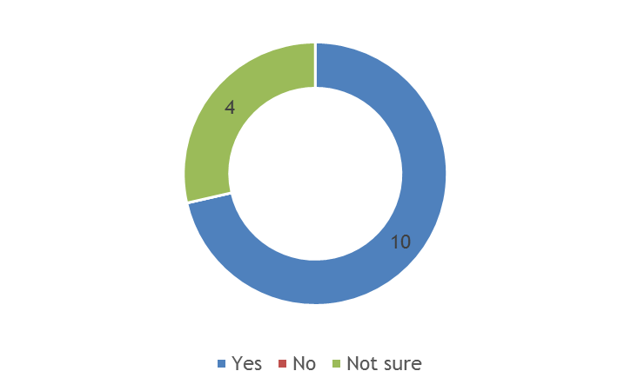
    - Collaboration & Partnerships
Almost all artists stated that they had been able to collaborate with other individuals and/or organisations; had built new relationships with individuals and/or organisations they had not come across before; and had developed existing relationships with other individuals and/or organisations that pre-dated Look Up.
Figure 16: Collaborative Opportunities
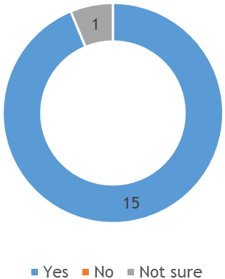

Figure 17: New Relationship Building Opportunities
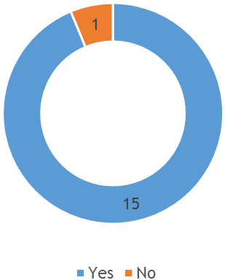
Figure 18: Existing Relationship Building Opportunities
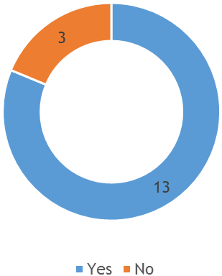

When asked which partnerships were most valuable, artists commonly mentioned:
- The relationship with the Look Up curators;
- Co-commissioners of the project;
- Technical and operations support at venues; and
- Subcontractors.
‘The relationship we had with Andrew and Hazel is kind of something we have built on from previous projects- … There is a certain amount of trust which is always really helpful in projects where there is a short timeframe to do it in. It always helps if you know the people that you are working with because that smoothes things.’
(Artist)
‘[The supplier] did an amazing job with the projection. They are the best in the business, but we had never worked with them properly … We had done projects together but this is the first time we have worked properly together. There challenges, all sorts of challenges, but they were just amazing … We would work with them again … Something like this is so far beyond what we could achieve on our own.’
(Artist)
‘Right at the beginning of this, before anyone did the tracking, I took my plans for the city …and I took a block and said to myself “it might be possible” … When [the engineering company] came to me with these exquisite geometric drawings and critical path analysis it did two things: one it was a really beautiful drawing and the second thing was that it showed that it was possible –‘we can do this’ and I was very excited about that moment … there an objective document which said it can be done … It was [also] showing what had to be taken out and that was really terrifying: what had to be cut down [or taken out].’
(Artist)
‘G.F Smith were absolutely brilliant to collaborate with and understood the whole process and were sophisticated, your dream partnership.’
Many artists spoke of how the partnerships they developed during their work on Look Up were ones that they would continue to foster in future.
‘The company I have worked with I would work with again and I have worked with them before. I hope to work with Andrew Knight again … I know how he works and that really helps when you are working very fast … there has to be a very high level of trust.’
(Artist)
‘I do I plan to work with both [the fabricator and structural engineer] in the future on similar scaled projects, but looking at wood and metal kind of work in installations using similar structures in terms of scale.’
(Artist)
    - Other Artist Outcomes
Working on Look Up has had a number of other positive outcomes for artists, with the majority agreeing or strongly agreeing with a range of statements about how Look Up had impacted on them (see Figure 19). The three statements with the highest level of agreement overall were:
- I enjoyed working with a wider creative team;
- I successfully reached more diverse audiences for my work; and
- I am more confident working on high quality public art projects.

Figure 19: Existing Relationship Building Opportunities
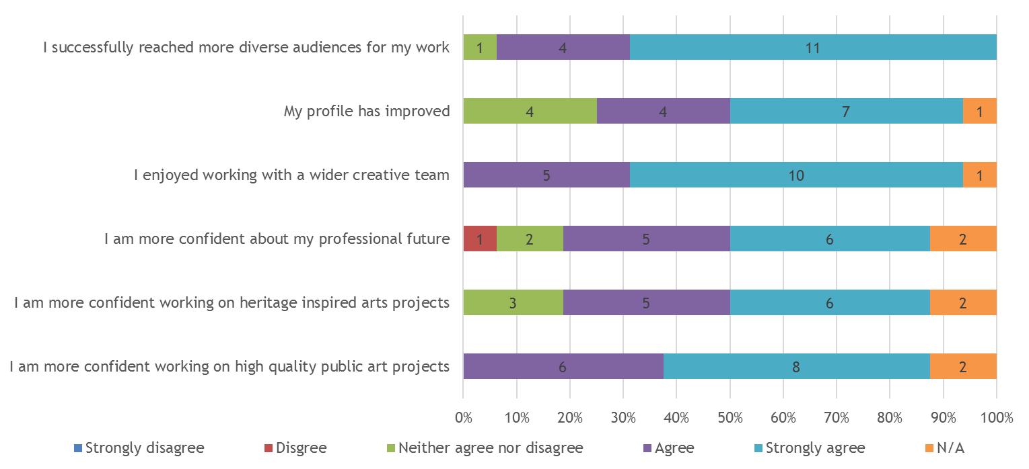
Confidence was something that also came out very strongly within the artist depth interviews.
‘It confirmed the importance of having good teams and that there was a lot of enthusiasm for this project amongst our team and that really helped, because it was quite tricky to do.’
(Artist)
‘Confidence! There's always a horrible part of any project at the beginning where it feels like its floundering and that there is no idea at all. When you're getting paid, this tends to increase the pressure to come up with a sound idea and almost felt like an obstacle at the time. Looking back at my early sketch book I can see the beginnings of all of the ideas I used in the final piece even though at the time I felt that I couldn't justify my fee. I had a valuable lesson in self confidence and self worth.’
(Artist)
‘I think it has made me more confident in the approach I have been using and made me do more applications in different areas of research and other applications using different materials. It is the formation of other ideas I have been exploring learning from nature and specifically using paper as a structural material.’
(Artist)
Only one artist provided a negative response to any of the statements. This was the statement ‘I am more confident about my professional future.’
    - Perceptions of Hull
When asked how they would have described Hull to someone else, prior to working on Look Up, key themes raised by artists linked to the city’s slightly isolated location; weather patterns; past industries (especially fishing); well know parts of its cultural offer; and reputation linked to deprivation. Others also spoke of fond memories they had of the city.
‘Industrial, windy, remote, agricultural, northern.’
(Artist)
‘Flat, windy, on the edge, geographically, down to earth.’
(Artist)
‘Holiday with son camping in Hull … For me just because it was by the coast, a fun park.’
(Artist)
‘We had worked here before and have a real fondness for the city but are aware that others may have no idea what a unique and interesting place it is - come and visit.’
(Artist)
‘An industrial fishing city and the home of the Ferens Gallery.’
(Artist)
‘City in the North where Philip Larkin came from, on the Humber. Had been a fishing town.’
(Artist)
‘I just heard from people that it was grim, one huge social housing estate and nothing there.’
(Artist)
‘A post-industrial northern city that had suffered from the collapse of the fishing industry and had high unemployment.’
(Artist)
‘A bit run down. It had a lot of exciting subcultures but these had started to disappear.’
(Artist)
Pre-event, because of their work to date on Look Up, 13 artists said they would speak more positively about Hull to others, as was the case post-event (see Figure 20). Reasons for this linked to the change they had seen in the city compared to previous visits; the proximity of the city to the water; an increased knowledge of the city; the city’s architecture; and the pride and friendliness of residents.
‘Having now visited Hull a number of times, and seen how it has developed and improved as a city since my childhood, I can appreciate Hull for what it has to offer for residents, tourists and creative professionals alike.’
(Artist)
‘Honestly I was visiting Hull a lot during the R&D phase … Since the phase of R&D I haven’t been back to go to Hull a lot. I saw Hull in that transitionary stage. It seemed very exciting, so much was being invested in the town there was a sense of optimism in a lot of things going on in Hull.’
(Artist)
‘The development of Humber Street has given renewed energy to Hull.’
(Artist) ‘It has masses of stuff going on. I spent time on site installing stuff and during site visits. Going back to install stuff even in a short time I noticed changes with renovations in the city centre and lots of public improvements in public spaces and … exhibitions going on as well.’
(Artist)
‘The atmosphere the volunteers generate is great. I can see the conversation around art is changing how people talk to each other, and take ownership of the City of Culture programme.’
(Artist)
‘The centre of Hull is beautiful. Very pretty architecture. It's wonderful to be so near water.’
(Artist)
Figure 20: Artists Perceptions of Hull Amongst

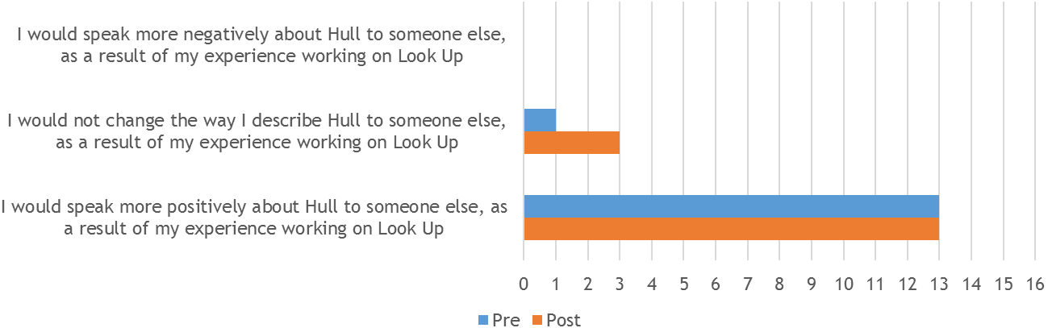
‘I didn’t realise that Hull had such a rich civic and architectural history.’
(Artist)
‘The workshop projects have deepened my knowledge of Hull.’
(Artist)
‘I thought the city was rather beautiful, the area around the marina was a hive of cultural activity, the architecture around the city is stunning and the people always had a story to tell.’
(Artist)
‘Been pleasantly surprised by the architecture of the city, the experience of walking around - beautiful old buildings, the marina, the old town, the minster, the university is also amazing. I love the relationship with the vast body of water right on the edge of town, and walking along its banks into the town. Love the big sky.’
(Artist)
‘I realised that people in Hull have a great pride in their city and that despite the effects of the last twenty years, Hull has a history to be proud of … I think mainly though, it is the experience of staying in Hull that changed my mind. The people are really friendly and welcoming and I was sad to leave.’
(Artist)
Post-event reasons for people speaking more positively about the city linked to the enthusiasm of the Hull 2017 Volunteers; the friendliness of the city; the positive reactions from audiences to the artwork and City of Culture more generally; the broader cultural offer; and attractiveness of the city.
‘I felt that the local Hull City of Culture volunteers who worked to communicate themes in my practice to others helped to contribute to the success of the project, their knowledge, understanding and enthusiasm for the work was then communicated to the audience.’
(Artist)
‘The audience reaction in Hull was very positive, the response was more positive than I had expected, there is a strong sense of place in Hull and that I think was why people responded so well.’
(Artist)
‘Having spent time working in Hull in the lead up to the projects launch I found a real interest in what we were doing and in the programme of events throughout the year – from the many volunteers who gave up their time, to passers by in the street, there was a real feeling of enthusiasm and pride in staging the City of Culture and Look Up events. I enjoyed my time working on the project and would happily return to Hull for future projects as a result of my experiences.’
(Artist)
‘The project brought to life an aspect of Hull’s history in an unexpected way through thinking and working with [local cultural partners].’
(Artist)
‘I was impressed by the enthusiasm of visitors to the project and their positive reactions.’
(Artist)
‘Everything was positive about the experience I had. The generosity of [the co-commissioner]; the open-minded people I met while working in Hull; the friendliness of the people; an attractive easily accessible city centre.’
(Artist)
‘It was a very lively place to visit.’
(Artist)
‘We have worked in Hull in the past so it wasn't a surprise to us at the openness and friendliness that the City offered and the genuine pride with which the city has embraced its identity through the City of Culture status. The project exceeded our expectations in many ways and Hull embraced it as it has done to many other projects throughout the year. Having another great experience of working in Hull has reinforced our opinion.’
(Artist)
‘There is definitely more happening in Hull culturally than a few years ago.’
(Artist)
‘I know more about the city, both its history and what it is like at present, and I had very good experiences of seeing a number of other artworks and exhibitions there.’
(Artist)
‘I had never visited Hull before, I found there was a great energy from people locally and visiting engaged with the city and the events it had one which was a really joy to see.’
(Artist)
‘I naturally have a nostalgic affection for the city I used to know. Although in some ways it was quite a depressing place in its clichéd post-industrial decline, this also gave it character and was really what made it interesting and different. I accept that things change and move on but I was quite disappointed to see that in the 'new' Hull, despite there being a growth in trendy bars and restaurants and other conspicuous signs of wealth, there is also an increase in the number of homeless people. Where my project was situated was a particular focal point for them.’
(Artist)

‘Everyone I personally spoke to about the project was positive and complimentary. A lot of people made a point of come backing more than once to gather every facet of the work they could whilst some people didn't stay long and probably never really engaged with it on any deep level. The Hull audience was like anywhere else, a mixture of people with different levels of attention span.’
(Artist)
‘It was important for me to spend time in Hull exploring the different areas in order to get to know its unique characteristics and generally get a feel for the culture of the city. I invited my wife and parents-in-law to visit as well and we were all enjoyed the Fruit Market, Marina and the Old Town areas very much. If it wasn't for the Look Up project I don't think I would have spent as much time in Hull engaging with the city or visiting other parts of the city. The city was evidently very busy with tourists and the Fruit Market area especially was packed with visitors during the week I was there, so in that case I'd suggest it has been an invaluable project for both the city and all the people involved.’
(Artist)
    - Final Comments
Artists were provided with an opportunity to share other feedback on their experience that they felt relevant to Look Up. Many shared their appreciation for being given the chance to be involved in their projects and reflected with great positivity.
‘Our experience bore out our observations of making artworks in diverse spaces for over twenty-five years, that when culture is allowed and encouraged to thrive openly and inclusively, people and places will readily embrace it and express themselves and sense of identity through it. Once a place warms to this then experimentation and innovation becomes a normal function of cultural life and the sense of possibility and change flows into the fabric of communities. Culture is an attitude as well as an activity.’
(Artist)
‘Let's do it again!’
‘I very much enjoyed working on the project, and found the Look Up team to be really engaging and supportive, helping us throughout all stages of the project until its eventual realisation … the team were a pleasure to work with and love the opportunity to work again in the future.’
(Artist)
‘I really enjoyed being part of a large diverse cultural event, Hull has got a lot of good press and people I know would have visited from London, because there is a lot of interest in Hull.’
(Artist)
‘I think it is quite nice to do a piece of work that is quite controversial and quite difficult … I think it is great that Hull and the people in Hull were willing to take that risk. A lot of cities would not have taken that risk. They have been adventurous and a sense of saying yes to things.’
(Artist)
‘Only in Hull, with this team led by great curators could this have happened.’
(Artist)
One artist shared their belief that it was already reaping its rewards via new opportunities that were coming their way.
‘The commission seems to be providing further creative opportunities for me to develop my practice. Since completing the project, informal conversations are taking place with a writer who is working on a play … I am currently writing a proposal for a heritage inspired project in Barnsley that also explores themes … that will build on archival-based skills of research I started during my work for Hull.’
(Artist)
One final piece of feedback linked to planning and the temporary nature of Look Up. The artist felt the it would have been good to consider what would happen to the artwork after being dismantled.
‘This isn't meant to be a criticism, but I suppose it would have been great to have considered how a more enduring legacy for actual work itself could have been incorporated into the project brief from the beginning … It is always sad to dismantle an exhibition when there isn't a plan for what happens with the work.’
(Artist)

