**PRSF NEW MUSIC BIENNIAL**

**HULL**

**29th JUNE to 2nd JULY 2017**

**ARTIST PACK**

**ARTIST**: Mark Simpson

**ARTIST CONTACT (Mobile number):** TBC – PROMOTER TO CONFIRM

**VENUE**: Mortimer Suite (Sharp)

[Address](https://www.google.com/search?biw=2400&bih=1217&q=www+fruitspace+co+uk+address&stick=H4sIAAAAAAAAAOPgE-LWT9c3LDOyTMpKK9GSzU620s_JT04syczPgzOsElNSilKLiwFSWNTXLgAAAA&sa=X&ved=0ahUKEwiT5cTKt7jUAhUlKMAKHZ4BA-AQ6BMIowEwEA): Hull City Hall, Queen Victoria Square, Carr Lane, Hull, Hu1 3RQ

[Phone](https://www.google.com/search?biw=2400&bih=1217&q=www+fruitspace+co+uk+phone&sa=X&ved=0ahUKEwiT5cTKt7jUAhUlKMAKHZ4BA-AQ6BMIpgEwEQ): direct no??

**LOADING IN FROM:** Paragon Street (Pink Dot)

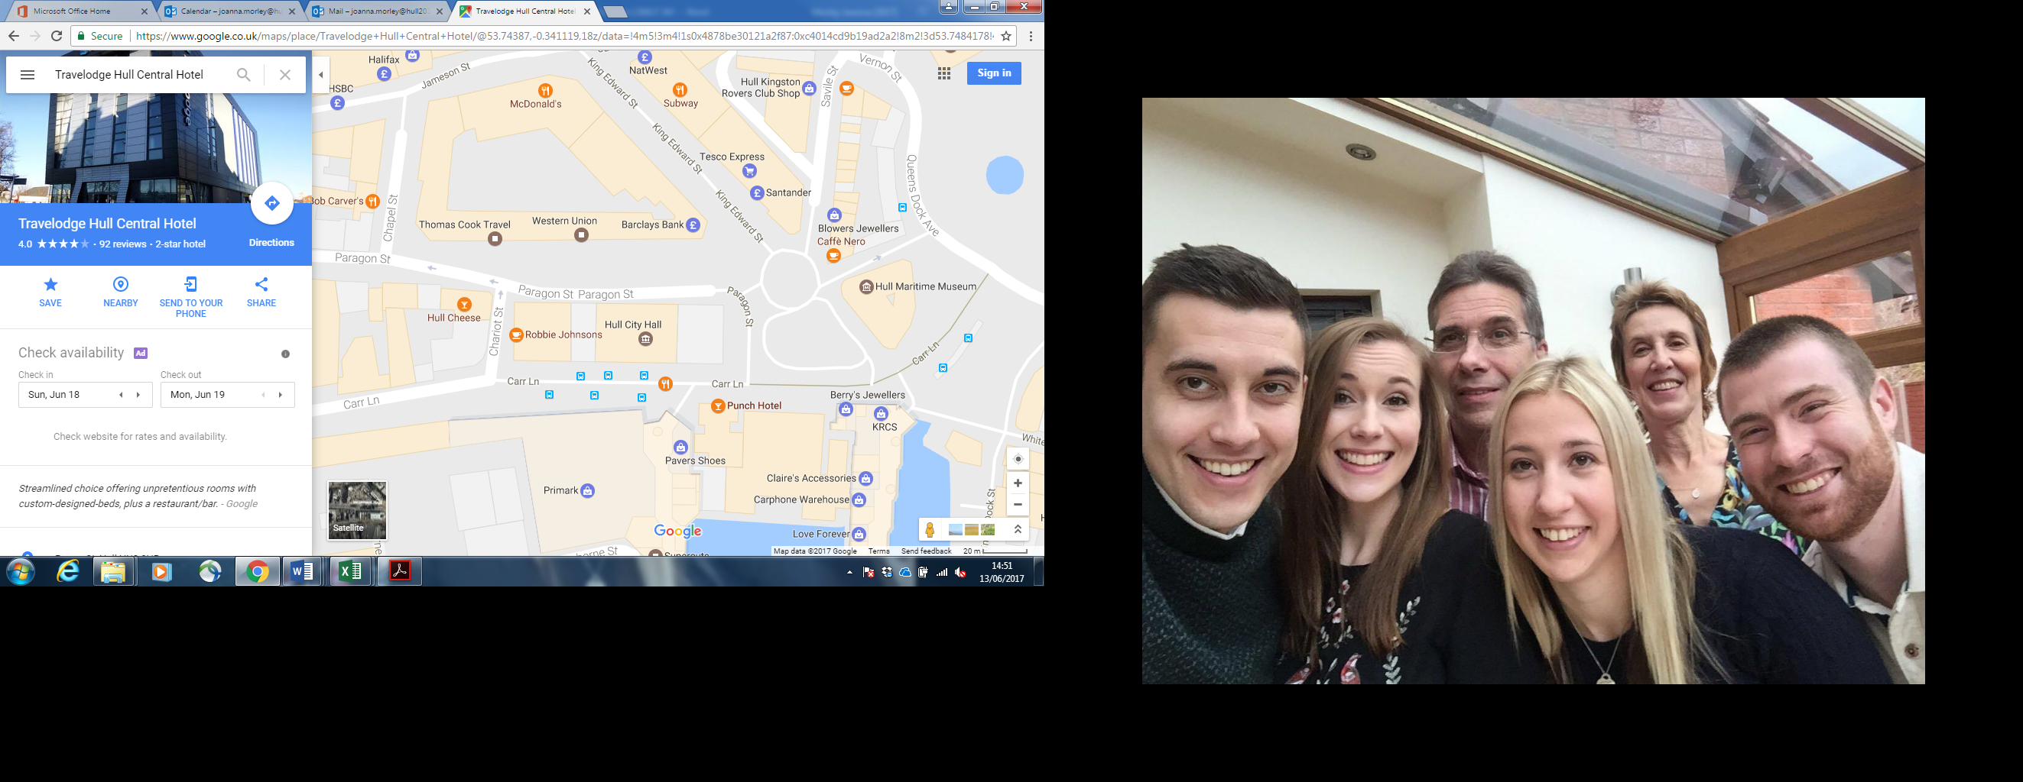

**PARKING REQUIREMENT and LOCATION:**

TBC – PROMOTER TO CONFIRM

**PERSONNEL**

**STAGE MANAGER (Primary contact show weekend only):** Danielle Harris - 07594 212377

**PRODUCTION MANAGER:** Gareth Hughes – 07733112272

**PRODUCTION ASSISTANT**: Joanna Morley – 07725 942808

**VENUE CONTACT**: Tony Evans (Technical)/Lorna (FOH)

**DATE AND TIME OF PERFORMANCE:Sunday 2ndJuly 11:00 (45mins)**

**PRODUCTION SCHEDULE:**

|  |  |  |
| --- | --- | --- |
| ***FRIDAY 30 JUNE*** |  |  |
| 06:00 - 00:00 (ACCESS) | 06:00 - 11:00 | Tech in - ALL |
|  | 09:00 | Piano delivery - Mortimer Suite - Sharpe |
|  |  | BOTH MORTIMERS AS DRESS ROOMS FOR BBC PHIL |
|  | 10:00 | Piano tuning - Mortimer |
|  |  |  |
| ***SATURDAY 1 JULY*** |  |  |
| 08:00 - 00:00 (ACCESS) | 09:00 | Piano tuning - Mortimer |
|  | 09:00 - 11:00 | Branding and dressing - Mortimer Suite (Sharp) |
|  | 11:00 - 14:00 | Emily Hall - Artists arrive and rehearsal - Mortimer Suite (sharp) |
|  | 15:00 | DOORS - Mortimer Suite (sharp) |
|  | 15:15 - 16:00 | Emily Hall - PERFORMANCE |
|  | 16:30 - 21:00 | Reset tech for Mortimer Suite (sharp) - Gould Piano Trio |
|  |  |  |
| ***SUNDAY 2 JULY*** |  |  |
| 08:00 - 20:00 (ACCESS) | 08:00 | Piano tuning - Mortimer Suite |
|  | 09:00 - 10:45 | Piano Trio rehearsal - Mortimer Suite (sharp) |
|  | 09:30 | Box office on site |
|  | 10:45 | DOORS - Mortimer Suite (sharp) - Mark Simpson |
|  | 11:00 - 11:45 | Mark Simpson PERFORMANCE |
|  | 14:00 - 20:00 | Derig and clear |
|  |  |  |
| ***MONDAY 3 JULY*** |  |  |
|  | AM | Materials back to storage |
|  | AM | Piano off site |

**TECHNICAL**

**Speech System**

**Basic PA System**

1 Combined System Rack 1

2 L Acoustic MTD108A

1 Camco Vortex 6

2 Powerdrive 44BE Speaker Stand

2 13A To 16A Adapter

8 XLR Splitter

**Microphones**

2 Pulse Headset Microphone - Beige

2 Sennheiser EW512 G3 - Belt Pack System - Range GB

**Staff**

1 Engineer - Systems

**RIDER:**

TBC

**BACKLINE**:

**ACCREDITATION**

David & Alice Porter (Directors)

Steve & Sam Shaw (Directors)

Peter & Lorraine Boardman (Directors)

Wes Zepherin (Director)

Kirsty & Gary Halliday (Marketing)

Ben Pugh (Production)