**PRSF NEW MUSIC BIENNIAL**

**HULL**

**29th JUNE to 2nd JULY 2017**

**ARTIST PACK**

**ARTIST**: Hannah Peel

**ARTIST CONTACT (Mobile number):** TBC – PROMOTER TO CONFIRM

Band management - Jeremy Davies - 07775 892780

Technical - Jamie Saye - 07500 007490

**VENUE**: Albermarle Music Centre

[Address](https://www.google.com/search?biw=2400&bih=1217&q=www+fruitspace+co+uk+address&stick=H4sIAAAAAAAAAOPgE-LWT9c3LDOyTMpKK9GSzU620s_JT04syczPgzOsElNSilKLiwFSWNTXLgAAAA&sa=X&ved=0ahUKEwiT5cTKt7jUAhUlKMAKHZ4BA-AQ6BMIowEwEA): Albermarle Music Centre, 60 Ferensway, Hull HU2 8LN

[Phone](https://www.google.com/search?biw=2400&bih=1217&q=www+fruitspace+co+uk+phone&sa=X&ved=0ahUKEwiT5cTKt7jUAhUlKMAKHZ4BA-AQ6BMIpgEwEQ): 01482 318800

**LOADING IN FROM:**

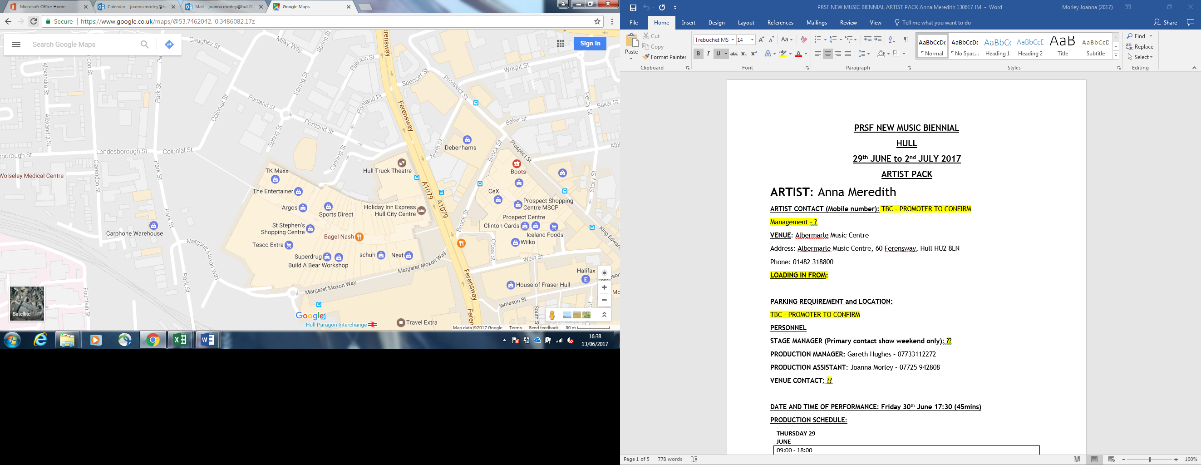

**PARKING REQUIREMENT and LOCATION:**

TBC – PROMOTER TO CONFIRM

**PERSONNEL**

**STAGE MANAGER (Primary contact show weekend only):** ??

**PRODUCTION MANAGER:** Gareth Hughes – 07733112272

**PRODUCTION ASSISTANT**: Joanna Morley – 07725 942808

**VENUE CONTACT**: ??

**DATE AND TIME OF PERFORMANCE: Saturday 1st July 16:00 (45mins)**

**PRODUCTION SCHEDULE:**

|  |  |  |  |  |  |  |  |  |  |  |  |  |  |  |  |  |  |  |  |  |  |  |  |  |  |  |  |  |  |  |  |  |  |  |  |  |  |  |  |  |  |  |  |  |  |  |  |  |  |  |  |  |  |  |  |  |  |  |  |  |  |  |  |  |  |  |  |  |  |  |  |  |  |  |  |  |  |  |  |  |  |  |  |  |  |  |  |  |  |  |  |  |  |  |  |  |  |  |  |  |  |  |  |  |  |  |  |  |  |  |  |  |  |  |  |  |  |  |  |  |  |  |  |  |  |  |  |  |  |  |  |  |  |  |  |  |  |  |  |  |  |  |  |  |  |  |  |  |  |  |  |  |  |  |  |  |  |  |  |  |  |  |  |  |  |
| --- | --- | --- | --- | --- | --- | --- | --- | --- | --- | --- | --- | --- | --- | --- | --- | --- | --- | --- | --- | --- | --- | --- | --- | --- | --- | --- | --- | --- | --- | --- | --- | --- | --- | --- | --- | --- | --- | --- | --- | --- | --- | --- | --- | --- | --- | --- | --- | --- | --- | --- | --- | --- | --- | --- | --- | --- | --- | --- | --- | --- | --- | --- | --- | --- | --- | --- | --- | --- | --- | --- | --- | --- | --- | --- | --- | --- | --- | --- | --- | --- | --- | --- | --- | --- | --- | --- | --- | --- | --- | --- | --- | --- | --- | --- | --- | --- | --- | --- | --- | --- | --- | --- | --- | --- | --- | --- | --- | --- | --- | --- | --- | --- | --- | --- | --- | --- | --- | --- | --- | --- | --- | --- | --- | --- | --- | --- | --- | --- | --- | --- | --- | --- | --- | --- | --- | --- | --- | --- | --- | --- | --- | --- | --- | --- | --- | --- | --- | --- | --- | --- | --- | --- | --- | --- | --- | --- | --- | --- | --- | --- | --- | --- | --- | --- | --- |
| |  |  |  | | --- | --- | --- | | **THURSDAY 29 JUNE** |  |  | | 09:00 - 18:00 (ACCESS) | 09:00 | Stage manager on site | |  | DAY | Delivery of Harmonium (Gavin Bryars) | |  | DAY | Set up dressing rooms | |  | DAY | Dressing and branding | |  | DAY | BBC to park up to the corner / rear | |  | 12noon | Tech set up | |  | 12noon | Set up Anna Meredith - percussion set up (see also Hannah Peel plot) | |  |  |  | | **FRIDAY 30 JUNE** |  |  | | 09:00 - 23:00 (ACCESS) | 09:00 | Stage manager on site - set for Anna Meredith | |  | 09:00 | BBC OB in | |  | 10:00 | Anna Meredith - Artists arrive | |  | 11:00 - 12:00 | Anna Meredith - Set up | |  | 13:00 - 16:00 | Anna Meredith - rehearsal | |  | 16:30 | Box office on site | |  |  |  | |  | 17:00 | Doors | |  |  |  | |  | 17:30 | Anna Meredith PERFORMANCE | |  | 18:15 | FINISH | |  | 18:30 - 18:45 | Reset for Gavin Bryars | |  | 18:45 | Rehearsal Gavin Bryars | |  | 19:00 - 21:00 | Moulettes rehearsal - rehearsal - Rivers and Railways | |  | 19:45 | Doors | |  | 20:00 | Gavin Bryars - PERFORMANCE | |  | 20:45 | FINISH | |  | 21:00 - 23:00 | Reset for Hannah Peel and Laurence Crane | |  | 21:00 - 23:00 | Reset Dressing rooms | |  |  |  | | **SATURDAY 1 JULY** |  |  | | 09:00 - 21:00 (ACCESS) | 09:00 | Stage manager on site | |  | 10:00 | Artists arrive - Laurence Crane | |  | 11:00 - 12:15 | Laurence Crane - rehearsal | |  | 12:00 | Box office on site | |  | 12:15 | Doors | |  | 12:30 | Laurence Crane - PERFORMANCE | |  | 13:15 | FINISH | |  | 13:30 | Hannah Peel - Artists arrive - rehearsal synthesisers and percussion | |  | 15:30 | Hannah Peel - Brass arrives - rehearsal | |  | 16:15 | Doors | |  | 16:30 | Hannah Peel - PERFORMANCE | |  | 17:15 | FINISH | |  | 17:30 | Set tech for Jocelyn Pook | |  | 21:00 | Clear | |  |  |  | | **SUNDAY 2 JULY** |  |  | | 09:00 - 21:00 (ACCESS) | 09:00 | Stage Manager on site | |  | 10:00 | Artists arrive - Jocelyn Pook | |  | 10:00 - 14:00 | Jocelyn rehearsals | |  | 14:00 | Box office on site | |  | 14:45 | Doors | |  | 15:00 | Jocelyn Pook - PERFORMANCE | |  | 15:45 | FINISH | |  | 16:00 - 20:00 | Clear and derig | |
|  |

**TECHNICAL**

**Sound**

**FOH Control**

1 Midas Pro 2C - Live Audio System

**Speaker System**

6 L Acoustics - ARCS

8 L Acoustic ARCS - ARCOUPL

2 Ratchet Strap (Black) - 7.5m 2T

4 L Acoustics - SB28

1 L Acoustics LA8 Rack (4 - Way)

2 NL4 Speakon Cable 4mm 20m

2 NL4 Speakon Cable 4mm 10m

2 NL4 Speakon Cable 4mm 5m

4 NL4 Speakon Cable 4mm 0.5m

3 NL4 Sub Split Cable

**Monitor System (Up to 4x Mixes)**

4 L Acoustic 115XT HiQ

**Microphones**

1 Shure ULXP Beta58 Handheld Radio System - CH38

**Misc**

1 63A 3-Phase Cable 20m

1 63A 3 Phase Mains Distro #5

1 Backline Power Prep - Standard

**Staff**

1 Engineer - FOH

1 Engineer – Systems

**AV**

**Material**

1 Blackmagic Design HDMI-SDI Converter

1 Blackmagic Design SDI-HDMI Converter

1 Black Magic ATEM 1 M/E Production Studio 4K

**Staff**

1 Engineer - AV

**Lighting**

Provided by House

**Staff**

1 Engineer – Lighting

**Headphone Monitoring – Tubular Brass**

**Material**

1 Art Head Amp 6

1 Closed Back Headphones

1 10m Balanced Jack Cable

1 5m Balanced Jack Cable

1 Jack to Jack Coupler

1 3.5mm to 6.35mm Jack Adapter

2 BSS AR133 DI

**Microphones – Jocelyn Pook**

**RF**

1 DPA 4088F - Headset Microphone

1 DPA DAD6034 - Microdot to 3.5mm Jack

1 Sennheiser EW512 G3 - Belt Pack System - Range GB

**Microphones**

3 Neumann KMS-105

3 AKG C451

3 AKG C414ULS

10 Microphone Stand – Tall

**Microphones – Tubluar Brass**

**Material**

6 BSS AR133 DI

2 AKG C451

1 Shure Beta 57

3 Microphone Stand – Tall

**Microphone – Gavin Bryars**

**Material**

1 Sennheiser e609

2 DPA DAD 4099-BC

1 DPA Clip for Violin and Mandolin (VC4099)

1 DPA Clip for Cello (CC4099)

2 DPA DAD 6001 XLR 48 volt adapter

1 Shure Beta 87

2 Shure SM57

2 BSS AR133 DI

1 Microphone Stand - Tall

2 Microphone Stand - Medium

1 Microphone Stand - Short

**RIDER:**

TBC

**BACKLINE**:

|  |  |  |
| --- | --- | --- |
| **BACKLINE** | 3 timps /stool |  |
|  | Bass drum | ALBEMARLE KIT 1 |
|  | Clash cymbals | ALBEMARLE KIT 1 |
|  | Suspended cymbal | ALBEMARLE KIT 1 |
|  | Mark tree |  |
|  | Glockenspiel |  |
|  | Xylophone |  |
|  | Tubular bells |  |
|  | Drum kit | ALBEMARLE KIT 1 |
|  | Traps tray | ALBEMARLE KIT 1 |
|  | 2 x extra snare drums + stands | ALBEMARLE KIT 1 |
|  | Stand for woodblock |  |

**ACCREDITATION**

David & Alice Porter (Directors)

Steve & Sam Shaw (Directors)

Peter & Lorraine Boardman (Directors)

Wes Zepherin (Director)

Kirsty & Gary Halliday (Marketing)

Ben Pugh (Production)

Artistic Personnel: Sandy Smith, Rob Westacott, Martin Britt, Chris Bradley, Norman Christie, Chic Cullen, Iain Culross, Andy Blackledge, Ronnie Wotherspoon, Colin Brooke, Jimmy Leggatt, Stuart Linguard, Owen Farr, Trevor McCormick, David Essex, Stevie Kane, Evelyn Bradley, Scott Kerr, Jonti Smith, Paul Kiernan, Johnathan Beatty, Mark Frost, Tony Whittingham, Jon Davies, Simon Gresswall, Andy Warriner, Rhianon Harding, josh Finzi and Pete Matthews.