**EVENT SAFETY**

**MANAGEMENT PLAN**

**FLOE**

**version 2**

DOCUMENT CONTROL

THIS DOCUMENT IS LIVE AND SUBJECT TO REVISION.

PLEASE ENTER REFERENCES IN THE TABLES BELOW.

*AUTHOR CONTROL*

|  |  |  |  |  |
| --- | --- | --- | --- | --- |
| Name | Version | Action | Sections | Date |
| *C Clay* | *1* | *1st draft* | *All* | *5/11/2017* |
| *C Clay* | *2* | *Event timings updated; security dot plan updated* |  | *9/11/2017* |
|  |  |  |  |  |
|  |  |  |  |  |

*RELEASE CONTROL*

|  |  |  |  |
| --- | --- | --- | --- |
| Name | Version | Release Date | Released to? |
| *C Clay* | *1* | *7/11/2017* | *ESAG & project team* |
| *C Clay* | *2* | *9/11/2017* | *Project team* |
|  |  |  |  |
|  |  |  |  |

|  |  |
| --- | --- |
| **Contents:**  **Section 1 – Overview**   1. Event Overview   1.1 Project Team  1.2 Event Management Structure  1.3 Contact List  1.4 Licensing & Permissions  **2.0** Safety Policy Statement  2.1 Appointed Persons  **3.0** Event Risk Assessment  **Section 2 – Contractors, Personnel & Site**  **4.0** Legislative duties  **5.0** Responsibilities of Contractors  5.1 Accident & near miss reporting  5.2 Equipment & Materials  5.3 Personal Protective Equipment  5.4 Segregation  5.5 Risk Assessment  5.6 Compliance  **6.0** General Site Conditions  6.1 Venue – Special considerations  6.2 Access & egress  6.3 Smoking  6.4 Alcohol & drugs  6.5 Venue Facilities  6.6 Work at Height  6.7 Manual Handling  6.8 Lifting Operations  6.9 Ladders  6.10 Fatigue  6.11 Electricity  6.12 Equipment suspended at height  6.13 Waste  **Section 3 - Operational Plans**  **7.0** Schedule  **8.0** Security & Crowd Management Plan  **9.0** Medical & First Aid Plan  **10.0** Waste Management Plan  **11.0** Noise Management Plan  **12.0** Alcohol Management Plan  **13.0** Fire Safety Plan  **14.0** Weather Management Plan | **15.0** Traffic Management Plan  **Section 4 – Public and Audience**  **17.0** Crowd Management and Welfare  17.1 Welfare Facilities  17.2 Evacuation plan  17.3 First Aid  17.4 Lost Children or Vulnerable Adults  17.5 Lost Property  17.6 Sanitary Facilities  **Section 5 – Site Plans**  **18.0** Site plans  **Section 6 - Contractors’ Risk**  **Assessments & Method Statements**  **19.0** Contractors RAMS  **Section 7 - Appendice**  **20.0** List of Appendices  **Section 8 - References**  **21.0** References |

**Section 1 - Overview**

**1.0 Event Overview**

*‘Floe’* is the latest commission in the series of ‘Look Up’ public art installations as part of Hull UK City of Culture.

Artists Anna Heinrich & Leon Palmer will create a spectacular, large scale projection event and soundscape that will virtually reshape and remodel the architecture and façade of The Deep. It will reflect the processes and environments within the submarium and its links with the study of interconnected ecosystems around the world. It will be a celebration of The Deep as an iconic international venue and the transformative role it has played in helping Hull to redefine itself.

The projections will be live between 18:00 and 22:00 from Friday 8th December and Sunday 10th December inclusive. The projections repeat on a 10 minute cycle.

**1.2 Event Management Structure**

A named event manager will be on duty during the periods when the installation is live. The event manager will be responsible for supervising stewards & security personnel and will be responsible for Health & Safety matters.

The staff below will be the named event manager for each day:

8th December TBC

9th December TBC

10th December TBC

**1.3 Contact List**

|  |  |  |
| --- | --- | --- |
| **Name** | **Role** | **Email address** |
| Chris Clay | Hull 2017 Technical & Operations Director | [chris.clay@hull2017.co.uk](mailto:chris.clay@hull2017.co.uk) |
| Sam Hunt | Hull 2017 Executive Producer | [sam.hunt@hull2017.co.uk](mailto:sam.hunt@hull2017.co.uk) |
| Hazel Colquhoun | Look Up curator | [mail@hazelcolquhoun.com](mailto:mail@hazelcolquhoun.com) |
| Andrew Knight | Look Up curator | [aknight@aknight.karoo.co.uk](mailto:aknight@aknight.karoo.co.uk) |

**1.4 Licensing & Permissions**

As this work is an art installation is not considered that it falls under the scope of regulated entertainment (*LA 2003, Schedule 1 (6)*)

**2.0 Safety Policy Statement**

This document is provided as a supplement to the requirements placed on individuals and organisations by current Health & Safety legislation and contractual agreements. Compliance with this document should therefore not be regarded as fulfilling all the relevant statutory obligations pertinent to a particular individual or organisation, which remains their own responsibility.

In keeping with its overall objectives and in accordance with the requirements of the Health & Safety at Work Act 1974 and the Management of Health & Safety Regulations 1999, the Organisers will take all reasonably practicable steps to ensure the health, safety and welfare of its employees, sub-contractors and public.

**2.1 Appointed Persons**

Chris Clay is the appointed Health & Safety lead for this project.

**3.0 Event Risk Assessment**

See appendix 1

**Section 2 – Contractors, Personnel & Site**

**4.0 Legislative Duties**

**The Health and Safety at Work etc Act 1974**

2(1) “It shall be the duty of every employer to ensure, so far as is reasonably practicable, the health, safety and welfare at work of all his employees”

3(1) “It shall be the duty of every employer to conduct his undertaking in such a way as to ensure, so far as is reasonably practicable, that persons not in his employment who may be affected thereby are not thereby exposed to risks to their health or safety.”

3(2) “It shall be the duty of every self-employed person to conduct his undertaking in such a way as to ensure, so far as is reasonably practicable, that he and other persons (not being his employees) who may be affected thereby are not thereby exposed to risks to their health or safety.”

7 “It shall be the duty of every employee while at work—

(a) to take reasonable care for the health and safety of himself and of other persons who may be affected by his acts or omissions at work; and

(b) as regards any duty or requirement imposed on his employer or any other person by or under any of the relevant statutory provisions, to co-operate with him so far as is necessary to enable that duty or requirement to be performed or complied with.”

**The Management of Health and Safety at Work Regulations 1999**

**3.**—(1) “Every employer shall make a suitable and sufficient assessment of—

(a) the risks to the health and safety of his employees to which they are exposed whilst they are at work; and

(b) the risks to the health and safety of persons not in his employment arising out of or in connection with the conduct by him of his undertaking, for the purpose of identifying the measures he needs to take to comply with the requirements and prohibitions imposed upon him by or under the relevant statutory provisions and by Part II of the Fire Precautions (Workplace) Regulations 1997.

(2) Every self-employed person shall make a suitable and sufficient assessment of—

(a) the risks to his own health and safety to which he is exposed whilst he is at work; and

(b) the risks to the health and safety of persons not in his employment arising out of or in connection with the conduct by him of his undertaking, for the purpose of identifying the measures he needs to take to comply with the requirements and prohibitions imposed upon him by or under the relevant statutory provisions.”

**5.0 Responsibilities of Contractors**

All work activities must be undertaken as per contractors’ risk assessment and carried out as per method statements, any work carried out that is deemed to be unsafe or unsatisfactory by a person responsible will be terminated immediately.

Contractors must:

* Provide a safe place of work and safe methods of carrying out the work
* Ensure that employees are competent and have the required knowledge and experience to carry out the work
* Ensure that adequate training and supervision for all staff is provided, where this is found necessary
* Ensure that all plant, equipment and tools are of the correct standard and type and are in good working order

**5.1 Accident and Near Miss Reporting and Investigation**

All accidents, incidents and near misses must be reported without delay to a person responsible. An accident book will be available at all times. The person responsible will report incidents to the enforcing authority as required by the Reporting of Injuries, Diseases and Dangerous Occurrences Regulations 2013 (RIDDOR).

**5.2 Equipment & Materials**

All equipment and tools brought onto site must be in good condition, fit for purpose and have valid test certificates as appropriate.

All floor coverings, furniture, furnishings, scenery, props and drapes brought onto site must comply with the relevant standards.

**5.3 Personal Protective Equipment**

Contractors shall provide, maintain and ensure the correct use of personal protective equipment (PPE) relevant to their task(s) where its use is required by legislation or identified in a risk assessment and/or method statement.

**5.4 Segregation**

Contractors shall ensure that their equipment and material is segregated from others, is not left unattended and that clear access is maintained at all times.

**5.5 Risk Assessment**

Contractors must provide written risk assessments of all potentially hazardous operations carried out by them. The risk assessments shall not be just generic but must contain elements specifically relating to this event.

**5.6 Compliance**

Contractors shall comply with any health and safety and other accompanying documentation or instruction issued by a person responsible, together with their own written procedures. Failure to do so may result in a person responsible requiring the immediate removal of the company or individual involved from site, at no cost to the client or organisers.

**6.0 General Site Conditions**

**6.1 Venue – Special Considerations**

When rigging projectors in C4DI, all contractors must be made aware that this is a working building and that they should behave appropriately at all times.

**6.2 Access & Egress**

There are no special access or egress arrangements.

**6.3 Smoking**

Smoking is only permitted in designated areas.

**6.4 Alcohol and drugs**

All personnel and contractors are not permitted to consume alcohol prior to or during work sessions. Any person who is believed by a person responsible to be intoxicated through the consumption of alcohol or the use of recreational drugs will be considered to be unable to carry out their duties safely and will be required to leave site.

Any person who is unable to carry out their duties safely owing to the effects of prescription medication or for any other medical reason must inform their line manager or a responsible person immediately and appropriate action will be taken, which may include the reallocation of duties or medical treatment.

**6.5 Venue Facilities**

Sanitary facilities are available in C4DI

**6.6 Working at Height**

When it is necessary to work at height precautions must be taken to prevent a fall.

* Where scaffolding is used, it must be provided and erected by competent, trained person(s) and must comply with all current regulations.
* Where working platforms are used handrails and toe boards must be used.
* When working at height, care must be taken to ensure that nothing can fall onto persons below.
* Where a risk assessment of method statement has identified the need for the use of a harness, it should be a full body harness attached to the correct fall arresters and/or work positioning lanyards. Body harnesses must be manufactured in accordance with BS5750, comply with EN361 and carry a CE mark.
* Before any work at height is undertaken a full and sufficient rescue plan must be in place.
* When working at height, all tools must be attached to a person or structure by a suitable lanyard.

**6.7 Manual Handling**

Like all other legislation enacted in 1992 the Manual Handling Operations Regulations are risk assessment based. To that end contractors and personnel shall:

* Identify any manual handling operations where there is a risk of injury to staff.
* Identify and implement any reasonably practicable means of avoiding the operation.
* Where the operation cannot be avoided the contractor will identify any measure that can be taken to control the risks.
* Carry out a task specific risk assessment, which will be recorded and be kept under review and revised as necessary.

**6.8 Lifting Operations**

* Lifting operations shall be planned and supervised by a competent person and carried out in a safe manner.
* Lifting equipment should be inspected and maintained in accordance with the relevant guidelines and legislation (Lifting Operations and Lifting Equipment regulations 1998) and the required documentation should be available onsite to support such maintenance and inspection.
* All lifting equipment, including, but not limited to, wire ropes, winches, chain hoists, shackles, spansets, ropes, slings etc. shall be suitable for their purpose.

**6.9 Ladders**

Should the work to be carried out identify ladders as the most suitable means of access, the following will apply:

* Where ladders are used, they must be selected and used with due consideration to the HSE publication INDG455 (Safe Use of Ladders and Stepladders).
* The ladder(s) should be in good condition and fit for purpose.
* The ladder(s) should be correctly positioned to prevent over stretching and be secure to prevent slipping.

**6.10 Fatigue**

An increased risk of accidents occurs if personnel are allowed to work for long periods of time with insufficient rest periods so that mental or physical fatigue becomes an issue. Mental fatigue can result in errors of judgment leading to accidents. Risk assessments are required to take into account the possibility of fatigue, especially when employees are operating machinery.

**6.11 Electricity**

* All electrical installations shall comply with the requirements of the Electricity at Work regulations 1989.
* Each contractor shall ensure, as part of their own ongoing inspection and maintenance procedures, that they regularly inspect all portable electrical equipment to be used onsite. Visual inspections should be carried out prior to use and any defects should be remedied prior to use or the equipment withdrawn from use.
* All portable electrical equipment brought onto site shall suitable and sufficient test certification (PAT or similar).

**6.12 Equipment Suspended at Height**

All equipment suspended at height shall be fitted with a suitable and sufficient secondary means of suspension.

**6.13 Waste**

All contractors will be required to remove any waste that their activities generate from the site and make appropriate arrangements to dispose of or recycle the waste.

**Section 3 - Operational Plans**

**7.0 Schedule**

|  |  |  |
| --- | --- | --- |
| **Date** | **Activity** | **Notes** |
| 5/12/17 | Set up projectors at C4DI |  |
| 6/12/17 | Continue set up and test |  |
| 7/12/17 | Complete set up and test |  |
| 8/12/17 | Event day 1 |  |
| 9/12/17 | Event day 2 |  |
| 10/12/17 | Event day 3 |  |
| 11/12/17 | De rig and clear site |  |

**More detailed schedule to follow**

**8.0 Security & Crowd Management Plan**

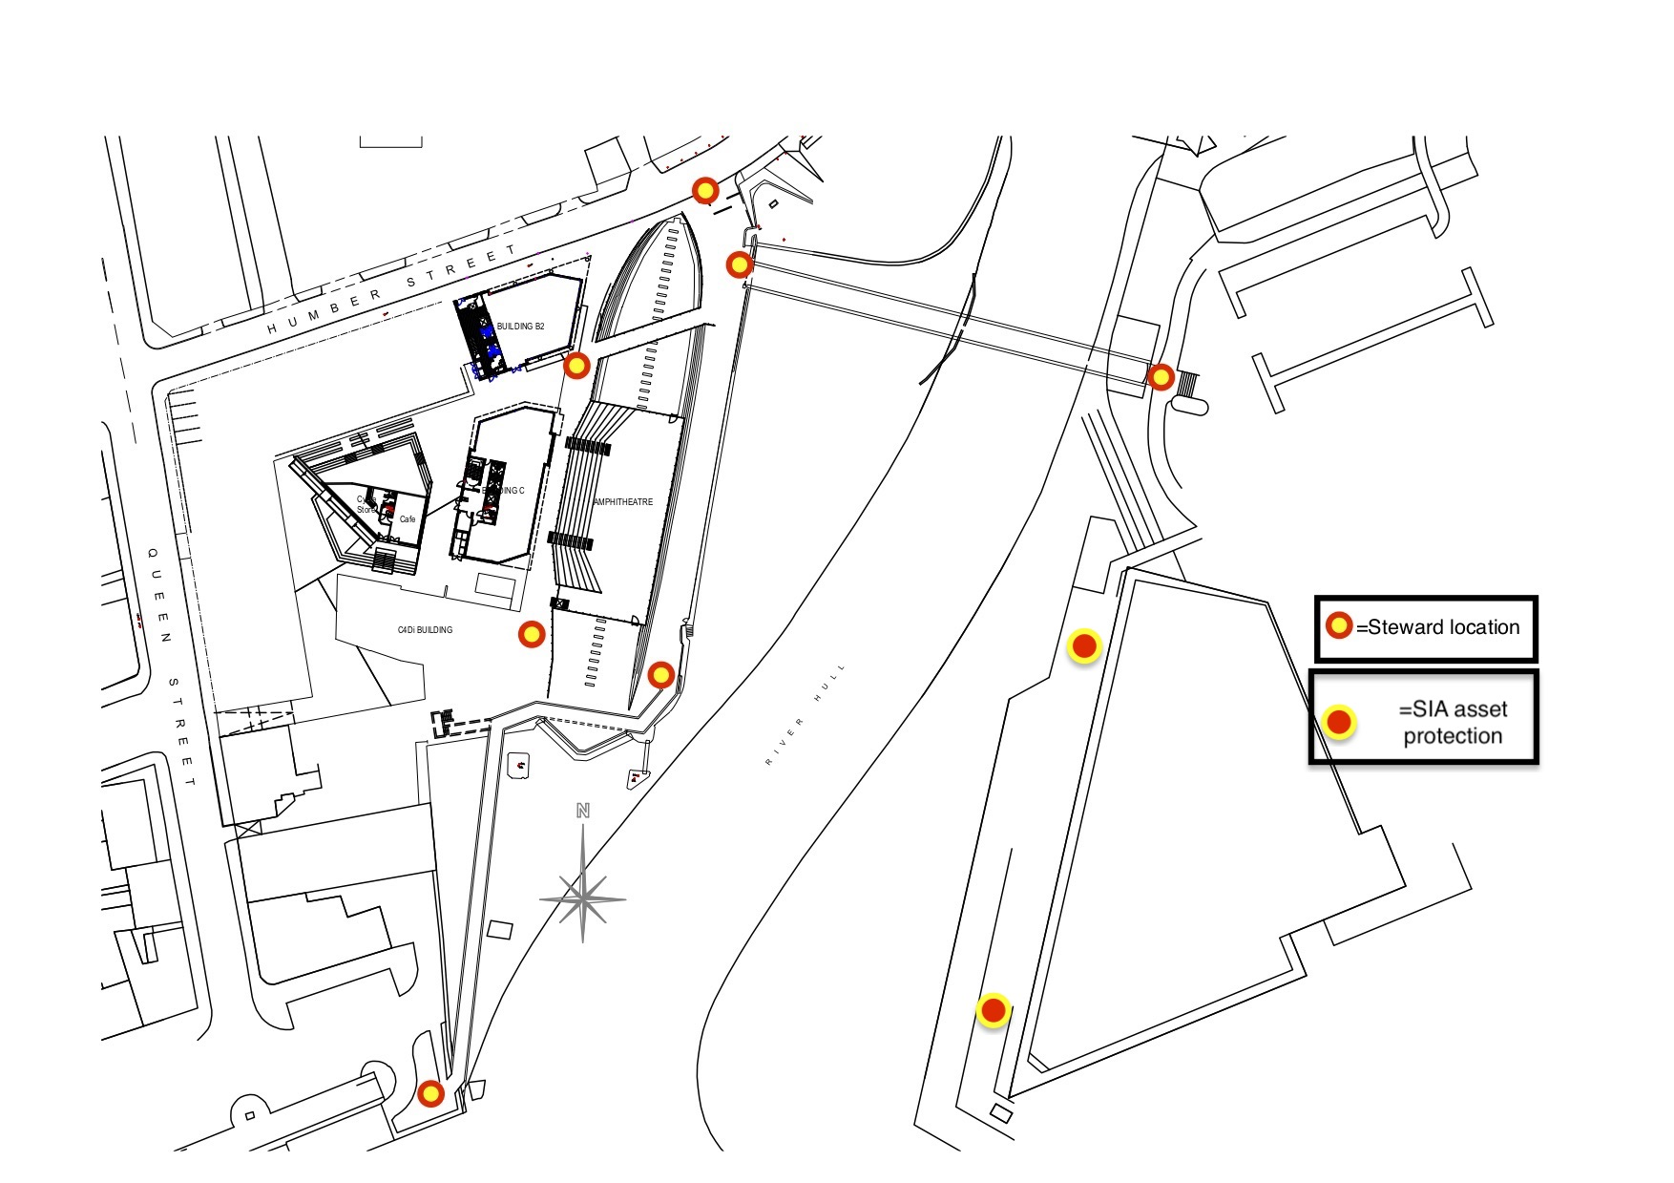

As the installation is open for 4 hours per day over 3 days and the projections repeat on a 10 minute cycle, this installation is not an event on the sense of having a start and finish time and audiences will be transitory, arriving and leaving across each evening.

The main viewing areas will be the footpath opposite The Deep, the area to the rear of Stage @the Dock and the footbridge between Stage @the Dock and The Deep. Stewards will be deployed as per the plan above, their main roles will be:

* To prevent overcrowding by guiding public to less crowded areas
* To prevent overcrowding by preventing access to viewing areas if they are full
* To clear the foot bridge if it needs to be opened to allow river traffic to pass

**9.0 Medical Plan**

As the public are likely to be in the area for a short time a full medical plan is not required, however 2 first aiders will be onsite during operational hours.

**10.0 Waste Management Plan**

Owing to the nature of the installation, the amount of waste generated is likely to be minimal and no additional resources are required.

**11.0 Noise Management Plan**

We are currently waiting for further details of the soundscape from the artists.

It is unlikely that the soundscape will generate high levels of noise, however this will be kept under review.

**12.0 Alcohol Management Plan**

Alcohol will not be onsale, therefore an alcohol management plan will not be required.

**13.0 Fire Safety Plan**

No infrastructure will be installed in public areas, therefore the installation presents no enhanced risk to the public.

All projection equipment installed in C4DI will be PAT tested and installed by competent personnel. Suitable and sufficient firefighting equipment will be provided in appropriate locations.

**14.0 Weather Management Plan**

Weather poses no additional risk as no infrastructure will be installed outside.

**15.0 Traffic Management Plan**

There will be no road closures or traffic management required for this installation.

**Section 4 – Public and Audience**

**17.0 Crowd Management and Welfare**

**17.1 Welfare Facilities**

As the installation is running on an 8 minute cycle the audience dwell time will be fairly short and therefore no additional welfare arrangements will be put in place.

**17.2 Evacuation Plan**

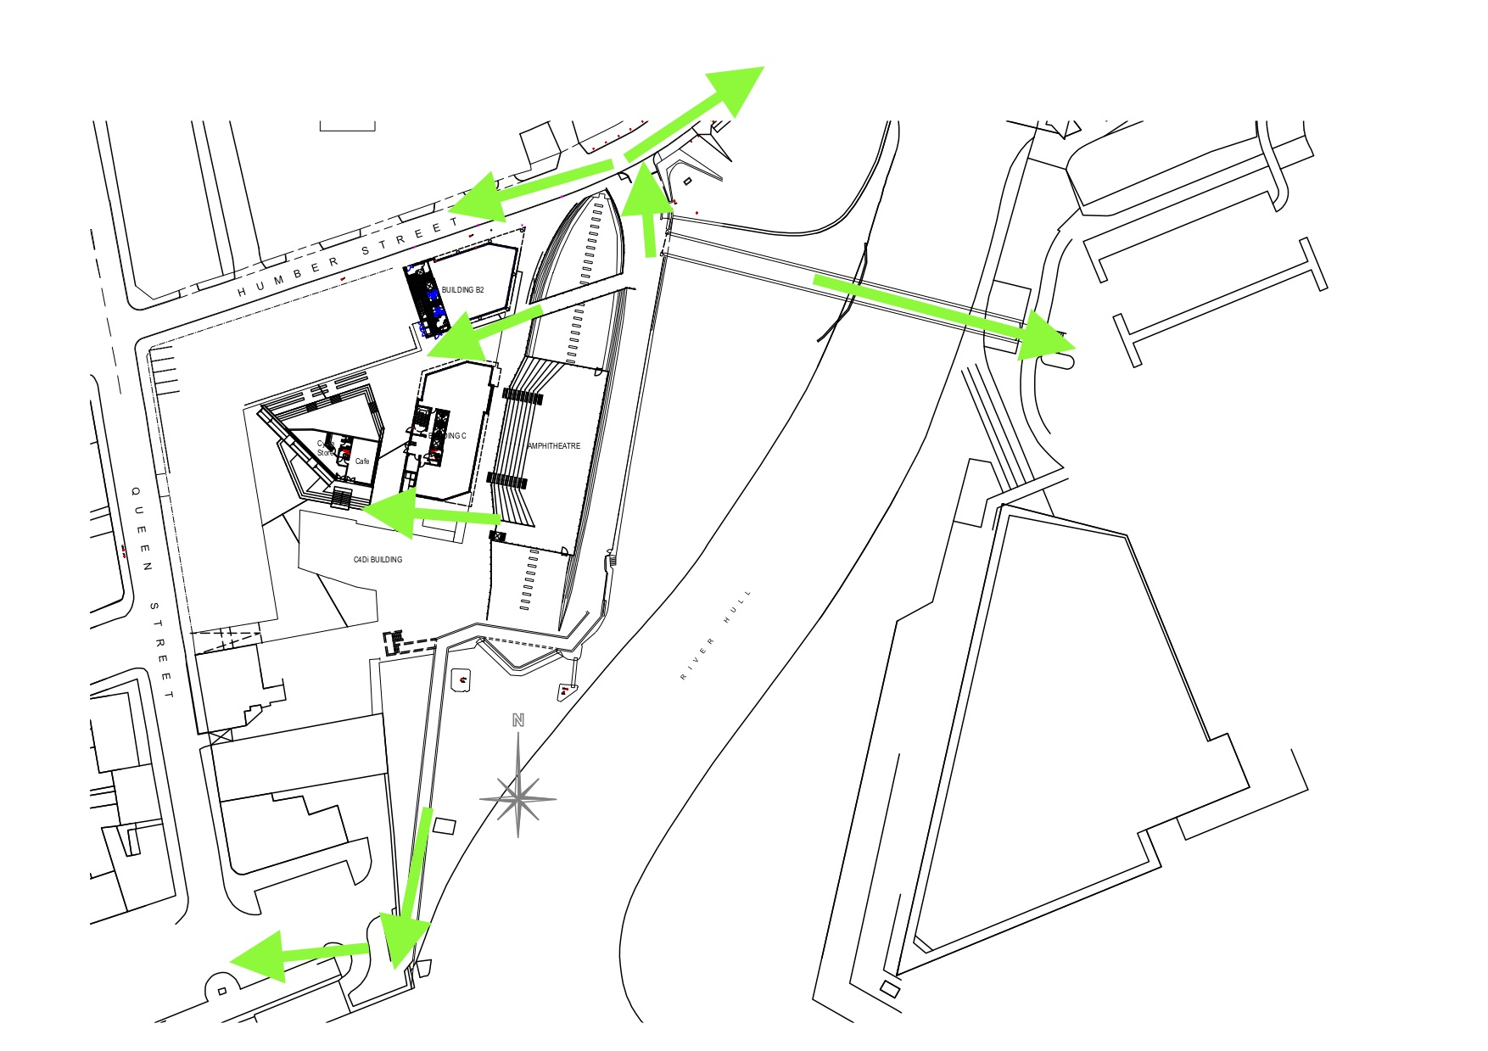

Multiple evacuation routes are available from the viewing areas. In the event of a situation requiring an evacuation the Event Manager will communicate this to the stewards who will move public to a safe area. Depending on the nature and location of the reason for the evacuation, the Event Manager may communicate that certain routes should not be used.

**17.3 First Aid**

Two first aiders, provided by a CQC registered organisation, will be on duty during operational hours.

**17.4 Lost Children** **or Vulnerable Adults**

Owing to the nature of the installation and the fact that it takes place in an open public space, lost childrens facilities will not be provided.

**17.5 Lost Property**

Any property found at the end of each evening will be taken to the Hull 2017 offices.

**17.6 Sanitary Facilities**

No additional sanitary facilities will be provided owing to the likely short dwell time.

**Section 5 – Site Plans**

**18.0 Site Plans**

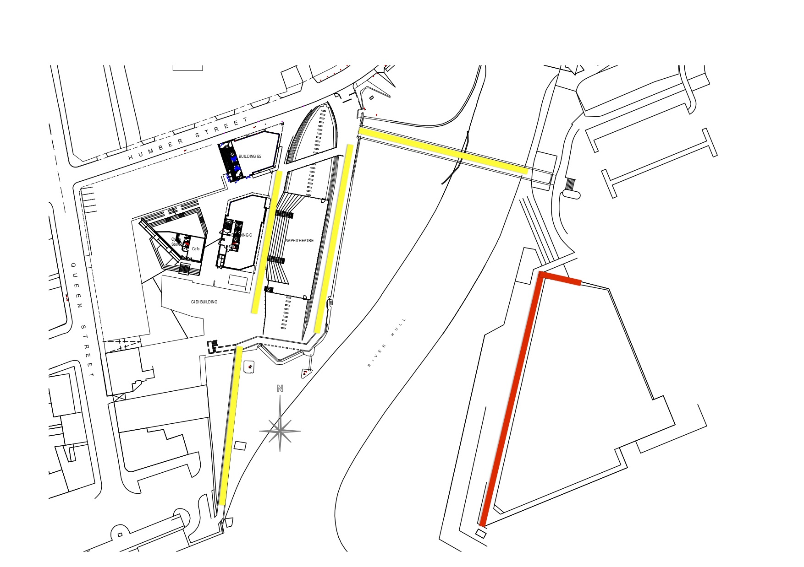

The main public viewing areas are indicated by yellow lines on the plan above. The images will be projected onto the Deep on the areas shown in red.

**Section 6 – Contractors Risk Assessments & Method Statements**

**19.0 Contractor RAMS**

See appendix 2

**Section 7 – Appendices**

**20.0 List of appendices**

1. **Installation risk assessment**
2. **Contractors risk assessments**

**Section 8 - References**

21.0 References

1. The Event Safety Guide (Second edition), HSG195, ISBN 9780717624539

2. Managing Crowds Safely, HSG154, ISBN 9780717618347

3. The Health and Safety at Work etc. Act 1974

4. The Management of Health and Safety at Work Regulations 1999  
4.5 The Management of Health and Safety at Work (Amendment) Regulations 2006

5. A Brief Guide to the Reporting of Injuries, Diseases and Dangerous Occurrences Regulations 2013, HSE INDG453(rev1), ISBN 9780717665747

6. A Brief Guide to Controlling Risks in the Workplace HSE INDG163(rev4), ISBN 9780717664634

7. The Work at Height Regulations 2005 (as amended) HSE INDG401(rev1), ISBN 9780717662319

8. Manual Handling Operations Regulations 1992 (as amended), ISBN 9780717628230

9. Lifting Operations and Lifting Equipment Regulations 1998. Approved Code of Practice and Guidance. ISBN 9780717665860

10. Provision and Use of Work Equipment Regulations 1998. Approved Code of Practice and Guidance. ISBN 9780717666195

11. Memorandum of Guidance on the Electricity at Work Regulations 1989. ISBN 9780817662289  
11. The Electricity at Work Regulations 1989 Guidance on Regulations. HSR25 (Third edition). ISBN 9780717666362

12. Maintaining Portable and Transportable Electrical Equipment. HSG107, ISBN 9780717628056

13. Safe Use of Ladders and Stepladders. INDG455, ISBN 9780717665181