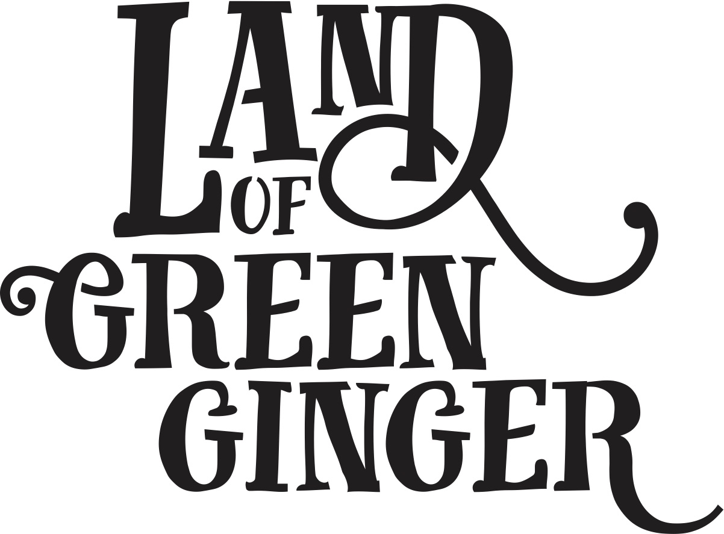

**Book**

**Project Plan**

**Summary**

Throughout the year Hull 2017’s ground-breaking community engagement project, Land of Green Ginger, invited Hull’s residents to immerse themselves in a magical citywide story, inspired by and celebrating the spirit of Hull.

In 2018, the Land of Green Ginger story will culminate in a seventh Act of Wanton Wonder – a beautiful book.

The Land of Green Ginger book will tell the stories of the project, the narrative as it took place and the stories of the local people it touched. It will be the record of City of Culture as lived by the residents of the city and as informed by their imagination and creativity.

This project plan outlines the formats, timescales and budget for delivery of the Land of Green Ginger book.

**Style**

260x210mm *(the same size as “hello hull” magazine)*

60 pages

300gsm outer cover

120gsm inners

Full colour throughout.

Special finish on cover.

PUR bound.

**Distribution**

On XX date before The Big Malarkey Festival a Land of Green Ginger book will be delivered to every single household in Hull.

**Quantities**

x118,500 for postage to reach every home in Hull.

x1,500 extra books printed for potential workshops.

**Timescales\***

The book will be distributed in the week of 18 June to tie in with a live moment/launch at The Big Malarkey Festival which takes place Thursday 20 – Sunday 24 June 2018.

To ensure delivery in the week of 18 June, the following deadlines will be in place:

|  |  |  |
| --- | --- | --- |
| **Date** | **Action** | **Lead** |
| W/C 29 January | Request for initial sketch submissions from contacted illustrators | Maddie, Illustrators |
| W/C 5 February | Initial sketches submitted by contacted illustrators | Maddie, Illustrators |
| W/C 12 February | Illustrator shortlisting | Maddie & Katy |
| W/C 12 February | Illustrator appointed | Maddie, Katy, Illustrator |
| W/C 26 February | First draft manuscript complete | Katy |
| W/C 26 February | Draft manuscript and full brief delivered for illustrator to start work | Maddie, illustrator |
| W/C 26 March | First draft sketches complete, feedback given | Illustrator |
| W/C 26 March | Final manuscript complete and submitted to illustrator | Katy |
| Monday 16 April | Quantity of books for print decided and addendum for print/delivery drawn up | Marketing lead |
| Monday 30 April | Final illustrations complete.  Illustrations, manuscript and design brief submitted to designer. | Illustrator  Marketing lead |
| Monday 30 April | Printing booked. | Marketing lead |
| Wednesday 2 May | Design work complete. Designer begin artworking. | Designer |
| Monday 7 May | Artworking complete | Designer |
| Monday 7 May | Book sent to print. | Marketing lead |
| Monday 7 May | Distribution company booked. | Marketing lead |
| w/c 11th June | Print complete and delivered to distribution agency for delivery to homes from Friday 15 June | Printer/ Distribution agency |
| Ws/C 11 and 18 June | Distribution | Distribution agency |
| Wednesday 20 – Sunday 24 June | Moment at The Big Malarkey Festival |  |

**\*Maddie – If you want to have the book ready and distributed BEFORE the Big Malarkey Festival, you’ll need to move all the deadlines forward by 2 weeks to ensure it makes this deadline.**

**Budget**

To be fully scoped – quotes with us in early January 2018.

|  |  |
| --- | --- |
| Writer/Illustrator | £15,000 |
| Design | £10,000 |
| Print | £60,000 |
| Postage | £50,000 |
| **Total** | **£135,000** |