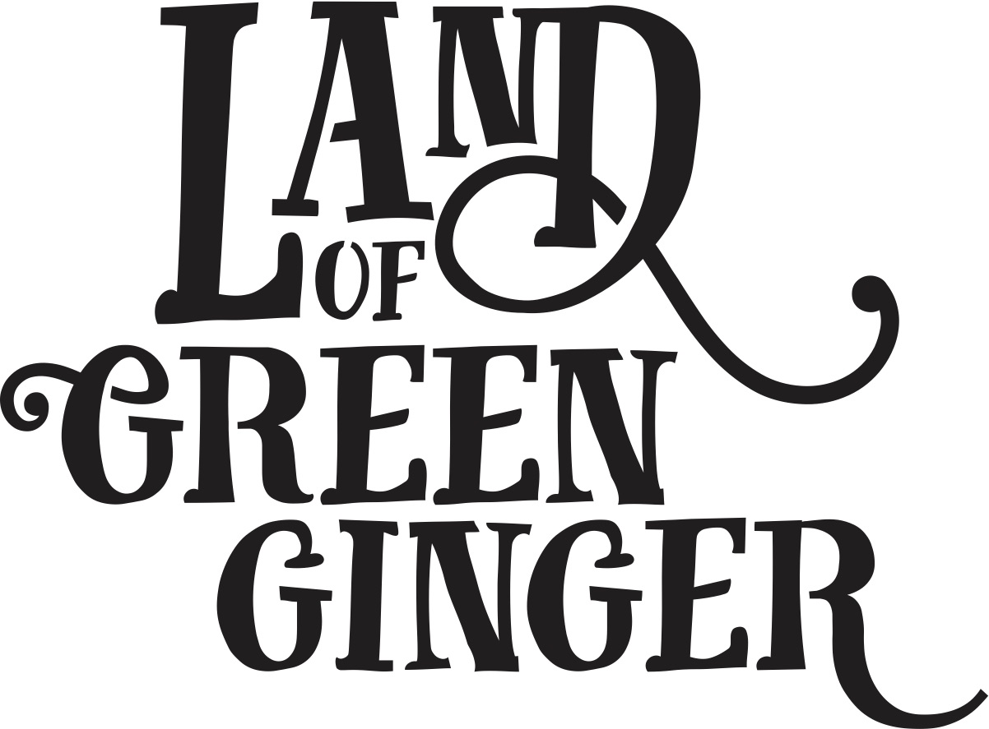

**Writer Brief**

Please find below stories for three of the six Acts, which are to be presented over up to 4 double-page spreads with text on the left-hand page and illustrations on the right.

We are interested in these stories being developed into a form that is more succinct, that tells the story, but doesn’t necessarily contain the amount of detail as below – the illustration will likely fill in the gaps. For information, we also attach the descriptions provided to the illustrator.

We’re looking for no more than **8-12 lines of text per page**. We’re interested in seeing a number of written forms for this, so please feel free to experiment. Often, we don’t know what we want until we’ve seen it!

Please send examples for as many of the stories as you can in the timeframe. We’d like to see examples by **Wednesday 28 March**.