**We made ourselves over**

For the last 18 months pioneering artists Blast Theory have been working with experts and residents in Hull and Aarhus to imagine a future city in 80 years time. Their project 2097: We Made Ourselves Over culminated in October and November with free public screenings of their short sci-fi films and immersive experiences imploring people to think about what they want for the future. Hear what Blast Theory have discovered on their journey and how we can work to achieve these future cities.

**Nick Tandavanitj**

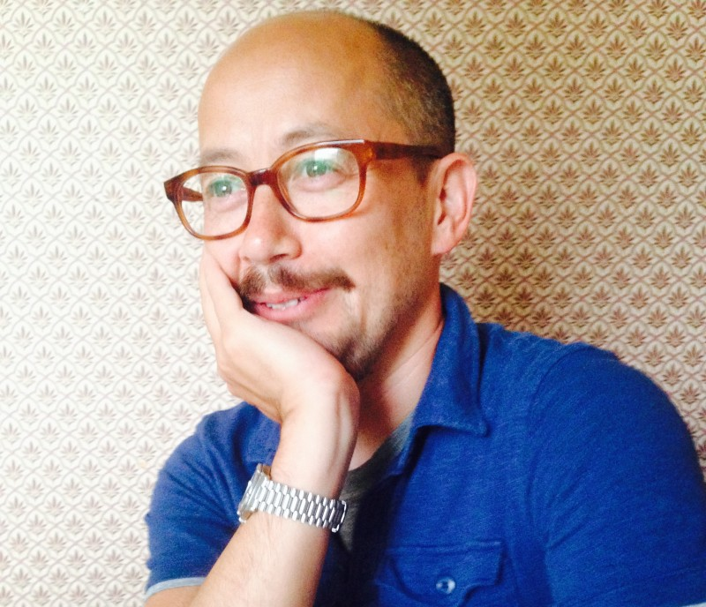

Nick Tandavanitj has worked with Blast Theory since 1994. In this time, Nick has focused on creative approaches to computing; contributing to the group’s unique mix of skills in structuring interactivity and narrative. This has led to particular skills in 3D modelling, technical design & programming for interactive installations and web based artwork.

**Rich Wilson**

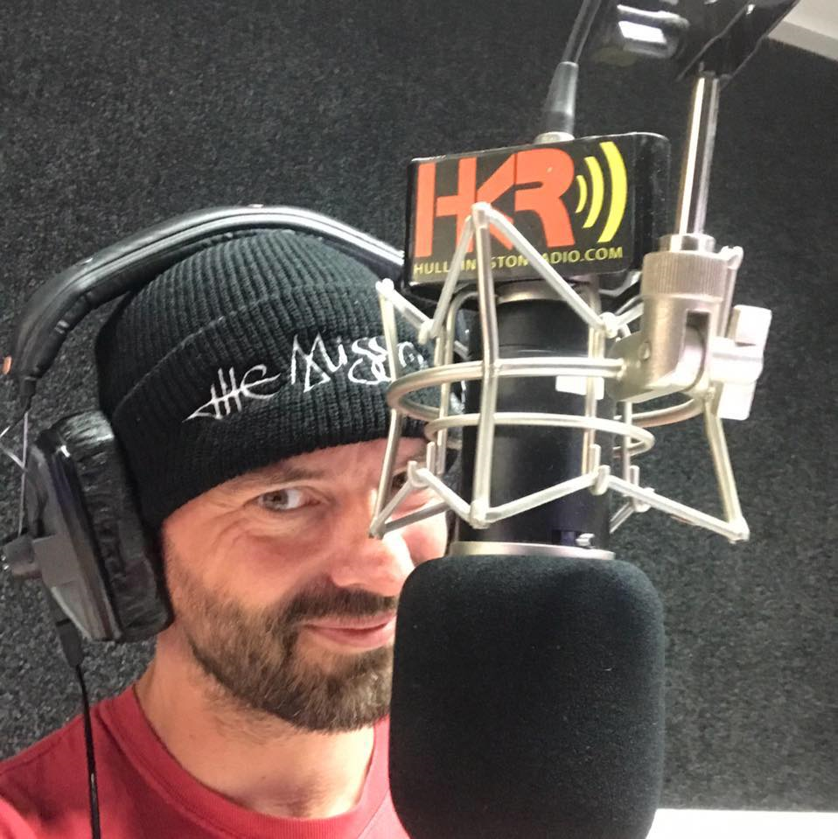 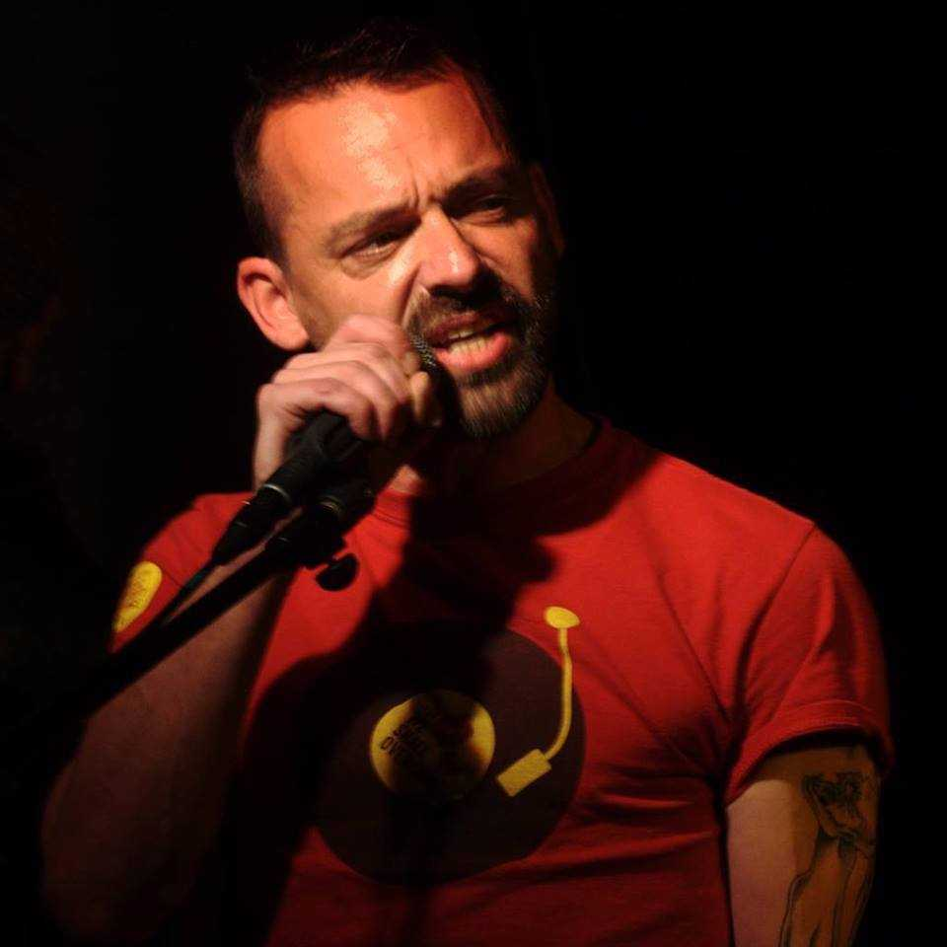

Founder of One Hull of a City, celebrating the wonderful and quirky culture Hull. Full of Hull humour and irreverent banter, often with great dollops of sarcasm. Information, events, arts, and positive discussions on issues that matter to the Hull community.