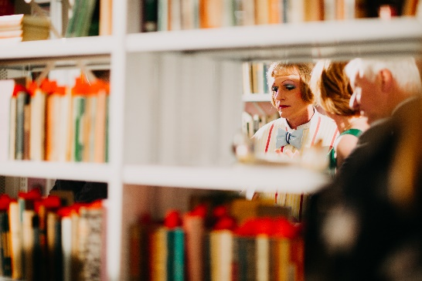

Grayson Perry at opening of Larkin:New Eyes Each Year exhibition with curator Anna Farthing and Philip Larkin Society member Philip Pullen. Photo: Thomas Arran

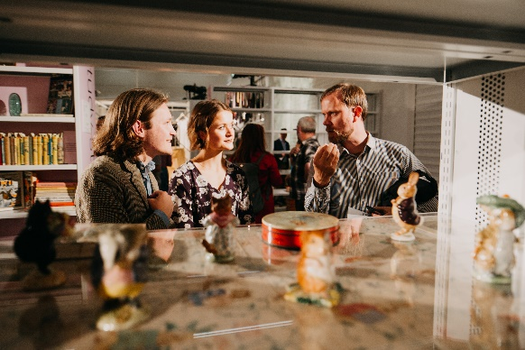

Visitors discussing Larkin’s obsession with Beatrix Potter characters. Photo Thomas Arran

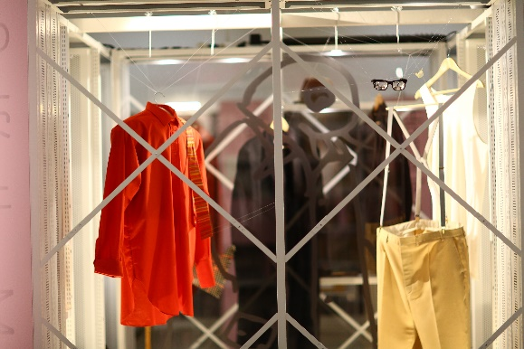

Larkin: New Eyes Each Year *Self’s the Man* installation exploring all the accessories to Philip Larkin’s sense of self, including his iconic glasses. Photo: Thomas Arran.

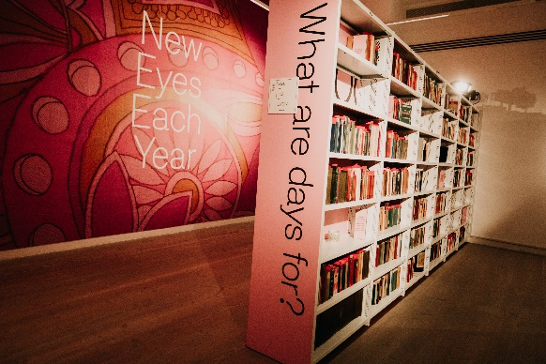

The entrance to Larkin: New Eyes Each Year featuring Larkin’s personal library overseen by a wallpaper inspired by one of Monica’s dresses also in the exhibition. Photo: Thomas Arran.