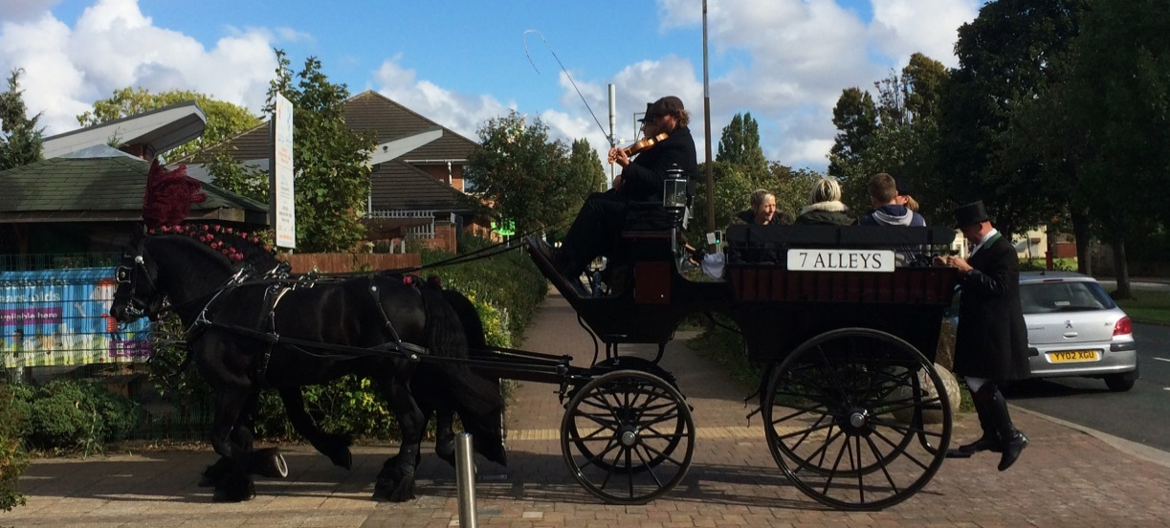

**‘7 Alleys’ by Periplum – a new outdoor night-time spectacle for Hull 2017 City of Culture**

**Opportunity for Volunteer Performers: Monday 1st May – Saturday 6th May 2017**

**Show** ‘7 Alleys’ is a brand new large-scale outdoor spectacle for audiences of up to 2,500 people, specially created for Hull 2017 by an internationally touring team of artists. It will be free to the public, performed at East Park and bring an East Hull legend to life. It features fire, pyrotechnics and promenading action taking place in and around the audience. This is a secret project and we would ask you to be part of keeping this secret to help bring a magical surprise to the East Hull community. If you’re interested in taking part in this exciting performance read on!

**Taking Part** This is an opportunity for up to 25 local participants to perform as part of a major outdoor spectacle. You will work with a team of expert practitioners, who will give you on-site training and workshops in outdoor performance. During the show you will accompany performers with lanterns, hand bells, fire torches and other pyrotechnic effects. Participants will be given fire and pyrotechnic safety training by an expert. Added to this, there will also be an opportunity for 2-4 pyrotechnic assistants to work with the pyrotechnic team, assisting them in preparation and performance.

**Information you should know** No previous acting experience is necessary, just an enthusiasm for taking part in outdoor work and an interest in chorus performance. You will need to bring black trousers and top (t-shirt/jumper/hoodie), wet weather gear, and solid walking shoes (preferably black) – you will be moving through dark and possibly soggy terrain. As performers carry fire and pyrotechnic effects, all participants must be over 18 years old.

**Dates & Times** If you want to take part, you will be required for all of the following times:

6pm – 9pm on Sunday 30th April

5.30pm – 10.30pm on Monday 1st May 2017

5.30pm – 10.30pm on Tuesday 2nd May 2017

5.30pm – 10.30pm on Wednesday 3rd May 2017

5.30pm – 10.30pm on Thursday 4th May 2017

6.30pm – 10.30pm on Friday 5th May 2017

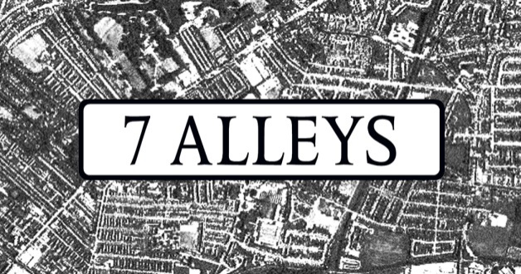6.30pm – 10.30pm on Saturday 6th May 2017

**Location/meeting point:** The Pavilion, East Park, Holderness Road, East Hull