**CREATIVE PARTNERS**   
**END OF PROJECT REPORT**

**GENERAL INFORMATION**

|  |  |
| --- | --- |
| **ORGANISATION NAME:** | Hull 2017 / Ferens Art Gallery |
| **PROJECT NAME:** | Turner Prize 2017 |
| **MAIN CONTACT:** | Lily Mellor / Pippa Gardner |
| **REPORT SUBMISSION DATE:** | January 2018 |

1. **PROJECT REPORT**

|  |  |  |
| --- | --- | --- |
| **DOCUMENTS** | **PROVIDED** | **N/A** |
| * Delivery Plan |  |  |
| * Budget |  |  |
| * Marketing & Communications Plan |  |  |
| * Learning & Engagement Plan |  |  |
| * Risk Register |  |  |

Final copies of these documents are stored separately to this report on SharePoint.

1. **MONITORING & EVALUATION REPORT**
2. **ACTIVITY**

|  |  |  |
| --- | --- | --- |
|  |  | |
| **ACTIVITY** | | |
| **PRODUCTIONS AND PERFORMANCES** | | |
| No. of productions or co-productions | 1 (Turner Prize Awards) | |
| No. of productions or co-production performances | 1 (Turner Prize Awards) | |
| No. of productions inspired by history / heritage | 0 | |
| No. of accessible performances | 0 | |
| **EXHIBITIONS AND SCREENINGS** | | |
| No. of exhibitions | 1 | |
| No. of exhibition days | 105 | |
| No. of exhibitions inspired by history / heritage | 0 | |
| No. of access provisions | 0 | |
| **LEARNING AND PARTICIPATION** | | |
| No. of participant opportunities* (in-house) | 15 | |
| No. of participant opportunities* (outreach) | 0 | |
| No. of school’s engagement opportunities* (in-house) | 0 | |
| No. of school’s engagement opportunities* (outreach) | 0 | |
| No. of artist development opportunities* (in-house) | 0 | |
| No. of artist development opportunities* (outreach) | 0 | |
| No. of staff training opportunities* (in-house) | 3 (Volunteer Training) | |
| No. of staff training opportunities* (outreach) | 2 (Volunteer Masterclasses) | |
| No. of opportunities exploring history / heritage | 1 | |
| No. of opportunities to build historical / heritage-based skills or knowledge | 0 | |
| No. of accessible learning and participation activities | 4 (BSL and Audio Described Tours) | |
| **ACTIVITY VENUES/LOCATIONS** | | |
| No. of activities delivered in HU1 – HU9 | | 17 |

**Please provide a short description of the activities delivered:**

Turner Prize, one of the world’s most renowned art prizes, is awarded by Tate to an artist who has exhibited outstanding work in the previous year. The four shortlisted artists for 2017 exhibited their work at Ferens Art Gallery, Hull, from September 2017 to January 2018 with the overall winner announced in early December 2017. Through genres such as portraiture, landscape and still life, the four artists explored how art is able to respond to political and social upheaval.

A series of events and workshops complemented the groundbreaking exhibition at Ferens Art Gallery.

[TURNER // RETURN](https://www.hull2017.co.uk/whatson/events/turner-return/)

16 Nov, 6pm until late (Free, unticketed), Ferens Art Gallery

Turner // Return (16 Nov) was a free, unticketed, late-night event at Ferens Art Gallery, giving visitors chance to see the exhibition in a whole new light. Turner // Return will be a night of panel discussions, debate, music and dancing, alongside film screenings and interactive workshops.

MEET ME AT THE BLUE BOX

Throughout October (Free, drop in), Across the city

The Blue Box is a place to meet, exchange conversation and join in workshops outside of the gallery.

[CURATOR TOURS](https://www.hull2017.co.uk/whatson/events/turner-prize-2017-curator-tours/)

12 Oct, 6pm / 13 Oct, 11am / 26 Oct, 6pm / 9 Nov, 6pm / 3 Dec, 10am (Free, ticketed), Ferens Art Gallery

The Turner Prize 2017 curators lead tours of the exhibition and discussions about the works on display. Tours lasted approximately 45 minutes.

AUDIO DESCRIBED TOURS

6 Oct, 1.30pm / 5 Nov, 1.30pm (Free, booking required), Ferens Art Gallery

Tours lasted approximately 45 minutes.

BSL CURATOR TOURS

13 Oct, 11am / 26 Nov, 11am (Free, booking required), Ferens Art Gallery

Tours last approximately 45 minutes.

WORKSHOPS FOR ADULTS:

[THROUGH THE LENS: FILM WORKSHOP](https://www.hull2017.co.uk/whatson/events/through-the-lens-film-workshop/)

7 Oct, 10.30 am – 2.30pm (£5), Ferens Studio

[BEYOND THE PENCIL: DRAWING WORKSHOP](https://www.hull2017.co.uk/whatson/events/beyond-the-pencil-drawing-workshop/)

28 Oct, 10.30 am – 2.30pm (£5), Ferens Studio

[EYE FOR DETAIL: CURATING WORKSHOP](https://www.hull2017.co.uk/whatson/events/eye-for-detail-curating-workshop/)

18 Nov, 10.30 am – 2.30pm (£5), Ferens Studio

[PRINTED OPINIONS: WRITING WORKSHOP](https://www.hull2017.co.uk/whatson/events/printed-opinions-writing-workshop/)

9 Dec, 10.30 am – 2.30pm (£5), Ferens Studio

WORKSHOPS FOR CHILDREN:

[MINI MASTERPIECES](https://www.hull2017.co.uk/whatson/events/mini-masterpieces-3/)

31 Oct, 10 – 11.30am (Free, ticketed), Ferens Studio, Age 2 – 5

[ART ACADEMY: FOCUS ON PRINTING](https://www.hull2017.co.uk/whatson/events/art-academy-focus-on-printing/)

1 Nov, 1 – 3pm (Free, ticketed), Ferens Studio, Age 8 – 12

[ART ACADEMY: FOCUS ON DRAWING](https://www.hull2017.co.uk/whatson/events/art-academy-focus-on-drawing/)

2 Nov, 1 – 3pm (Free, ticketed), Ferens Studio, Age 8 – 12

[THE BIG DRAW](https://www.hull2017.co.uk/whatson/events/the-big-draw-3/)

4 Nov, 11am – 3pm (Free, drop in), Ferens Studio, All ages

The Turner Prize 2017 Award Ceremony took place on 5th December 2017 and was presented by artist and DJ Goldie.

**If any of the above has been inspired by, explored, or built skills and knowledge in history / heritage (especially that linked to Hull’s past), please briefly explain how below.**

The ‘MEET ME AT THE BLUE BOX’ was inspired by history and heritage.

*“Yes and people would refer to it locally as the blue box and it was like a meeting point, you know - Meet Me at The Blue Box at the station. And it’s quite a common thing that people know of locally. Not necessarily younger generations because it hasn’t exited there for 10 years minimum, but a newsstand, we just thought using a newsstand, it’s something that everybody recognises. So we wanted to sort of tap into that nostalgia whilst keeping it as something everybody – no matter where they’re from would be able to connect with in some way.”* – Meet Me At The Blue Box Project Lead

**Thinking about your project as a whole, what would you say have been the main successes and challenges in terms of the activity delivered:**

Turner Prize 2017 ran at the Ferens Art Gallery from 26th September 2017 – 7th January 2018, attracting over 119,625 visitors in total, an average of 1208 a day. This figure makes it the second most visited Turner Prize exhibition outside of London and helped the Ferens secure a 309% increase in visitor numbers over the year. The exhibition surpassed our overall prediction of 100,000 visitors and was the third most visited Turner Prize ever when compared to past totals:

2016 54,554 (574 per day)

2015 74,787 (Glasgow)

2014 50,331 (519 per day)

2013 52,696 (Derry-Londonderry)

2012 70,547 (759 per day)

2011 149,770 (Gateshead)

2010 51,975 (579 per day)

2009 76,799 (883 per day)

2008 92,332 (855 per day)

2007 71,802 (854 per day, Liverpool)

2006 79,415 (786 per day)

2005 94,042 (1,000 per day)

2004 75,928 (1,168 per day)

2003 101,216 (1,281 per day)

2002 69,245 (1,065 per day)

2001 70,754 (983 per day)

2000 (68,727 (870 per day)

1999 133,597 (1,201 per day)

1998 102,454 (1,404 per day)

1997 85,003 (1,076 per day)

1996 59,362 (813 per day)

Over 30 arts correspondents travelled from London for the press preview and the exhibition received critical acclaim, with review headlines reading; “Deals with themes you might actually care about” (The Times), “Turner Prize 2017: Older artists, better show” (Financial Times) and “A quiet but powerful Turner Prize” (Apollo Magazine).

Upon entering the gallery, the Ferens Central Court gallery offered an orientation space for visitors, including a written welcome from the curators, a map and a bespoke bureau which housed the four specially made artists’ films. Two editions of a newspaper, The Ferens Echo, were developed by the curators and available for free from the gallery. The first edition offered further context including words from the curators, an art quiz and interviews with the artists. The second edition was launched at Turner//Return – a free, late night event at the gallery which formed part of the joint Hull 2017 and Hull Culture and Leisure public programme. This edition included responses from the curators to some of the best comments left by visitors, reinforcing one of the chosen marketing phrases, “Whatever you think about Turner Prize 2017, you’re right”. Screens in the central court bureau also showcased comments that were collected through iPads and through physical cards, encouraging discussion and interaction. The success of the above highlighted the lack of orientation space when entering the Ferens and the bureau has been donated to the gallery for future use.

The Turner Prize 2017 learning and engagement programme was a collaboration between Hull 2017 and Heritage Learning, Hull Culture and Leisure’s engagement department. Together, we developed an extensive programme of workshops, talks and events for schools and for the public. Building on existing Heritage Learning formats, Hull 2017 were able to support our partners by expanding their artist and audience networks, and through underwriting costs so that events were made more financially viable for audiences. A large proportion of the public programme was free and the majority of paid events were £5 or under. We were able to test innovative ideas that were new to the gallery and to Hull; These risks paid off, with the majority of events selling out within the first week of the exhibition.

Highlights included Turner//Return: an ‘artist take over’ of the gallery which succeeded in attracting a new, less engaged audience to the Ferens and Turner Prize 2017 through a range of exciting talks, performances, workshops, tours and live music. The event brought 735 people to the gallery, compared to the usual average of 84 on a Thursday evening. Meet Me At The Blue Box was one of the Ferens’ most ambitious community outreach projects, engaging with over 5000 people in hard-to-reach communities around Hull to break down barriers and build confidence in thinking and talking about visual art.

The free curator tours were extremely popular; However, demand shows that it would have been beneficial to programme more, or to train Front of House staff or Volunteers to lead tours. School group visits were also popular, with almost 3000 school children coming to see the prize on organised visits. To avoid overcrowding, groups were encouraged to book in to time slots. Although self-led, each group were provided with learning resources to aid their visit but tours, if resources were available, would have been beneficial. Many more people attended BSL Interpreted and Audio Descriptive Tours of the exhibition than we expected, when compared with take-up for similar tours on other Hull 2017 events across the year. These tours have helped strengthen the Ferens’ reputation for providing bespoke opportunities for those with access needs, as it was not something they had previously offered.

The Turner Prize 2017 Award Ceremony took place on 5th December 2017 and was presented by artist and DJ Goldie. The grandeur of the venue made it an excellent choice for the ceremony and it looked great for the press, but came with inherent difficulties such as having to bring in field catering and lack of accessible toilets. Hull 2017’s experienced events team led on the operational logistics of the event, and mediated between Tate, BBC and Bolton & Quinn to ensure the smooth running of the ceremony over two venues; Hull Minster and the Ferens Art Gallery. We received a positive amount of RSVPs on our first wave of invitations, meaning a second wave was not sent out. The guest list was a healthy mix of local, national and international artists and arts professionals. Local and national press attended the event, including 15 arts correspondents from London. Pinning down timings for the live BBC broadcast proved difficult as it was only the second Turner Prize with them as media partners and, because of this, they were unsure about which format they’d like their coverage to take. Despite this, we were able to plan as much as possible and still managed to send the invitations with timings out on time.

1. **CAPACITY TO DELIVER THE PROJECT**

|  |  |  |  |
| --- | --- | --- | --- |
|  | **TOTAL NO. INDIVIDUALS** | **TOTAL NO. WHO ARE HULL RESIDENTS** | **TOTAL NUMBER OF DAYS WORKED** |
| **CATEGORY OR ROLE** | | | |
| **CORE PROJECT TEAM (HULL 2017 AND HC&L EMPLOYEES)** | | | |
| Producer | 3 | 2+ | Employees |
| Other Production | 1 | 0+ | Employees |
| Curator | 0 | 0 | Employees |
| Conservator | 0 | 0 | Employees |
| Archivist | 0 | 0 | Employees |
| Other Curatorial | 0 | 0 | Employees |
| Executive Director | 0 | 0 | Employees |
| Researcher | 2 | 1+ | Employees |
| Marketing & Communications | 6 | 0+ | Employees |
| Learning & Participation | 2 | 0 | Employees |
| Development | 0 | 0 | Employees |
| Finance | 0 | 0 | Employees |
| Operations | 0 | 0 | Employees |
| Admin | 0 | 0 | Employees |
| Front of House | 0 | 0 | Employees |
| Other staff | 1 | 0+ | Employees |
| **ADDITIONAL CAPACITY (PROJECT SPECIFIC CONTRACTS)** | | | |
| Other Production | 8 | Unknown |  |
| Artist / Performer | 4 | Unknown |  |
| Co-Curator | 3 | Unknown |  |
| Front of House | 4 | Unknown |  |

**In the tables on this and the following page, please enter the number of people contracted to make this project happen, who fall into each of the equal opportunities categories listed. If you do not know please leave this blank.**

|  |  |  |  |  |
| --- | --- | --- | --- | --- |
|  | **TOTAL** |  |  | **TOTAL** |
| **AGE GROUPS – DELIVERY TEAM** | |  | **DISABILITY/LONG TERM ILLNESS – DELIVERY TEAM** | |
| 16-17 years | 0 |  | Yes – limited a lot | 0 |
| 18-19 years | 0 |  | Yes – limited a little | 1 |
| 20-24 years | 0 |  | No | 8 |
| 25-29 years | 5 |  | Prefer not to say | 8 |
| 30-34 years | 2 |  | **ETHNICITY – DELIVERY TEAM** | |
| 35-39 years | 2 |  | Welsh/English/Scottish/Northern Irish/British | 10 |
| 40-44 years | 0 |  | Irish | 0 |
| 45-49 years | 0 |  |  | 0 |
| 50-54 years | 1 |  | Polish | 0 |
| 55-59 years | 0 |  | Any other White background | 0 |
| 60-64 years | 0 |  | White and Black Caribbean | 0 |
| 65-69 years | 0 |  | White and Black African | 0 |
| 70-74 years | 0 |  | White and Asian | 0 |
| 75+ years | 0 |  | Any other Mixed/multiple ethnic background | 0 |
| Prefer not to say | 7 |  | Indian | 0 |
| **GENDER - DELIVERY TEAM** | |  | Gypsy or Irish Traveller | 0 |
| Male | 5 |  | Pakistani | 0 |
| Female | 4 |  | Bangladeshi | 0 |
| Transgender | 0 |  | Chinese | 0 |
| Gender non-conf | 1 |  | Any other Asian background | 0 |
| Prefer not to say | 7 |  | African | 0 |
|  |  |  | Caribbean | 0 |
|  |  |  | Any other Black/African/Caribbean background | 0 |
|  |  |  | Arab | 0 |
|  |  |  | Any other ethnic group | 0 |
|  |  |  | Prefer not to say | 7 |

**Thinking about your project as a whole, what would you say have been the main successes and challenges in terms of the staff employed and the partnership working invovled to deliver your activity?**

The curatorial team, Sacha Craddock and George Vasey, brought a mix of experience, opinion and character to their roles, creating a healthy dialogue and resulting in a well-balanced and dynamic Turner Prize exhibition. Each curator worked closely with two of the artists, and with a staggered install, were able to devote enough time and means to support each artist properly. The curators presented solid reasoning for each artist exhibiting in each particular room: All were pleased with the choice and embraced working alongside the collection and with the history of the building and the city.

4 members of the core project team reported gaining new skills and 4 reported developing existing skills. 5 respondents answered the following question and reported gaining or developing a wide range of skills:

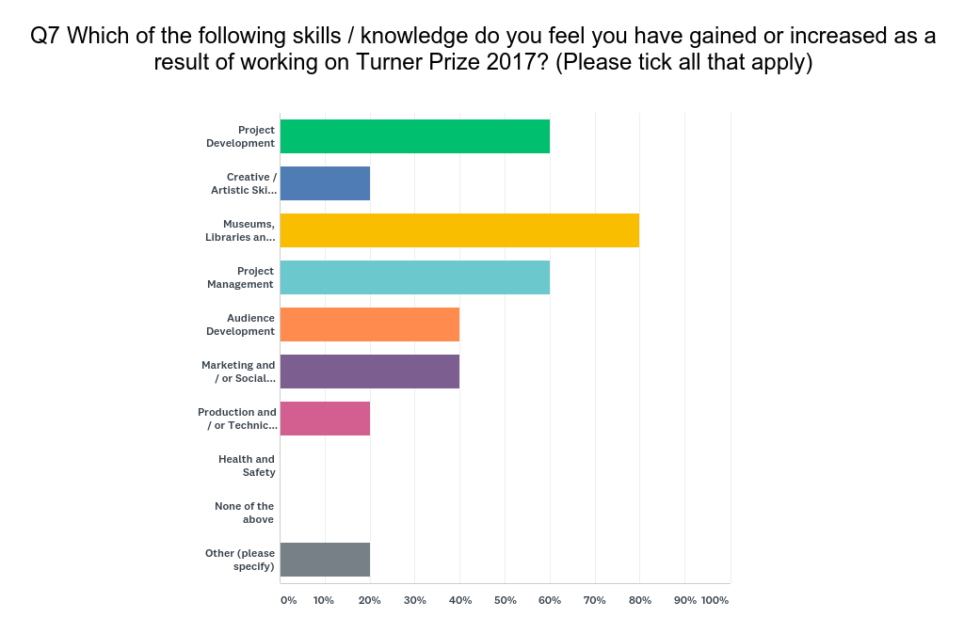

*“Having worked on the Turner Prize 2017, I have had the opportunity to work on all aspects of the exhibition and the wider learning & participation programme which was fulfilling and enabled me to have more responsibility and ownership of events than my previous role within the Hull 2017 organisation”* – Core Project Team Member

Respondents gave very mixed ratings regarding the ability to collaborate, the ability to form new partnerships and the ability to develop existing relationships. This is explained in some of the comments:

*“Hull 2017 were the contractual partners and as such HCAL had little direct involvement with the process of curation other than installation and deinstall, the day to day management of the exhibition (all already our core business) and addressing all matters arising. We have a long standing and close working relationship with Tate teams but had virtually no contact with Tate over the TP exhibition as it was dealt with by Hull2017 colleagues. There was an intent to involve the Ferens team in the planning and curation more but it never happened perhaps as the partnership between Hull2017 and Tate itself (and the artists) required much time and was complex/many people involved. Much info such as copy for catalogue was never supplied and issues such as PR and Ferens brand entirely missed. Had Ferens brand been used alongside Tates (alone) this would have significantly helped to raise future awareness of the Ferens and its ongoing role in visual arts delivery in the city.” –* Core Project Team Member

*“In almost all cases, the partnerships developed over the course of the project into a more comfortable and collaborative space, from an early position which was less so.” –* Core Project Team Member

Elements of the Learning and Participation programme were felt to have been a success, although many challenges with timescales and partnership working were noted by survey respondents.

*“Very successful, the main challenge was producing the Turner // Return event under tight timescales with little planning time. We also had a great turnout for all BSL tours, especially BSL users turning up without booking which is very unusual.” –* Core Project Team Member

*“The partnership element was quite challenging and we ended up with parallel programmes to some degree. Turner Return was successful thanks to dedicated team working on it.” –* Core Project Team Member

*“Turner Return - great! But last minute. Blue Box - didn't meet expectations.” –* Core Project Team Member

Four Turner Prize Supervisors were hired for the duration of the 15 week exhibition, whose roles were to oversee the daily running of the exhibition and to manage 452 specially-trained Turner Prize volunteers. Throughout the course of the 15-week exhibition, the exhibition remained popular and the Ferens saw little drop in visitor numbers.

Overall, the partnership working between different organisations with their own policies and procedures was the largest challenge of the project identified by the project team. In response to the question “What were the major challenges of Turner Prize 2017?”:

*“Working with 2017 team and artists. A lack of understanding of high museum and gallery standards.”* – Core Project Team Member

*“Working alongside HCAL and changing their attitude towards Hull 2017 and the demanding programme was a challenge. Their commitment to the exhibition, in particular the out of the ordinary events (awards night, Turner // Return) however was exceptional.”* – Core Project Team Member

Respondents also identified areas of learning that they would take forward in future projects:

*“Partnership experience and complexity as a stumbling block- too many involved to make it work effectively to really bring benefit back to us as an organisation ie in terms of staff development. Realisation that we could NOT have delivered the Turner Prize without the H2017 team following the delivery of the refurb and programme to April 2017. The freelance specialist contemporary art curators and project management by Hull2017 and their vols etc was done well and all roles were critical to the good results so - no matter how hard at the time- the decision to deal at arms length and relinquish our usual involvement was the right one.”* – Core Project Team Member

*“Working alongside multiple organisations, each with specific needs was challenging in the best way possible. It was necessary to ensure, during the planning stage, that we allowed enough time to ensure all the information was circulated to the correct people at the right time to maintain lines of communication without overwhelming everybody.”* – Core Project Team Member

*“It is vital that Tate/Turner Prize teams work more closely with venues and make detailed plans well in advance of the exhibition. HCAL offered our knowledge and experience in advance of the exhibition, but this wasn't taken on board until we were ready for installing, which caused a huge amount of unnecessary stress and pressure on our team. Use the resources that are available and the outcome will be much better for everyone. I also think that there needs to be clarity with the artists how they behave towards the team involved, which in this case was pretty disgraceful, both for the 2017 team and HCAL.”* – Core Project Team Member

1. **AUDIENCES**

|  |  |  |  |  |  |  |
| --- | --- | --- | --- | --- | --- | --- |
|  | | | | **TOTAL** | **% FROM HU1-HU9\*** | |
| Number of audience members* (in-house) | | | | 116262 | 19.8% | |
|  | **%** |  |  | | | **%** | |
| **AGE GROUPS - AUDIENCES** | |  | **DISABILITY/LONG TERM ILLNESS - AUDIENCES** | | | | |
| 0-2 years | Not Represented in Survey |  | Yes – limited a lot | | | 2.3% | |
| 3-5 years |  | Yes – limited a little | | | 6.0% | |
| 6-10 years |  | No | | | 90.9% | |
| 11-15 years |  | Prefer not to say | | | 0.8% | |
| 16-17 years | 0.4% |  | **ETHNICITY** | | | | |
| 18-19 years | 0.9% |  | Welsh/English/Scottish/Northern Irish/British | | | 94.9% | |
| 20-24 years | 1.8% |  | Irish | | | 0.8% | |
| 25-29 years | 2.2% |  | Gypsy or Irish Traveller | | | 0.4% | |
| 30-34 years | 2.7% |  | Polish | | | 0.0% | |
| 35-39 years | 6.7% |  | Any other White background | | | 0.0% | |
| 40-44 years | 8.9% |  | White and Black Caribbean | | | 0.4% | |
| 45-49 years | 8.0% |  | White and Black African | | | 0.0% | |
| 50-54 years | 9.8% |  | White and Asian | | | 0.4% | |
| 55-59 years | 13.8% |  | Any other Mixed/multiple ethnic background | | | 0.0% | |
| 60-64 years | 23.6% |  | Indian | | | 0.0% | |
| 65-69 years | 20.0% |  | Pakistani | | | 0.0% | |
| 70-74 years | 0.0% |  | Bangladeshi | | | 0.0% | |
| 75+ years | 0.9% |  | Chinese | | | 0.0% | |
| Prefer not to say | 0.4% |  | Any other Asian background | | | 0.0% | |
| **GENDER** | |  | African | | | 0.0% | |
| Male | 36.1% |  | Caribbean | | | 0.0% | |
| Female | 62.7% |  | Any other Black/African/Caribbean background | | | 0.0% | |
| Transgender | 0.4% |  | Arab | | | 0.0% | |
| Gender non-conf | 0.4% |  | Any other ethnic group | | | 0.0% | |
| Prefer not to say | 0.4% |  | Prefer not to say | | | 3.1% | |

**Thinking about your project as a whole, what would you say have been the main successes and challenges in terms of audience engagement and feedback for your project?**

Turner Prize 2017 was the first Turner Prize exhibition to have no set route; There were multiple entrances to the exhibition and visitors were free to view the rooms in any order they wished. This encouraged audiences to spend more time in the exhibition and allowed them to interact with the entire gallery and collection, not just the prize. Permanent collection galleries were used to display Turner Prize 2017, cementing the prize in the history of the building and, through a re-hang, the well-known and well-loved collection was reinvigorated for both new and familiar audiences.

26% of audience members had previously attended the Turner Prize exhibition in previous years, whereas for 73% of respondents it was their first time. In response to the question “What was your main reason for attending Turner Prize 2017?”, the following responses were given:

|  |  |  |
| --- | --- | --- |
| Because it’s part of Hull UK City of Culture 2017 | 40.94% | 113 |
| Because I'm a regular attender of Turner Prize | 1.45% | 4 |
| Because I'm a regular attender of Ferens Art Gallery | 10.51% | 29 |
| It’s a unique experience not to be missed | 21.38% | 59 |
| General interest in this type of event | 9.78% | 27 |
| Wanted to see / do something creative | 0.72% | 2 |
| Getting involved in what’s happening | 1.45% | 4 |
| Trying something new or different | 1.45% | 4 |
| Something to do while I’m in Hull on business | 0.00% | 0 |
| It’s affordable / good value | 0.00% | 0 |
| Something to do with friends / family | 2.90% | 8 |
| Something to do with the kids | 1.09% | 3 |
| Interested to find out more about Hull | 1.09% | 3 |
| No particular reason / someone else’s idea | 0.72% | 2 |
| I was in the area anyway | 2.54% | 7 |
| Other motivation | 3.99% | 11 |

* 67% of audiences agreed or strongly agreed that the Turner Prize 2017 gave everyone the chance to share and celebrate together.
* 87% of audiences agreed or strongly agreed that the Turner Prize 2017 was an enjoyable experience.
* 96% of audiences agreed or strongly agreed that the Turner Prize 2017 has introduced them to some of the artists exhibited for the first time.
* 64% of audiences agreed or strongly agreed that the Turner Prize 2017 increased their knowledge of art.
* 62% of audiences agreed or strongly agreed that the Turner Prize 2017 showed them that there is more to Hull than they expected.
* 46% of audiences agreed or strongly agreed that the Turner Prize 2017 gave them the opportunity to interact with people who I wouldn’t have normally interacted with.
* 72% of audiences agreed or strongly agreed that the Turner Prize 2017 provided them with a different experience of the city.
* 36% of audiences agreed or strongly agreed that the Turner Prize 2017 has made them think that getting involved in a project as a volunteer looks like fun.
* 94% of audiences agreed or strongly agreed that they felt welcomed by staff and 97% agreed or strongly agreed that they felt welcomed by Hull 2017 volunteers.

Comments from audience members spoke about their perspectives of the artwork (some positive, some negative) which demonstrates that the exhibition succeeded in encouraging audience members to think about and form opinions about contemporary art.

* *“I always thought the Turner prize was awarded for ‘crazy art’. This changed my perception as the art seemed accessible to all. I loved the exhibits”*
* *“I thought that the finalists were pretty representative with current fashion in the art world where politics, hype and conceptual thinking take precedence, while what i call true artistic endeavor remains unrecognized.”*
* *“The "art" really was crap. Embarrassing crap. Parasitical crap. Predictable crap. Crap crap crap.”*
* *“Not being an arty person I could not get excited about exhibits, I love Rembrandt and artist of that era impressionist and new era artist sorry but not for me”*
* *“Great gallery space and the volunteers and staff were all lovely. I enjoyed this years Turner Prize much more than the show up in Glasgow. I particularly liked that there was a diversity of mediums and styles/ways of working in This years selection of artists and in particular a return to painting. I’m delighted that the age restriction has been lifted too.”*
* *“Variety of approaches were a challenge worth trying to understand”*

Other comments spoke about the value of the exhibition taking place in Hull.

* *“It was fantastic to be able to see the exhibits rather than just hear about them on tv. It is important that other places get to host important art exhibitions so those of us who don’t get chance to visit London still get chance to be culturally enriched”*
* *“Hull provided an opportunity to see a major exhibition without travelling to London”*
* *“I am always interested in the Turner Prize and watch each year as the winner is announced. I am pleased that once again the prize exhibits were being shown outside London.”*
* *“I liked the opportunity to visit the whole exhibition first, and then come back to look at the individual artists in more detail because I live near the city.”*

A few comments gave feedback on the curation and interpretation of the exhibition.

* *“I think the initial videos that explain about each artist is a really vital part of the show and really put all the pieces together. I think more should have been made of these films”*
* *“Well laid out. Good information from knowledgebase staff.”*
* *“Not sure if I missed seeing a simple biog and pic of the artist, but would have liked to have seen that in each room.”*
* *“The Hull Volunteers were so very welcoming and extremely keen to talk and discuss the exhibitions. Even though I'm a regular attender at exhibitions and arts events I've never had such a positive supporting experience. The conversations with the volunteers added so much more to my overall enjoyment of the exhibitions.”*
* *“No postcards of exhibits to buy. The shop at Ferens is awful. If Hull wants to up its game as a venue for great exhibitions it needs to provide much better cafe and shop like the Hepworth does.”*
* *“Thought it was very good that there was free entry. I liked the separate gallery space for each artist. Seating for the films was comfortable and acccessible. Slightly disappointed that there was limited internet access in Ferens Gallery (one hour only) as I would have loved to sit in the cafe with a coffee and my iPad and explore the artists' websites and see more of their work. I visited the gallery each day during my five day stay in Hull, so soon exhausted my free hour.”*

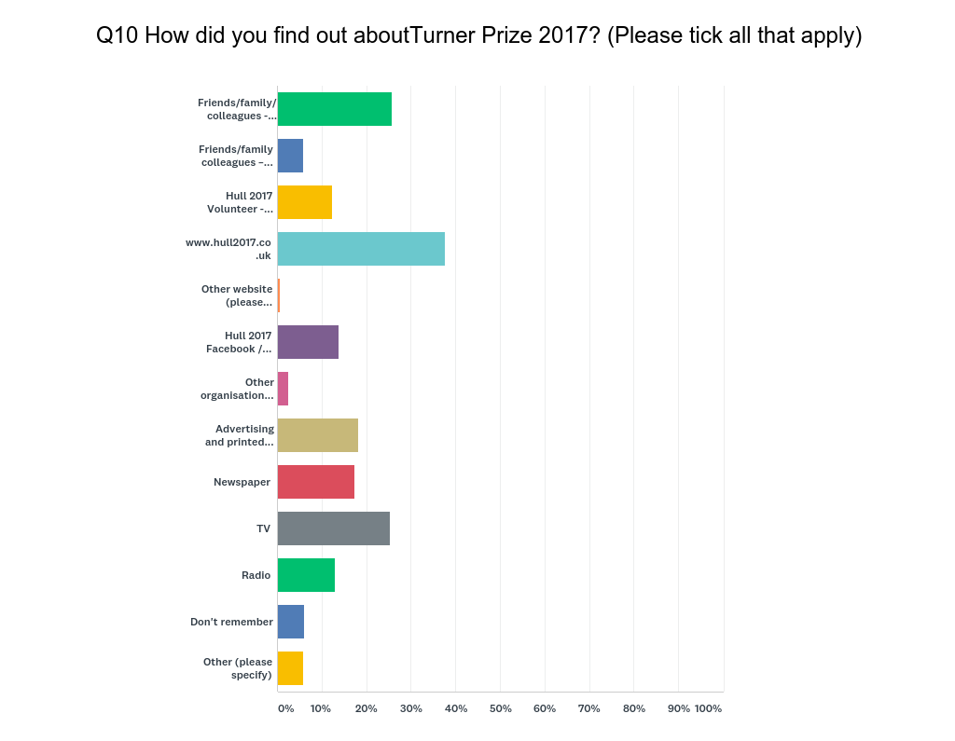

1. **PARTICIPANTS**

|  |  |  |
| --- | --- | --- |
|  | **TOTAL** | **% FROM HU1-HU9** |
| Number of participants* (in-house) | 405 (Workshops and Tours) |  |
| Number of outreach participants | 1200 (Volunteer Masterclass) |  |
| **TOTAL PARTICIPANTS** |  |  |

|  |  |  |  |  |
| --- | --- | --- | --- | --- |
|  | **%** |  |  | **%** |
| **AGE GROUPS - AUDIENCES** | |  | **DISABILITY/LONG TERM ILLNESS - AUDIENCES** | |
| 0-2 years | Not Included in Survey Sample |  | Yes – limited a lot |  |
| 3-5 years |  | Yes – limited a little |  |
| 6-10 years |  | No |  |
| 11-15 years |  | Prefer not to say |  |
| 16-17 years |  | **ETHNICITY** | |
| 18-19 years | 0.0% |  | Welsh/English/Scottish/Northern Irish/British | 78% |
| 20-24 years | 0.0% |  | Irish | 0% |
| 25-29 years | 0.0% |  | Gypsy or Irish Traveller | 0% |
| 30-34 years | 11.1% |  | Polish | 0% |
| 35-39 years | 0.0% |  | Any other White background | 0% |
| 40-44 years | 22.2% |  | White and Black Caribbean | 0% |
| 45-49 years | 22.2% |  | White and Black African | 0% |
| 50-54 years | 0.0% |  | White and Asian | 0% |
| 55-59 years | 22.2% |  | Any other Mixed/multiple ethnic background | 0% |
| 60-64 years | 22.2% |  | Indian | 0% |
| 65-69 years | 0.0% |  | Pakistani | 0% |
| 70-74 years | 0.0% |  | Bangladeshi | 0% |
| 75+ years | 0.0% |  | Chinese | 0% |
| Prefer not to say | 0.0% |  | Any other Asian background | 0% |
| **GENDER** | |  | African | 0% |
| Male | 56% |  | Caribbean | 0% |
| Female | 33% |  | Any other Black/African/Caribbean background | 0% |
| Transgender | 0% |  | Arab | 0% |
| Gender non-conf | 0% |  | Any other ethnic group | 11% |
| Prefer not to say | 11% |  | Prefer not to say | 11% |
|  |  |  |  |  |

Thinking about your project as a whole, what would you say have been the **main successes** and **challenges** in terms of participant engagement and feedback for your project?

**<INSERT FINDINGS FROM PARTICIPANT SURVEY AND ADD AS APPENDIX>**

1. **VOLUNTEERS**

|  |  |
| --- | --- |
|  | **TOTAL** |
| Number of volunteers trained | 498 |
| Number of volunteers completing shifts | 452 |
|  |  |

|  |  |  |  |  |
| --- | --- | --- | --- | --- |
|  | **%** |  |  | **%** |
| **AGE GROUPS** | |  | **DISABILITY/LONG TERM ILLNESS** | |
| 0-2 years |  |  | Yes – limited a lot |  |
| 3-5 years |  |  | Yes – limited a little |
| 6-10 years |  |  | No |  |
| 11-15 years |  |  | Prefer not to say |  |
| 16-17 years |  |  | **ETHNICITY** | |
| 18-19 years |  |  | Welsh/English/Scottish/Northern Irish/British |  |
| 20-24 years |  |  | Irish |  |
| 25-29 years |  |  | Gypsy or Irish Traveller |  |
| 30-34 years |  |  | Polish |  |
| 35-39 years |  |  | Any other White background |  |
| 40-44 years |  |  | White and Black Caribbean |  |
| 45-49 years |  |  | White and Black African |  |
| 50-54 years |  |  | White and Asian |  |
| 55-59 years |  |  | Any other Mixed/multiple ethnic background |  |
| 60-64 years |  |  | Indian |  |
| 65-69 years |  |  | Pakistani |  |
| 70-74 years |  |  | Bangladeshi |  |
| 75+ years |  |  | Chinese |  |
| Prefer not to say |  |  | Any other Asian background |  |
| **GENDER** | |  | African |  |
| Male |  |  | Caribbean |  |
| Female |  |  | Any other Black/African/Caribbean background |  |
| Transgender |  |  | Arab |  |
| Gender non-conf |  |  | Any other ethnic group |  |
| Prefer not to say |  |  | Prefer not to say |  |
|  |  |  |  |  |

**Thinking about your project as a whole, what would you say have been the main successes and challenges in terms of volunteers working on your project?**

Volunteer training consisted of three waves; A Masterclass to raise awareness, an Introduction to cover the prize history and this year’s shortlist and an Orientation, giving them a sneak peak of the exhibition before it opened to the public. Volunteers were integral in mediating between the artworks and the visitors, encouraging increased engagement and initiating a mass of positive feedback, donations and repeat visits. However, an increase in hired staff to manage the invigilation and safety of the artworks would have been valuable. Overall, 452 volunteers supported the delivery of the Turner Prize exhibition through a combined total of 3224 volunteer shifts, with some individuals completing up to 29 shifts. The majority of these shifts were four hours in length and, as a result, represent roughly 12,900 hours of volunteering. Using HLF guidelines for calculating the value of this unskilled labour (£50 per day), the hours of volunteering on the Turner Prize equate to around £86,000.

**<INSERT FINDINGS FROM VOLUNTEER SURVEY AND ADD AS APPENDIX>**

- Number of volunteers who completed the turner prize training

498

- Number of volunteers who did shifts/total number of shifts/total number of hours this equates to

452 / 3224 / 12,896hrs (based on 4hr shift length)

1. **DIGITAL AND MEDIA**

**Overall, how has your project impacted upon your online presence?**

|  |  |  |  |
| --- | --- | --- | --- |
|  | **TOTAL PAGE VIEWS** | **UNIQUE PAGE VIEWS** | **AVERAGE TIME ON PAGE** |
| https://www.hull2017.co.uk/whatson/events/turner-prize-2017/ | 50,840 | 43,496 | 1 min 26 secs |

Hull 2017 Marketing and Digital teams identified a number of different audiences to engage and developed a campaign with key copy lines which fitted in with the existing Hull 2017 voice. Phrases were chosen for particular locations and advertisements spanned; locally around the city and key venues; regionally across Northern arts institutions and travel networks; and nationally/internationally through selected editorials and a strong online presence. The success of this marketing campaign is evidenced through collected audience data: 57% of visitors came from outside of Hull and East Riding, with 1.9% coming from outside the UK. Hull 2017 Facebook posts and advertisements saw 664158 impressions and the event webpage had 51,000 views.

Announcement of the winner of Turner Prize 2017 received international coverage, including headlines such as “Turner Prize 2017: Lubaina Himid’s Win Makes History” (BBC News) and “Turner Prize win shows art can flourish up north” (The Guardian). Additional coverage from the BBC included BBC News at Ten, BBC Breakfast, BBC Radio Lancaster, BBC Radio Humberside, BBC Radio 3 – Free Thinking, BBC Look North, BBC The World Tonight and BBC Radio 4 Today. Lubaina Himid was the first black female artist to win the Turner Prize and her win has helped her to secure new commissions for Glasgow International, BALTIC Centre for Contemporary Art, Knole House and the Berlin Biennial over the coming year.

**vii. PARTNERS**

|  |  |  |
| --- | --- | --- |
|  | **TOTAL BASED IN**  **HU1 – HU9** | **TOTAL BASED OUTSIDE**  **HU1 – HU9** |
| **PARTNER TYPE** | | |
| Artistic partner (e.g. theatre, art gallery, music venue) | 1 | 1 |
| Heritage partner (e.g. museum, archive) | 0 | 0 |
| Funder (e.g. Arts Council England, business, private trust) | 0 | 0 |
| Public Sector partner (e.g. libraries, GPs) | 0 | 0 |
| Voluntary sector partner (e.g. community group, charity) | 0 | 0 |
| Education (e.g. school, college, university) | 0 | 0 |
| Other | 3 | 3 |
| **PARTNERSHIP STAGE** | | |
| Number of new partnerships established via this project | 0 | 3 |
| Number of existing partners involved in this this project | 4 | 1 |

**Thinking about your project as a whole, what would you say have been the main successes and challenges in terms of your partnerships on this project?**

Turner Prize 2017 and the associated programme was organised in partnership between Hull UK City of Culture 2017, Hull Culture and Leisure and Tate, with BBC as the official media partners. Turner Prize 2017 was the first event of the wider Hull 2017 programme to be announced; The Hull 2017 team led on planning and delivery, with a core project team of a Project Manager, Assistant Producer and two Curators all appointed by late April 2017. The team then worked with colleagues across internal departments to develop an extensive learning programme, a marketing strategy and to evaluate the exhibition. In hindsight, it would have been beneficial for the core project team to take up their posts earlier, so that they were involved in the preliminary research, planning and budgeting. The appointment of a dedicated core team worked well and allowed the staff to build fruitful relationships with partners and each other. This team also worked as a central point of knowledge to ensure that deadlines across departments were met, questions could be answered quickly, and which allowed the project to continue seamlessly when the Project Manager left post in late September 2017.

The four shortlisted artists were announced on 3 May 2017, receiving a flurry of international press coverage, including headlines such as “The Turner Prize 2017 shortlist is here, and it’s more diverse (and older) than ever” (ArtNet), “Turner Prize: Black painting pioneers break award age barrier” (BBC News) and “Turner Prize’s diverse shortlist ‘makes a powerful political statement’” (The Guardian). This, along with an artists’ visit in late May, helped build anticipation locally, regionally and internationally. This enthusiasm and excitement helped us to secure in-kind support from a number of businesses, including G.F. Smith, Crown Paints, JZ Flowers, Jayhawk Fine Art Shippers, Marino Gamper and exhibition design by David Kohn Architects. The artists worked closely with David Kohn and the curators to produce an exhibition with an impressive two-room cinema, bespoke plinths, benches and shelves. The scale of the above meant that we spent more on exhibition build than we had originally budgeted for and the fast-paced timescale of the Turner Prize meant we faced difficulties with procurement as many contractors were already booked up.

The Hull 2017 team recently hosted a group from Turner Contemporary, Kent County Council and Thant District Council to hand over knowledge about what is involved in hosting Turner Prize and to give advice on how they might leverage the opportunity to link with other cultural activities and develop a complete tourist experience for those visiting Margate.

**<INSERT FINDINGS FROM CORE PROJECT TEAM SURVEY>**