Works for Hull:

Framed drawings for The Deep:

Tania Kovats

*Evaporation (Black) 19*, 2014

ink, salt, water on blotting paper, framed

42 x 30 cm, 16.5 x 11.8 in

H7014

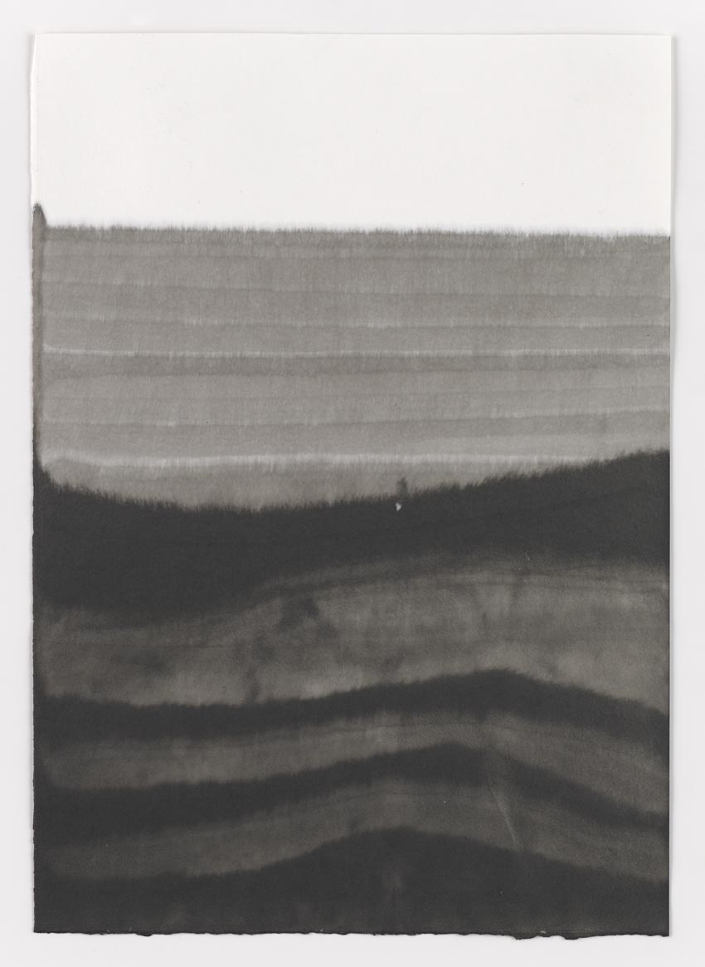

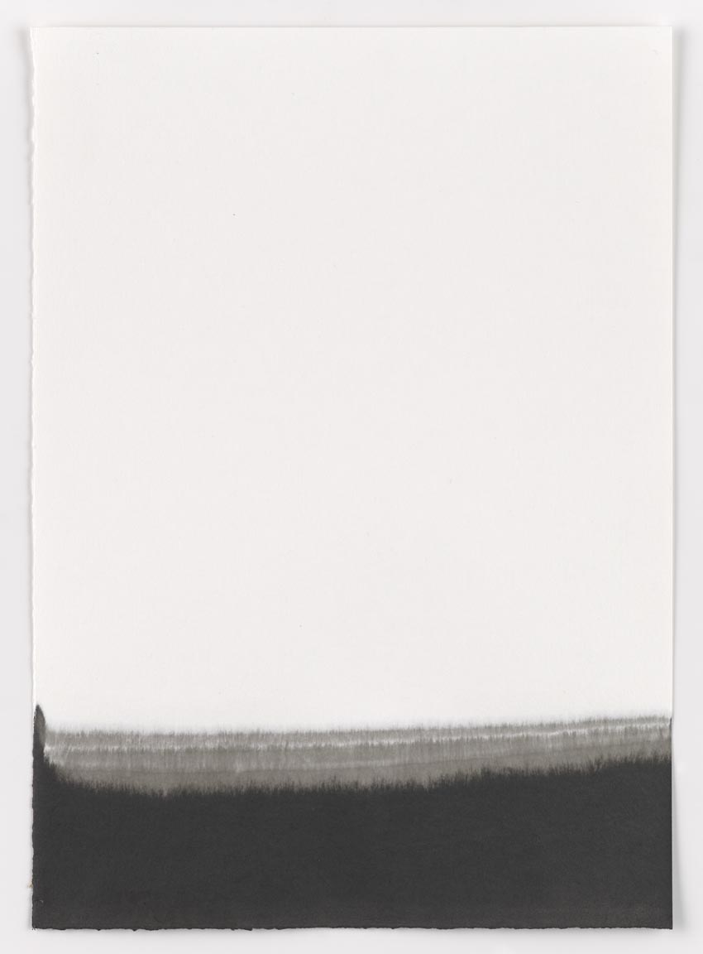

Tania Kovats

*Evaporation (Black) 20*, 2014

ink, salt, water on blotting paper, framed

42 x 30 cm, 16.5 x 11.8 in

H7015

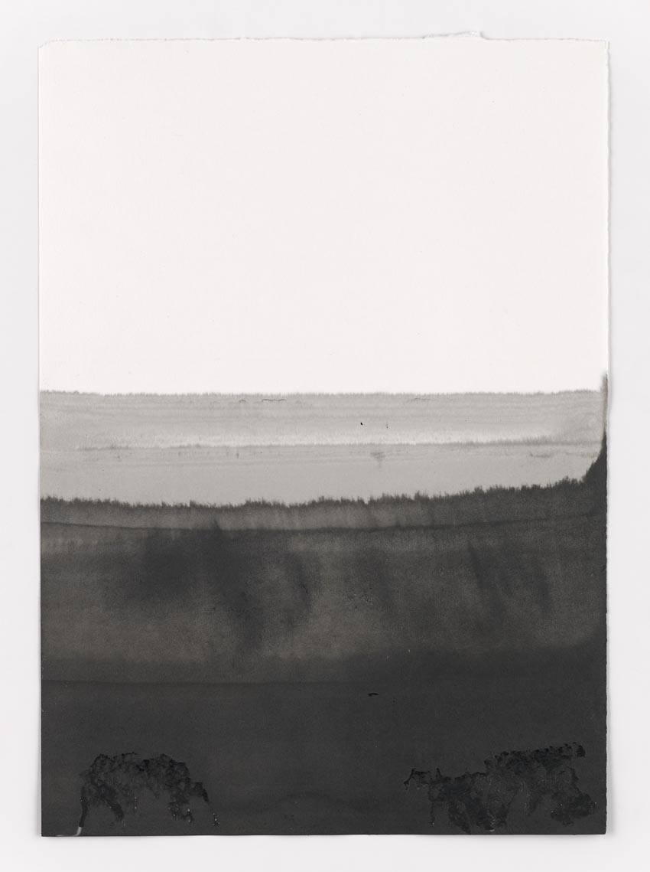

Tania Kovats

*Evaporation (Black) 21*, 2014

ink, salt, water on blotting paper, framed

42 x 30 cm, 16.5 x 11.8 in

H7015

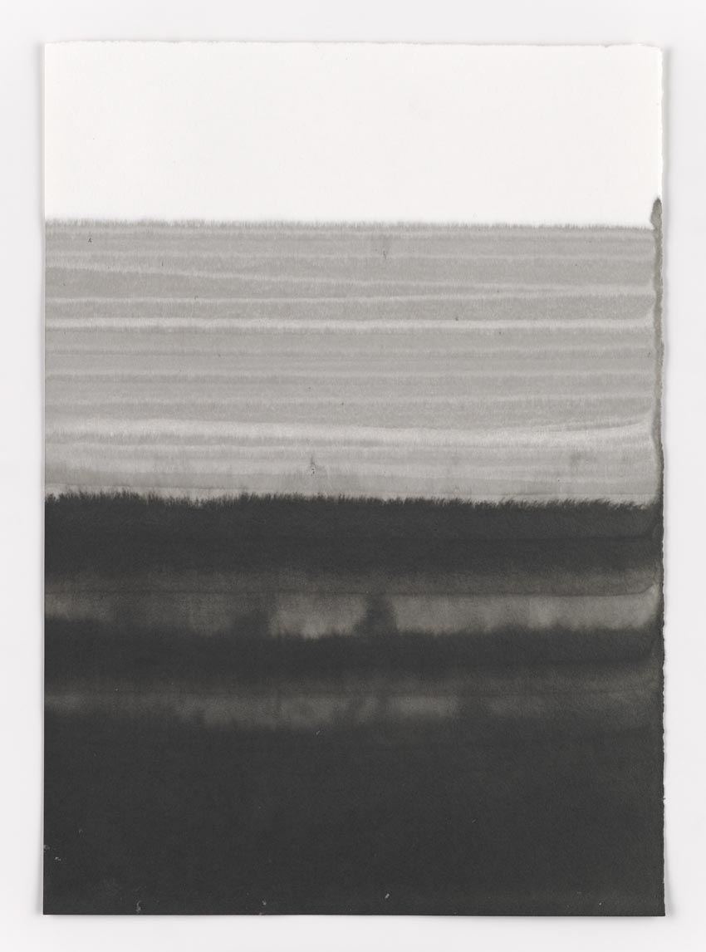

Tania Kovats

*Evaporation (Black) 22*, 2014

ink, salt, water on blotting paper, framed

42 x 30 cm, 16.5 x 11.8 in

H7017

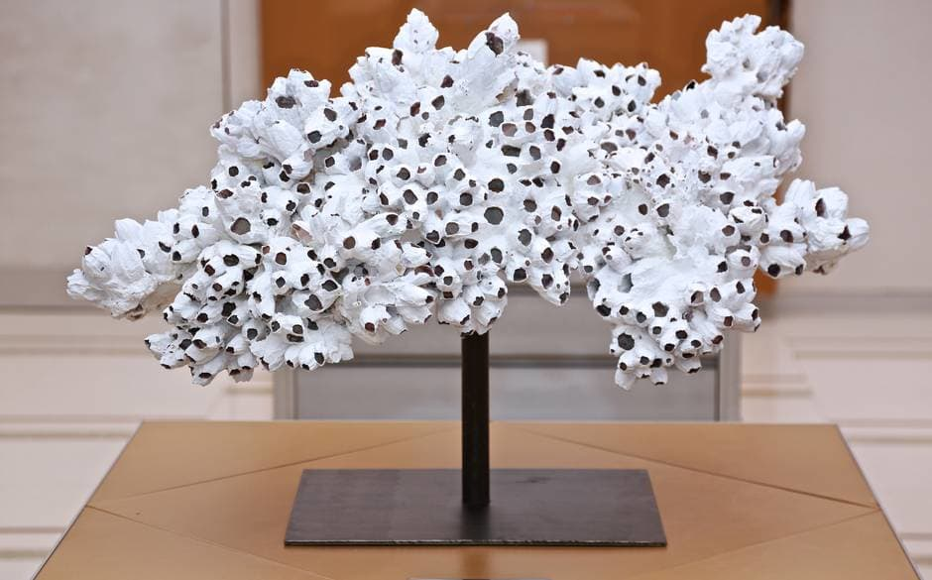

*Colony*

2012

barnacles, acrylic compound, steel