Assessment of: | Humber Bridge Test installation | Assessment carried out by: | Chris Clay
Assessment number: | HB001 | Position: | Technical & Operations Director
Date: | 9th August 2016 | Review date: | 11th August 2016

No. | ACTIVITY & WHO IS AT RISK | HAZARDS PRESENT | EXISTING CONTROL MEASURES | No. at risk | Risk factors |  |  | FURTHER ACTION REQUIRED & BY WHOM | DATE OF ACTION
 |  |  |  |  | Likelihood | Severity | Risk Level
1. | Installation of LEDs on Bridge hangers.  General public and contractors at risk. | Contact with moving vehicles.  Items dropped from height.  Use of MEWP  Fall from height | Safe systems of work identified in Star Events Health and Safety Management System for this activity to be followed | 10+ | 2 | 4 | M | Star Events Health & Safety documentation to be kept under review by Roger Barrett and Chris Clay. | ongoing
2. | Evening and night time testing of LEDs. Drivers and vehicle occupants on the Humber Bridge at risk. | Drivers on the bridge could be distracted, leading to road traffic accidents. | Only a small number of LEDs are being installed on 5 hangers, the overall effect will be minimal.  The LEDs will not be flashing or displaying distracting effects.  The LEDs are mounted on the outside of the hangers and will not be visible to drivers on the bridge. | 100+ | 1 | 5 | L | Situation to be kept under review during the testing by Chris Clay and the project team. | ongoing
3. | Evening and night time testing of LEDs. Drivers and vehicle occupants on the A63 and surrounding roads at risk. | Drivers on the A63 and surrounding roads could be distracted, leading to road traffic accidents. | Only a small number of LEDs are being installed on 5 hangers, the overall effect will be minimal.  The LEDs will not be flashing or displaying distracting effects.  The LEDs are not bright enough to dazzle drivers in oncoming vehicles. | 100+ | 2 | 5 | M | Situation to be kept under review during the testing by Chris Clay and the project team. | ongoing

RISK MATRIX

LIKELIHOOD  SEVERITY | 1. Very unlikely  (no known history) | 2. Unlikely  (unlikely sequence of events) | 3. Possible  (Foreseeable under unusual circumstances) | 4. Likely  (Easily foresseable – some incidents may have occurred) | 5. Very likely  (Common occurrence – aware of incidents)
1. Negligible  (no visible injury – no pain) | LOW | LOW | LOW | LOW | LOW
2. Slight  (minor cuts or bruises – no long term effects) | LOW | LOW | LOW | MEDIUM | MEDIUM
3. Moderate  (Heavy bruising, deep wounds, lost time) | LOW | LOW | MEDIUM | MEDIUM | HIGH
4. Severe  (Major injuries, lost time accidents, RIDDOR reportable) | LOW | MEDIUM | MEDIUM | HIGH | HIGH
5. Very Severe  (Long term disability or death) | LOW | MEDIUM | HIGH | HIGH | HIGH

NAME OF ASSESSOR: | Chris Clay | DATE OF ASSESSMENT: | 9th August 2016
SIGNATURE: | 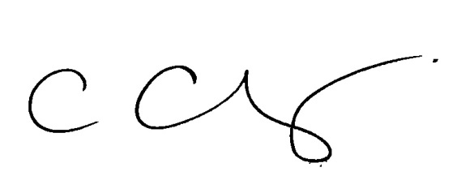
CONTACT DETAILS
EMAIL: | chris.clay@hull2017.co.uk | PHONE: | 07771 788 221

